Put the following into the correct section of the triple Venn diagram. For example, if it applies to all three religions, you would write it in the very center of the circles (where they all overlap).
YOU ONLY HAVE TO WRITE THE LETTER in the Venn diagram section. Make sure your letters are neat to read!
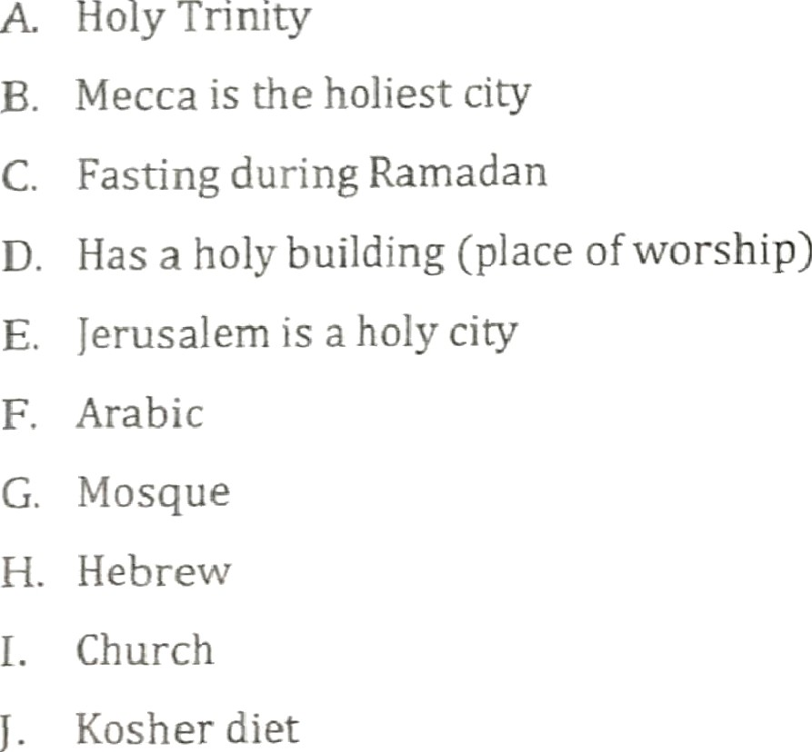

K. Hajj

L. Monotheistic
- AIlah
- Koran (Qu’ran)
- Jesus is seen as the son of God
- M uhammad
- Synagogue
- The first five books of the Old Testament
- Has a holy text
- Trace back to Abraham
- Abraham is the founder

Three Religions Born in Southwest Asia
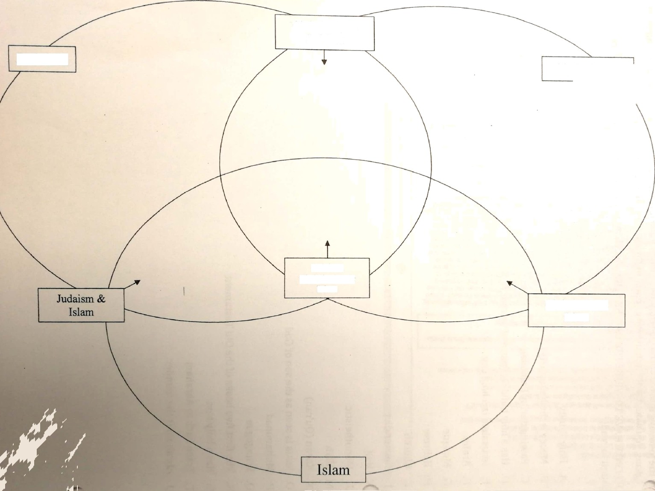

Judaism

Christianity & Judaism

Judaism, Christianity, & Islam

Christianity

Christianity &
Islam
Scanned by CamScanner

