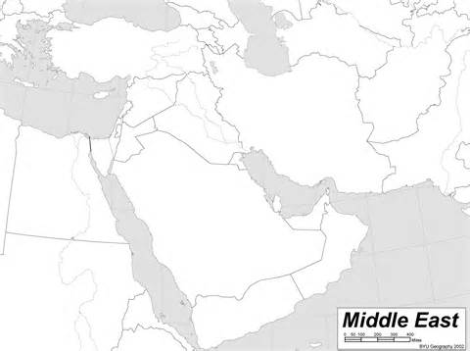

**Water Sources**

Jordan River

Mediterranean Sea

Red Sea

Dead Sea

Tigris River

Euphrates River

**Population**

**(persons per square mile)**

* >260
* 130-260
* 25-130
* 3-25
* <3