*Article has been shortened and modified for the sake of time and content*

25 Aug 2014: Analysis

Mideast Water Wars: In Iraq,
A Battle for Control of Water by fred pearce

Conflicts over water have long haunted the Middle East. Yet in the current fighting in Iraq, the major dams on the Tigris and Euphrates rivers are seen not just as strategic targets but as powerful weapons of war.
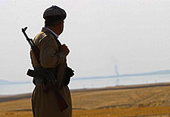
There is a water war going on in the Middle East. Blood is being spilled to capture the giant dams that control the region’s two great rivers, the Tigris and Euphrates. These structures hold back large amounts of water. With their engineers fleeing as the Islamic State (ISIS) advances, the danger is that the result could be catastrophe — either deliberate or accidental.
Fights over water have pervaded the Middle East for a long time now. Water matters at least as much as land. It is at the heart of the siege of Gaza – the River Jordan is the big prize for Israel and the Palestinians. And over the years, water has brought Iraq, Syria and Turkey close to war over their shared rivers, the Euphrates and Tigris.
The Euphrates flows out of Turkey, and through Syria and into Iraq, before entering the Persian Gulf via the Mesopotamian marshes. The Tigris rises further east in Turkey and flows through territory currently controlled by the Kurdish army in Iraq. There, it follows a parallel path to the Euphrates before the two rivers mingle their waters in the southern marshes.
The two rivers water a region long known as the “Fertile Crescent.” They were the first rivers to be used for large-scale irrigation. Not much has changed. The dependence persists, and so do the disputes. The main difference today is that the diversion dams are bigger, and supply hydroelectric power as well as water. And that is why in recent months, many of the key battles in Iraq’s civil war have been over large dams.
The Islamic State’s quest for hydrological control began in northern Syria, where in early 2013, it captured the Tabqa Dam, which barricades the Euphrates as it flows out of Turkey. The dam, which is the world’s largest earthen dam, is a major source of water and electricity for five million people,
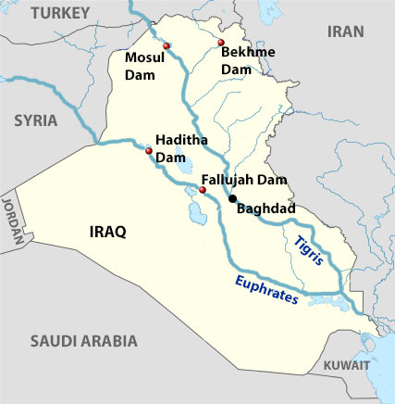
Wikimedia Commons/Yale Environment 360
Key dams along the Tigris and Euphrates rivers.

including Syria’s largest city Aleppo. It also irrigates a thousand square kilometers of farmland.
The Islamic State’s control of the Tabqa Dam has been haphazard, to say the least. In May, the Arab news service Al Jazeera quoted engineers at the dam as saying that their new masters had ordered them to maximize the supply of electricity. That required emptying the reservoir’s water through the dam’s hydroelectric turbines.
From the Tabqa Dam, the Euphrates flows downstream through Iraq. It meets the Fallujah Dam, which diverts water for massive irrigation projects that produce the crops that feed the country. In early April, Islamic State forces captured the dam. Reports of what happened next are confused, but it appears that the troops immediately shut the dam and stopped flow downstream.
This left towns such as Karbala and Najaf, a Shiite holy city 160 kilometers away, without water. But it also caused the reservoir behind the dam to overflow east, flooding some 500 square kilometers of farmland and thousands of homes as far as Abu Ghraib, about 40 kilometers away on the outskirts of Baghdad. Later, the rebels reopened the dam, causing flooding downstream.
This mayhem may have been a simple failure by Islamic State fighters to understand the hydrology of the river and the consequences of how it operated the dam. It may initially have been an attempt to deprive Shiite communities downstream of water. But Ariel Ahram, a security analyst at Virginia Tech University, suggests the eastward flooding was a deliberate act to drive back Iraqi government forces attempting to retake the dam.
The UN secretary-general’s special representative in Iraq, Nickolay Mladenov, called the flooding deliberate, and demanded the restoration of “legitimate” control of the river. The Iraqi government says it has since recaptured the Fallujah Dam. But the conflict in the area continues, and events remain very worrying for anyone downstream.
If the Sunni rebels want to use water as a weapon of war against the Shiite south of the country, the Haditha Dam would be a powerful weapon. “They could disrupt downstream flow, either by withholding water or releasing a wall of floodwater, as they did from Fallujah this spring,” says Sticklor. “It would have a potentially crippling effect on food production and economic activity in central and southern parts of the country.”
It could also be lethal. The water behind Haditha has long been recognized as a potential weapon of war. In late June, employees at the dam told the New York Times that Iraqi government generals were prepared to open the floodgates against Islamic State forces rather than giving up the dam.
The Islamic State fighters have also at times gained control of the other great river, the Tigris. Early on in their offensive, they grabbed the Samarra Barrage, just upstream of Baghdad, which diverts water to fields for irrigation. Messing that up could cripple the country’s food supply.
Called the Sirwan in Iran, the Diyala River is a major tributary (secondary river) of the Tigris, watering crops east of Baghdad. But in the past 15 years, the Iranians have reduced its flow by more than half. And worse is to come in 2018, when the Iranians plan to complete a new dam. The Karkeh River once helped fill the Mesopotamian marshes. But Iran now takes so much of its water for irrigation that the river rarely crosses the border.
This dam-building flies in the face of growing evidence that the entire region is becoming drier. Below average rainfall has persisted for almost a decade now. Less rainfall combined with water diversions (rerouting) have reduced the flow of both the Tigris and Euphrates by more than 40 percent in recent years, says Al-Ansari. Some analysts say that the intense drought of 2007-2009, and the resulting failed crops, helped trigger Syria’s civil war by creating social breakdown as farmers became refugees and food prices soared in cities.
Climatologists predicted in 2009 that the drought is likely to be permanent and the Fertile Crescent, which has sustained the region for thousands of years, “will disappear this century.” As the rivers empty, the temptation to fight over what remains can only grow. It is a true tragedy of the commons.
POSTED ON 25 Aug 2014 IN Business & Innovation Climate Policy & Politics Policy & Politics Pollution & Health Water Asia Middle East

