STEAM: Ndebele Inspired Art Project

Background:
Students will create a Geometric artwork inspired by the homes of the Ndebele people of South Africa and, their most famous daughter, Dr. Esther Mahlangu. Students will use a series of geometric shapes and patterns to create an original Ndebele-inspired geometric designed piece of art.

Materials Needed:
-White cardstock or construction paper
-ruler
-pencil
-colored pencils
-black (and if you have colored) markers

INSTRUCTIONS:
Begin by drawing out a grid to guide your patterns. Use a pencil and a ruler to draw faint lines on your paper.
For Example: You can draw a border around all four sides of your paper, and diagonal lines across your page.
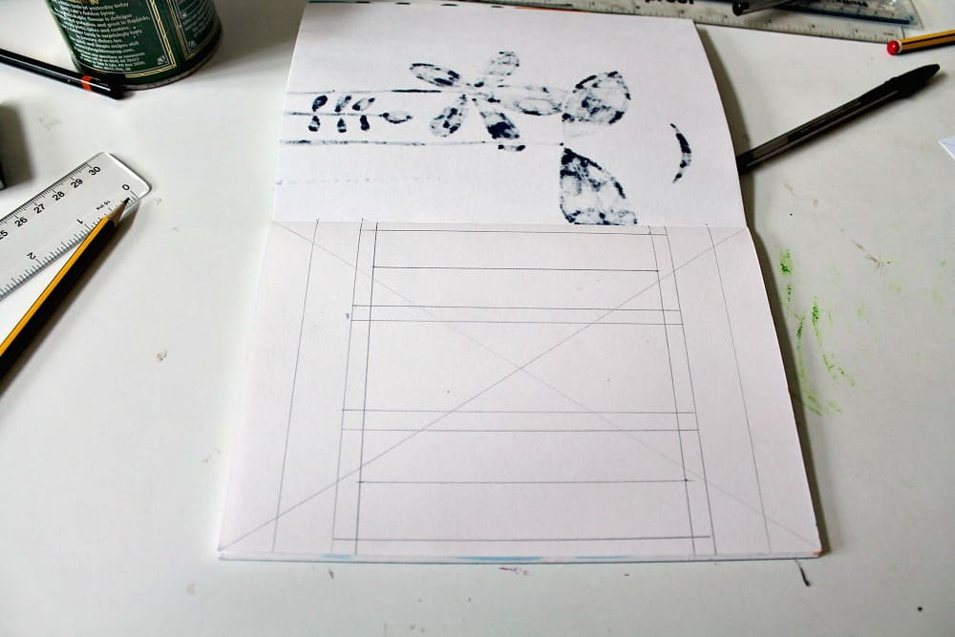
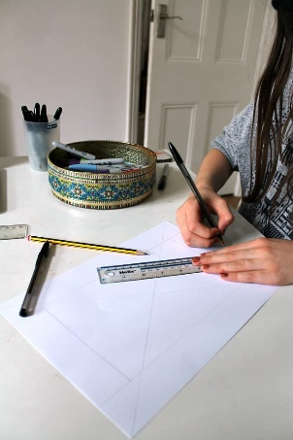

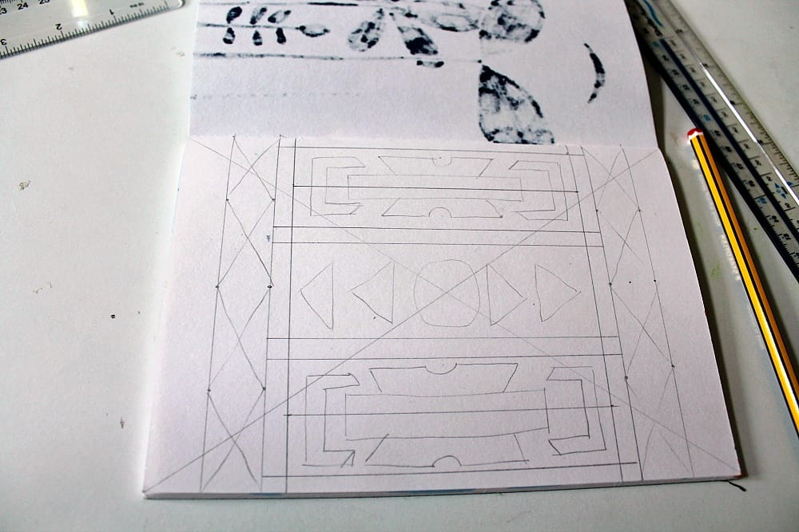
From this simple framework, add more lines to your page, dividing it up into sections. Try to make your grid symmetrical in its layout.

Once you have a grid to guide your design, draw in your patterns. You can use the shapes you have seen in the photographs of Ndebele houses and Esther Mahlangu’s artworks.

Use repeating patterns, geometric shapes (squares, rectangles, and triangles) and symmetry, as is the Ndebele style.

Draw over the outline of your shapes with a black marker pen. Use a ruler to get clear straight lines.

Then use colored pencils to add color. You may want to use some of the shades that you have seen in the Ndebele houses.

Use the black marker to add extra elements to the borders of your design.

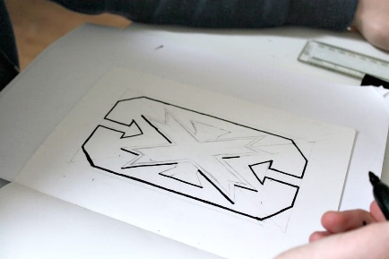
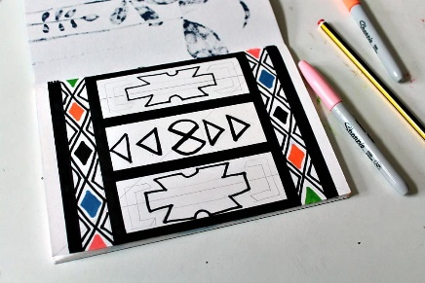
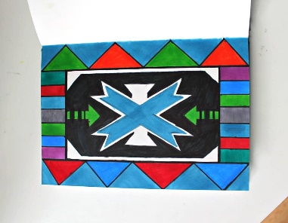
Use repeating lines of shapes and create symmetry in different sections of your design.

James, C., 2021. Esther Mahlangu African Art Lesson for Children - Nurturestore. NurtureStore. <https://nurturestore.co.uk/esther-mahlangu-african-art-lesson-for-children> [Accessed 13 January 2021].

