Name:____________________________________________________________ Date:_________________ Pd:_______
Southeast Asia Environmental Issues
How has pollution and flooding affected Southern & Eastern Asia?
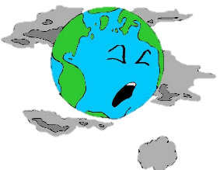
Causes Effects

Air Pollution Definition:

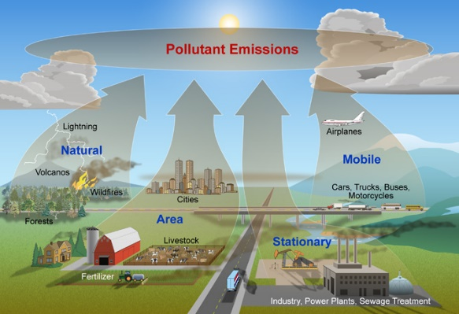

Asian Brown Cloud: _________________________________________________________________________
Interesting fact about Asian Brown Cloud: ______________________________________________________
Flooding & Water Pollution
Label the rivers on the map with the appropriate names. These rivers are a major source of pollution in SE Asia: Mekong, Huang He, Ganges, Indus, Yangtze
1. _______________ 2.__________________ 3.__________________ 4._______________ 5.______________
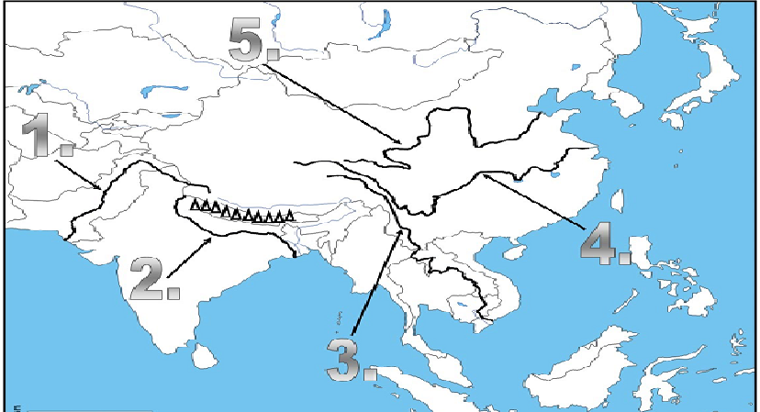
Because parts of China and India
are located along ___________
they are subject
to flooding, which can ________
___________________________

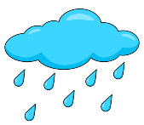
Causes Flooding Effects

Monsoon: A monsoon is a
seasonal change in _______________
_______________________________
_______________________________
Monsoons can cause _____________
Flooding can occur during the _____
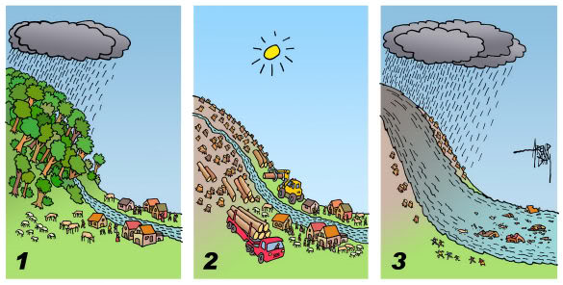

Causes Effects

Water Pollution

Water Pollution Definition:

