The Kingdom of Aksum: Sub-Saharan empire of late antiquity
By National Geographic Society, adapted by Newsela staff on 02.05.20 Word Count 854
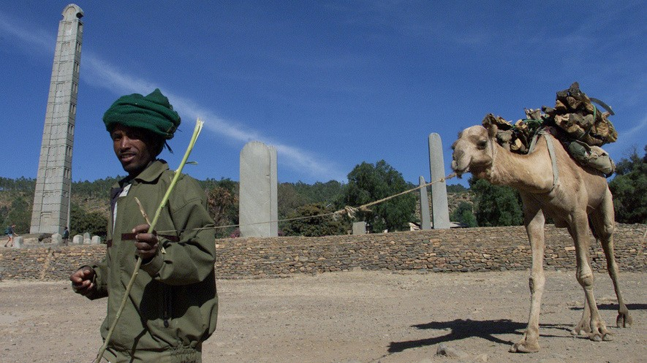
Level 870L
An Ethiopian man leads his camel past the Obelisk stele in Aksum, January 17, 2002. This is some 311 miles north of the Ethiopian capital Addis Ababa. In 1937, Italian dictator Benito Mussolini ordered that the obelisk be taken to Rome, Italy. Italian soldiers took it there. They were in the country between 1936 and 1941. The top piece of the obelisk was 1,700 years old and 82-feet tall. It was finally returned in 2005. Its return ended the dispute over the stolen religious monument. Photo by Karel Prinsloo for AP

For centuries, the Kingdom of Aksum ruled much of what is now the African country of Ethiopia. It controlled a large territorial state and vast trade
routes.
Aksum, the capital city, had a population as high as
20,000. The kingdom was also notable for its elaborate monuments and written script. Additionally, it introduced the Christian religion to Africans south of the Sahara desert.
Aksum sat in the highlands of northern Ethiopia, in a region called Tigray. That's near present-day Eritrea. Humans had lived in the area since the Stone Age. Farming communities had been there for at least 1,000 years. Still, the origins of the Kingdom of Aksum are mysterious.

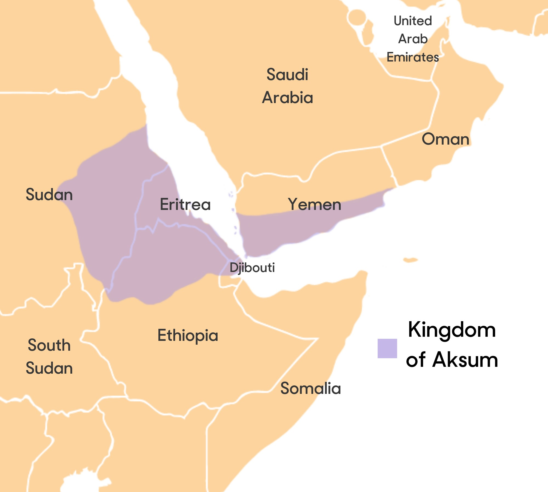
People from the Kingdom of Saba may have migrated into the area in the first millennium B.C. They
lived across the Red Sea on the southern Arabian Peninsula. In this region, archaeologists have found evidence of a complex society called Da'amat. It preceded the rise of Aksum by several centuries. This culture was apparently based in the village of Yeha,
about 31 miles northeast of Aksum. Another city-state seems to have existed on a hill next to Aksum.
However the culture came about, it is clear that by around the first century A.D., Aksum had emerged as a state to unify the area.

Local Geography, Trade Routes

The local geography contributed to the rise of Aksum. Its climate, rainfall patterns and fertile soil made the area good for livestock herding and agriculture. Most importantly, the city was well- positioned between trade routes. These passages ran in every direction, linking the Roman Empire to the Middle East and India.
Gold and ivory were perhaps their most valuable items to trade. They also traded tortoise shells, rhinoceros horns, emeralds, salt, live animals and human slaves. In exchange, they imported
textiles, iron, steel, weapons, jewelry, spices and wine. Their trading partners included most of the major states in the known world: Egypt, South Arabia, the Middle East, India and China. Perhaps their most important business partners were the Romans of the Byzantine Empire. Aksum was the first African country to make its own coins, in gold, silver and bronze. These coins have been found as far away as India.
Divisions Between Rich And Poor

The Kingdom of Aksum reached its peak power between the third and sixth centuries A.D. In those years, it was a large, wealthy society. It displayed class divisions. At the top were high nobles. Then there were lesser members of the high classes, and common folk. Meanwhile, smaller towns and
rural villages sprang up in the surrounding areas. The kingdom exercised control over much territory covering Tigray and northern Eritrea. It also had power over the desert and coastal plains to the south and east. Much of the Red Sea coast, in present-day Djibouti and Somalia, was under its control, too.
Aksum expanded its territory through warfare. Led by King Ezana I, Aksumites conquered the city-state of Meroe in the early fourth century A.D. That is part of present-day Sudan. In the sixth century, the Aksumite King Kaleb sent a force across the Red Sea to overtake the Yemenites.
Aksum ruled over them for several decades.
In the fourth century, Aksum became Christian. It became the first African state south of the Sahara to accept the new religion. A figure named Frumentius is given credit for bringing it to Ethiopia. He became an adviser to the court at Aksum and a tutor to the crown prince, Ezana.
After assuming the throne, Ezana proclaimed Christianity the state religion. It is unclear whether this decision was sparked by the kingdom's relations with Rome. Over a hundred years before,
Roman traders had already brought the Christian religion to the Aksumite trade network.

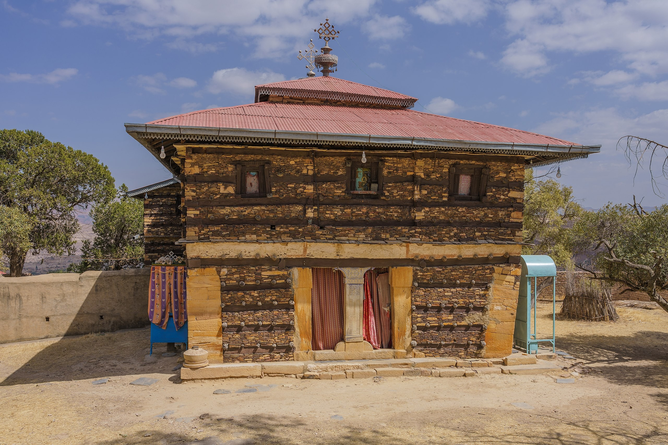
Written Language

The Ethiopian written language, known as Ge'ez, grew originally from the Arabian kingdom of Saba. Some inscribed stone slabs from the time of Aksum's King Ezana are engraved in three languages: Ge'ez,
Sabaean and Greek. Ge'ez is mostly no longer spoken in the region.
The kingdom's power had disappeared entirely by the end of the eighth century. One reason for its decline was the migration of the roaming Beja peoples into
the area. Their independent herding activities threatened Aksum's total power over land. The
Aksumites lost their hold on southern Arabia. Persians then conquered Yemen around A.D. 578.
The final blow was the rise of the Arab Muslims. They became the region's true power in the seventh century. Arab Muslims assumed naval control of the Red Sea. The loss of wealth
undermined the capacity of Aksum's ruling class to hold a large state together. Additionally, its rich soils had lost quality from overuse.
Political power shifted to a new ruling group, the Agau people. They created the Zagwe Dynasty, based in the city of Lalibela. People live in the city of Aksum even today. It is now considered an important historical site.

