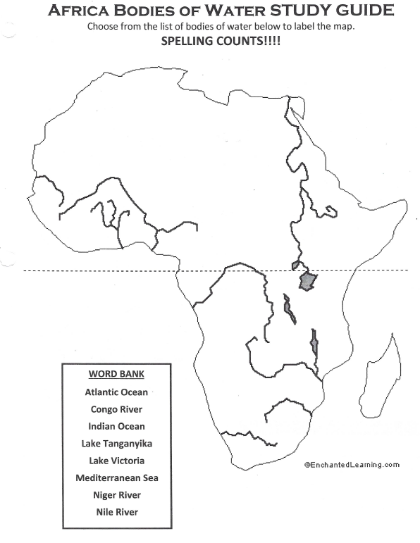

**Key/Legend for SketchNotes**

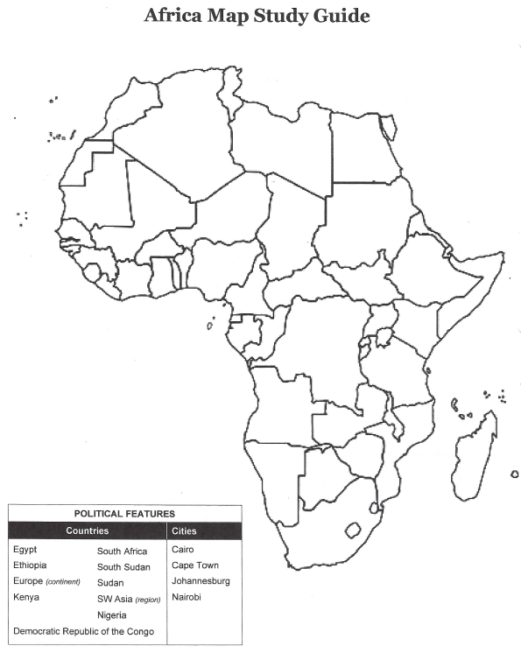

**Key/Legend for SketchNotes**