The Ancient Kingdom of Mali, ruled by the Lion King
By UShistory.org, adapted by Newsela staff on 02.22.17 Word Count 809
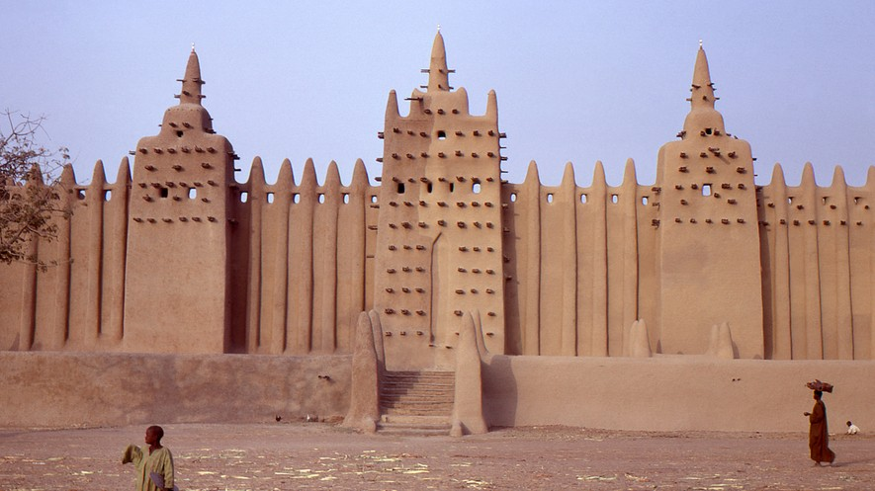
Level 960L
TOP: The Great Mosque in Djenne, Mali, in the morning. Photographed in 1972 by Gilles Mairet, courtesy of Wikimedia Commons. BOTTOM: Image of a king of West Africa, believed to be Emperor Mansa Musa of Mali, in the "Catalan Atlas of 1375" composed by cartographer Abraham Cresques of Majorca, Spain.

What would life be like if a magician ruled the land? The history of ancient Mali gives us some ideas. The founder of this West African kingdom was known among his people as a man of magic who had more than a few tricks up his sleeve.
Before the sorcerer ruled and the Malian kingdom was born, years of fighting went on in these lands west of the upper Niger River. Finally, in the 13th century A.D., a group known as the Soso emerged as victors. The Soso's new lands had once belonged to the kingdom of Ghana. They were like giant pots of gold.
However, before the Soso could settle in and enjoy the wealth, the great "sorcerer-king" Sundiata moved in to take over.
Eight spirits help defeat king

Sundiata claimed that Mali belonged to him by right of inheritance. In 1230 A.D. he defeated the Soso and took back the land. Legend says that Sundiata's rival, King Sumanguru, was also a
sorcerer. Sumanguru conjured up the heads of eight spirits for assistance fighting Sundiata. But Sundiata had stronger magic. He defeated the eight heads and then shot an arrow, which grazed
Sumanguru's shoulder, draining him of all of his magic. With a pat on the back, Sundiata declared himself ruler, or mansa, of the region. He set up a capital in the city of Niani.
Sundiata, also known as the "Lion King," was determined to make changes, and indeed he did. He decided to assign occupations to family groups and developed a social system for it. For example, anyone born into a family of warriors was destined to be a warrior. Anyone born into a family of djeli, or storytellers, had to join the djeli custom. Choice of career was not allowed.
Conveniently for Sundiata and his family, this system meant that anyone born into a family of mansa was part of the line of rulers. The ruling dynasty was called the Keita. This was one of Sundiata's "tricks" to keep power in the family.
For the most part, the system worked. However, for a short time, power escaped the Keita and landed in the hands of a former slave. The disruptive rule of the ex-slave, known as Sakura, paved the way for Sundiata's nephew, Mansa Kankan Musa, to regain the throne. Known for his wealth, generosity and dedication to the religion of Islam, Mansa Musa took the kingdom to new heights.
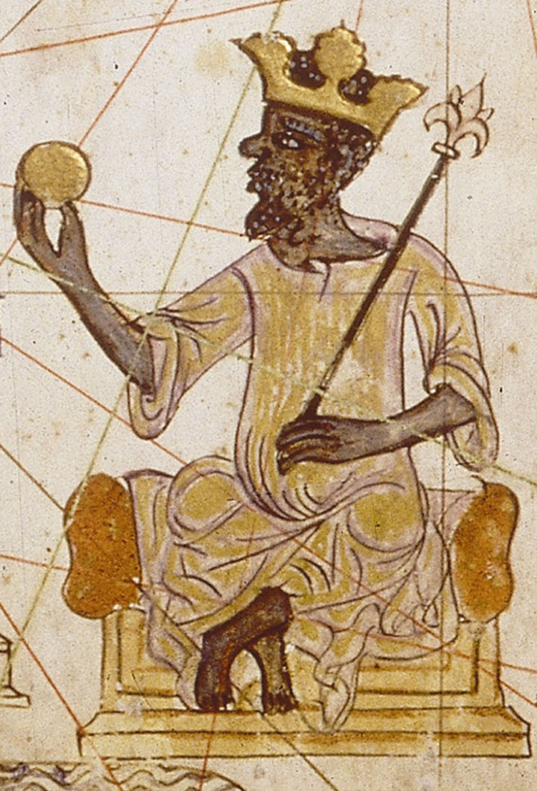
Lucky few suddenly rich

Mansa Musa led Mali to great riches. The kingdom was involved in the gold trade that swept through
Africa and reached all the way to Europe. The region's wealth was nothing new. However, based on Egyptian records, Mansa Musa's display of the riches, and the way he distributed Mali's wealth, had not been seen before.
In 1324, Mansa Musa set out on a pilgrimage to Mecca, a holy city for those who practice Islam. Wearing his finest clothes, Mansa Musa passed through Cairo with 500 slaves, each carrying a 6- pound staff of gold. With them were 100 camels,
carrying over 30,000 pounds of the precious metal.
Surely this was a sight to behold. The accounts left behind say that the show got even better. While cruising through Cairo, Mansa Musa reportedly handed out gifts of gold to bystanders. He entertained the crowds and made a lucky few suddenly rich.
Relationship between religion and politics

Mansa Musa made an important mark in Mali by introducing the kingdom to Islam and making it one of the first Muslim states in northern Africa. He used the laws of the Quran, Islam's main
religious text, in his justice system. Cities such as Timbuktu and Gao developed into international centers of Islamic learning. Elaborate mosques, some almost 60 feet high, were built, as were

libraries. The university built in Timbuktu might have been the world's first. The cities became centers for poets, scholars and artists.
Though not everyone accepted the new faith, a strong relationship between religion and politics quickly developed. Mansa Musa ruled with all the ideals of a fine Muslim king. He died in the mid- 14th century, and Mali was never quite the same. Squabbling between ruling families weakened Mali's governing, and its network of states started to unravel. Then, in 1430, a group of Berbers, a North African ethnic group, seized much of Mali's territory, including Timbuktu.
Though the wealth and power of Mali were swept up by the next great empire, its history stands proudly. At its peak, from 1200 to 1300, the Mali Empire extended across West Africa to the
Atlantic Ocean. It included parts of present-day Mali and southern and western Mauritania and Senegal. The Malian kingdom ruled over an estimated 40 to 50 million people. The pioneering
spirit and groundbreaking accomplishments of Mali's kingdom make its rise and fall an important chapter of African history.

