Trading Salt for Gold: The Ancient Kingdom of Ghana
By USHistory.org, adapted by Newsela staff on 06.27.17 Word Count 828
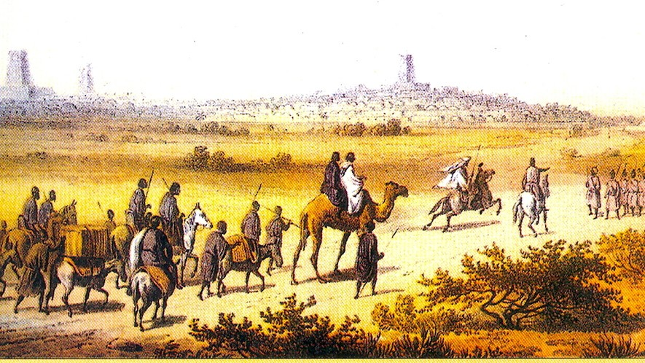
Level 920L
A trade caravan traveling in Africa. Ghana played an important role in early trans-Saharan trade. Photo from Wikimedia

Between the 9th and 11th centuries A.D., the kingdom of Ghana was rich. So rich, in fact, that its dogs wore golden collars and its horses slept on plush carpets. It is no wonder that many foreigners thought of Ghana's kings as the richest men in the world. The kings were living the high life, but how did they do it?
Today, there is a country named Ghana in western Africa. It is named after the ancient kingdom of Ghana. But the ancient kingdom of Ghana was in a different place. Ghana's ancient kingdom is located within today's borders of the countries of Mauritania, Mali and Senegal in western Africa. Back then, Ghana had many gold mines on its land. This allowed its rulers to trade for many years and become very wealthy.
Wagadugu was a rich and mysterious place

Ancient Ghana was called Wagadugu, Wagadou or Awkar. Most of what is known of the kingdom is from writings of travelers who came in contact with Ghana. "Ghana" was the title given to

Wagadugu kings and was used for the rich and mysterious place they ruled.
Ancient Ghana was established by a tribe known as the Soninke. The Soninke leaders have been credited with strengthening Wagadugu and expanding its territories.
By 1000 B.C., the nation had expanded. Ghana's rulers had taken control of the land between the upper Niger and Senegal Rivers. This area was rich in gold. Having control of this land meant that Ghana would become a leading force in the trans-Saharan trade route, a trading network that went across the Sahara Desert.
The king had all the power

The leader with the most power was the king, who was also known as the ghana, or war chief. His word was law. He was the leader of the army, the controller of all trade and the head administrator of justice. Other leaders were appointed by the king to assist him, but at all times the king was in charge.
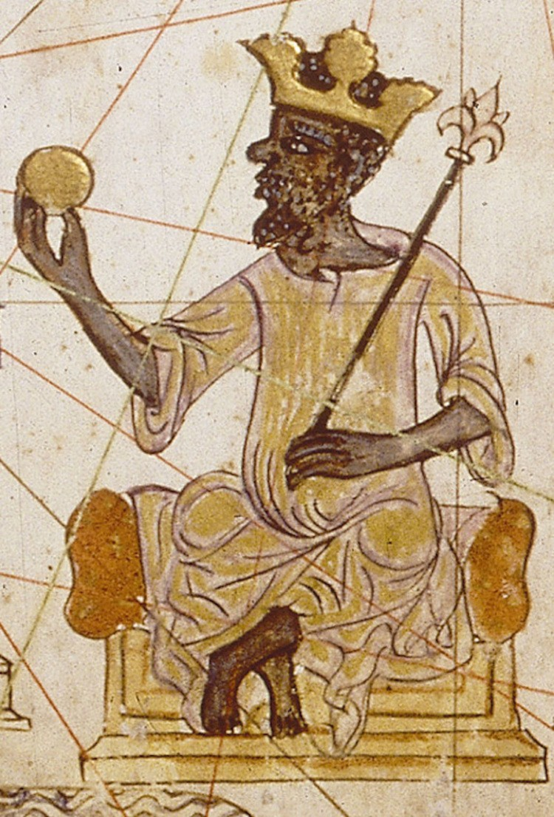
Each day, the king assembled his court and allowed people to publicly voice their complaints. Beating drums signaled that people should gather to speak their minds. The king listened to the complaints and gave his judgment.
Such hearings were peaceful, unless the issues were criminal, such as not paying someone back or physically hurting someone. These crimes were tried by ordeal. This means the person would be tested in a painful way to determine if he was guilty.
Vomiting signaled innocence

For example, the person accused of the crime was given a drink made from sour and bitter-tasting wood and water. If he vomited after drinking it, he was declared innocent. If he did not vomit, he was considered guilty and suffered the king's wrath.
The people of Ghana were not the only ones put to the king's test. People who lived in Ghana's conquered lands were examined for their good behavior and loyalty as well. In territories where the king's laws
were followed, people were given some independence. But in other areas, Ghanaian governors were watchdogs and they reported almost everything that happened to the king.
Ghana did a lot of trading

The king of Ghana also used his power to help trade grow between countries. At its peak, Ghana mostly traded gold, ivory and slaves. They wanted salt from Arabs and horses, cloth, swords and books from North Africans and Europeans.

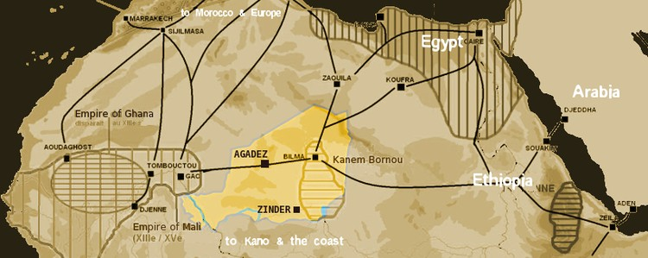
Back then, salt was worth its weight in gold. Because there was so much gold in Ghana, the kingdom became wealthy by trading with the Arabs. Some people traveled over two months through the desert to reach Ghana to trade. They were taxed for both what they brought in and what they took out. With this
system, it is no wonder that Ghana got rich quickly.

The Almoravids invaded Ghana

But soon jealousy, fear and anger of Ghana's power led nearby countries to stand up against the kingdom. Their efforts were at first weak and insignificant. But, by the mid-11th century, a Muslim empire led by a dynasty known as the Almoravids invaded Ghana's capital city of Koumbi Saleh.
The Almoravids controlled North Africa, including the area now called Morocco. Some of Ghana's territories were seized by the Almoravids and Ghana's government now had to pay taxes. But,
Ghana eventually recovered and forced the invaders to withdraw.
About 200 years later, however, Ghana was not so lucky. The kingdom was weakened by attacks and cut off from international trade.
It was unable to prevent defeat. In A.D. 1240, Ghana was absorbed into the growing nation of Mali, which soon became the next great empire.

