How the modern nation-states of the Middle East were created
By WGBH, adapted by Newsela staff on 11.01.19 Word Count 813
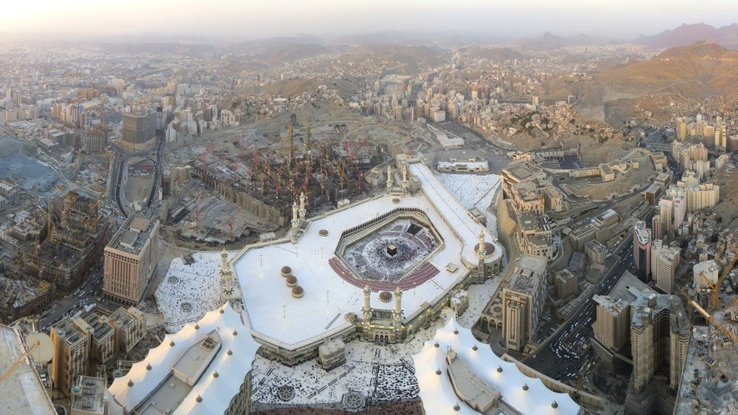
Level 830L
Image 1. Cropped panoramic image of an aerial view of Mecca, Saudi Arabia. Mecca is a city that is an important pilgrimage site for Muslims around the world. The city was once under control of the Ottoman Empire. Photo from: Wikimedia Commons/Wurzelgnohm.

The map of the Middle East, as we know it today, was shaped by the events of World War I. Before that, the Ottoman Empire controlled much of the area.
The Ottoman Empire

The Ottoman Empire ruled a huge area from around 1300 to 1922. At its height, the lands controlled by the Ottomans included modern-day Turkey, Hungary, Greece, Bulgaria, Egypt, Syria,
Iraq, Israel, and much of North Africa as far west as Algeria. The Ottoman Empire was a
multicultural, multi-religious world power. The empire ruled a quarter of Europe for hundreds of years.
By the 1700s, the Ottoman Empire was beginning to weaken. While the Ottoman Empire lost power, the influence of western European nations grew. European traders began buying up raw materials from the Ottomans. This drove up prices in the Ottoman Empire. Some people got rich. They then bought goods from the Europeans. But soon the Ottomans didn't have enough raw

materials to make as many of their own goods. The Ottoman Empire also lost land in North Africa to Europeans in the 1800s.
The Ottomans began to modernize to keep up with the Europeans. Their plan to compete with Europe did not quite work. They had to borrow money from European countries in order to complete their projects. They built railroads, telegraph lines and modern ports. At the same time, countries in the Ottoman Empire wanted to go their own way. Greece won independence from the Ottomans in 1832. Then, other Balkan nations did the same.
World War I

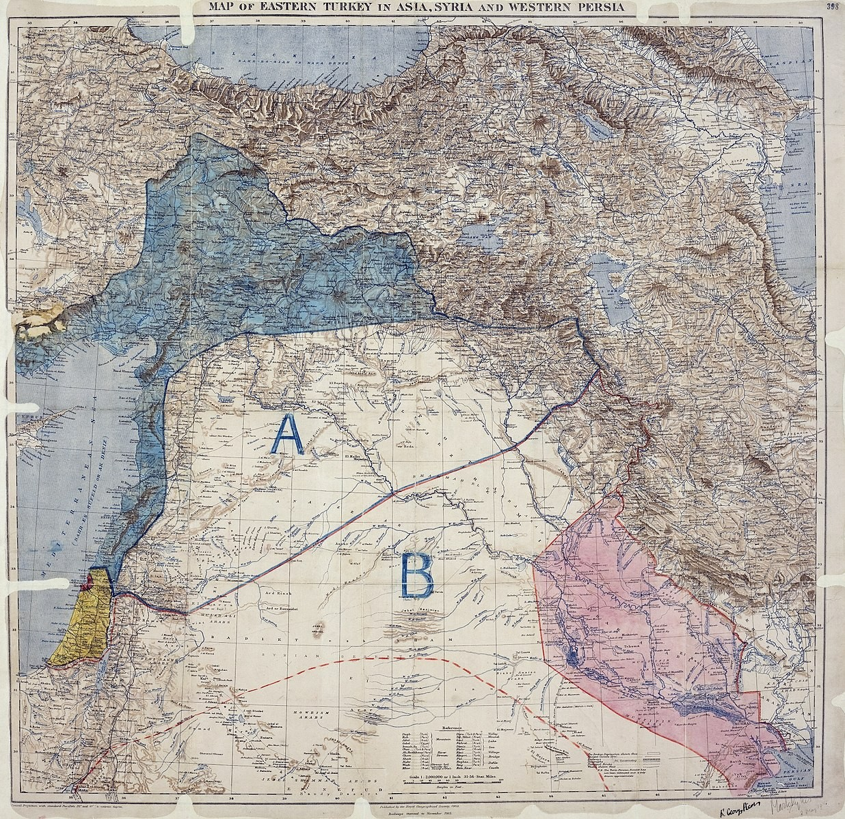
In World War I, the Ottoman Empire joined forces
with the Germans and Austro-Hungarians. Some Arab leaders were tired of living under Ottoman rule. They agreed to help the other side, the Allies. The Allies included Britain, France, Russia, Italy and the United States. In return for revolting against the Ottomans, the British promised Arabs independence after the
war. The British and French, however, had already made a secret deal. It was called the Sykes-Picot
Agreement. The deal carved up the Middle East between the British and the French. Some areas they would directly control. Others would be partly run by local leaders.
A final complication was the Balfour Declaration made by the British in 1917. It promised British
support for making a "National Home for the Jewish People" in Palestine. This agreement conflicted with the promise of an independent Arab nations. It would create future conflict.
After World War I, an international group, the League of Nations, was created. Its job was to help in international issues. One of those was what to do with the Arab lands once ruled by the
Ottomans.
In 1920, the League divided Ottoman Arab provinces between Britain and France. It followed the lines of the Sykes-Picot Agreement. New borders were drawn up entirely by the colonial powers. Different European countries were given control of different Arab states. The Arab states had no say in the matter.
France got Lebanon and Syria. Britain was allowed to govern Palestine, which eventually became Israel and Jordan. It was also allowed to govern Iraq. Britain let Egypt become an independent nation.
Modernization In Turkey And Iran

Mustafa Kemal Atatürk created a new state in Anatolia and Thrace. He created the Republic of Turkey and introduced national pride and modernization. In Iran, Reza Shah Pahlevi took power. He introduced reforms there, as well to make Iran more like a European country.
Political Structures Today

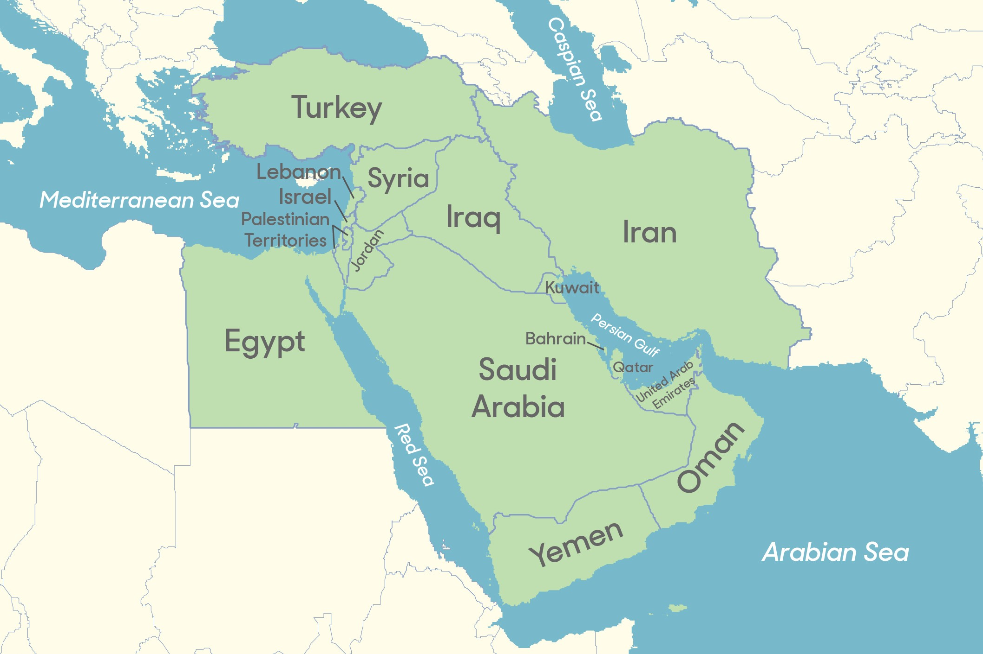
Some Middle Eastern states are governed by a royal family, with a parliament or advisors. These include Jordan, Saudi Arabia, Kuwait, Oman and Morocco. Some other states in the Middle East are republics, with a president.
A few Middle Eastern nations do have some form of democracy or some genuinely democratic parts of the state system. However, some of those governments are often oppressive, or controlling. They do not allow citizens to speak against them. They do not allow
political opposition. Political openness varies widely throughout the Middle East.
Middle Eastern states are no longer governed by western European countries. Still, some influence has remained. The events after WWI created much mistrust of western Europeans.

