How the modern nation-states of the Middle East were created
By WGBH, adapted by Newsela staff on 11.01.19 Word Count 499
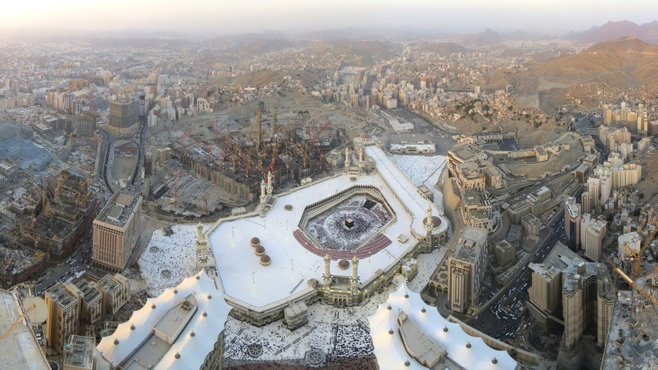
Level 630L
Image 1. Cropped panoramic image of an aerial view of Mecca, Saudi Arabia. Mecca is a city that is an important pilgrimage site for Muslims around the world. The city was once under control of the Ottoman Empire. Photo from: Wikimedia Commons/Wurzelgnohm.

The Ottoman Empire was very powerful. It existed from around 1300 to 1922. At its largest,
Ottoman lands included one-fourth of Europe. They included modern-day Turkey, Greece and parts of Eastern Europe. The Ottomans conquered the Byzantine Empire. The Ottomans also conquered Arab lands. This included much of the Middle East and North Africa.
The Ottomans ruled for hundreds of years.
In the 1700s and 1800s, the Ottoman Empire was weakening. The power of western European nations grew. European nations wanted more natural resources. This could help them become very wealthy. European traders bought raw materials from the Ottomans. This drove up prices in the Ottoman Empire. Some people in the Ottoman Empire got rich. They then bought goods from the Europeans. Soon the Ottomans didn't have enough raw materials. It was harder to make their own goods. Also, Europeans conquered land in North Africa.
World War I

World War I started in 1914. During the war, the Ottoman Empire joined forces with Germany and Austria-Hungary. Those countries lost the war. During the war, Britain and France made a secret plan to split up the Ottoman Empire. In a separate agreement, the British also promised to make Palestine into a "National Home for the Jewish People."
After the war, the League of Nations was created. the Ottoman Empire was split up between Britain and France. They made totally new countries and borders. The people who lived there didn't get a say. Some countries were given to Arab rulers. This included Iraq and Jordan. Some ethnic groups got no country at all.
Political Structures Today
After the war, many people of these new nations rebelled against the governments. They became independent nations.
Today, some Middle Eastern states are ruled by a royal family. They also may have lawmakers. These include Jordan, Saudi Arabia, Kuwait, Oman and Morocco. Some other states in the Middle East are republics. They have a president and elected government.
Some Middle Eastern states have a form of democracy. But their governments are often very controlling. They do not allow people to speak against them. They do not allow political opposition. Political openness varies widely in the Middle East.
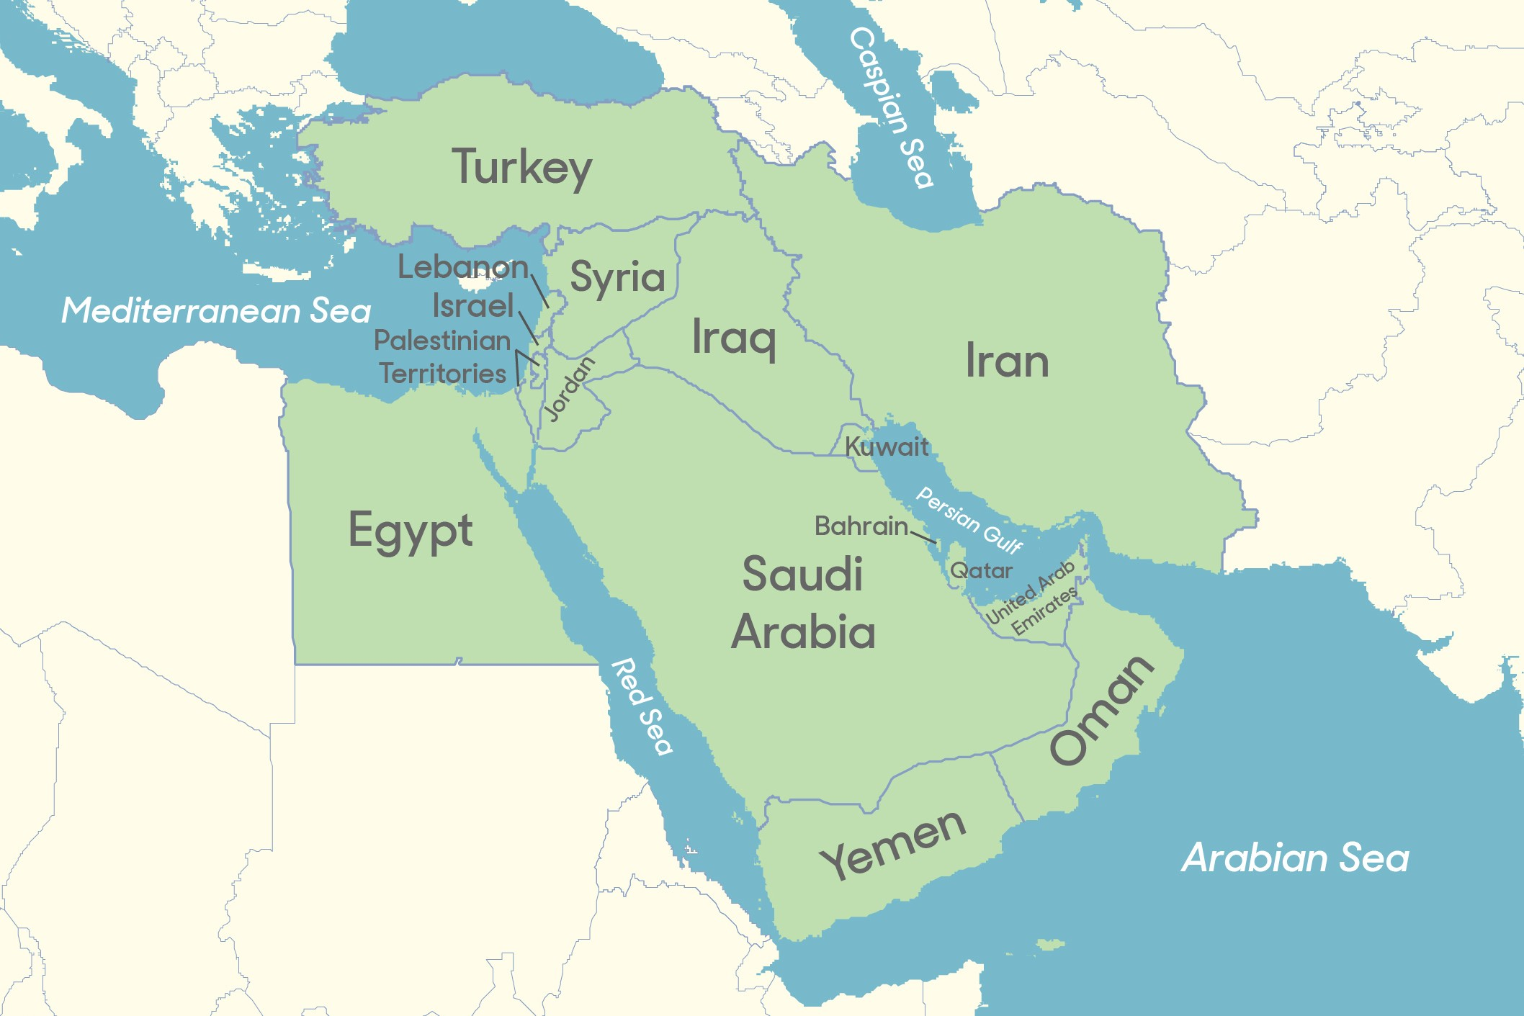
Ethnic Groups

In the Middle East, there are many different ethnic groups. They are key to understanding conflicts in the region. They often struggle to keep their cultural character. They also struggle to have at least some political influence.
Major ethnic groups include the Kurds in Turkey,
Iraq, Iran and Syria. Another is the Berbers in North Africa. Both of these groups want greater rights in their countries. They are fighting for freedom from their countries. They often face strong resistance.

