Geography of the Middle East, an ancient and modern crossroads
By WGBH Educational Foundation, adapted by Newsela staff on 01.09.18 Word Count 442
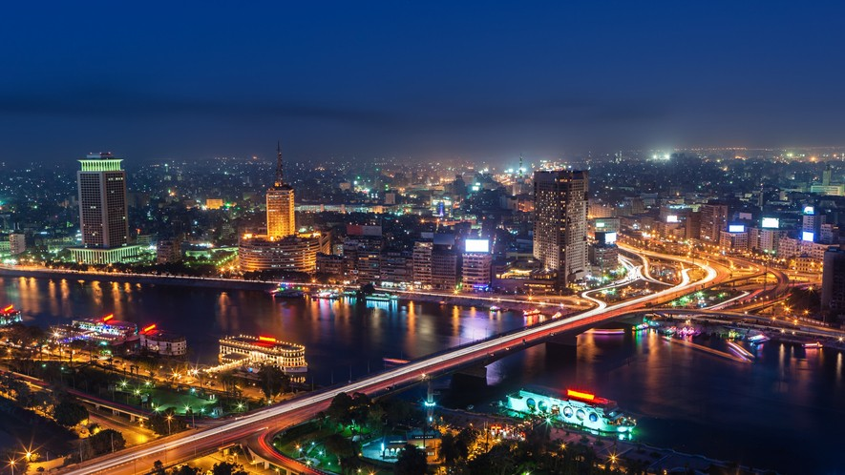
Level 560L
Image 1: The Nile River runs through the city of Cairo, which is the capital of Egypt and the second largest city on the African continent. Cairo and its surrounding areas are home to over 20 million people. Photo by: hadynyah/Getty Images

The Middle East is a crossroads. It is where three continents meet – Asia, Africa and
Europe. Trade routes came to the Middle East from all over the world. Many different people have come and settled here over the years. This has deeply affected the region.
More Than Just Deserts

The Middle East's land is full of variety. It is not just desert, like they show in movies. It has large rivers and rich farmland. Long ago, the first cities in the world were built here. Mountains and deserts protected them from other people.
The Middle East had fertile soil. Crops planted here grew well. Between two large rivers, the land was very rich. The two rivers were called the Tigris and the Euphrates. The area between them was called Mesopotamia. In Mesopotamia, the rich farmland helped towns become rich. Rich towns grew into the first cities. The Zagros Mountains protected Mesopotamia from other people who
might invade it. In Egypt, the land along the Nile River also had fertile soil. Egyptians built big

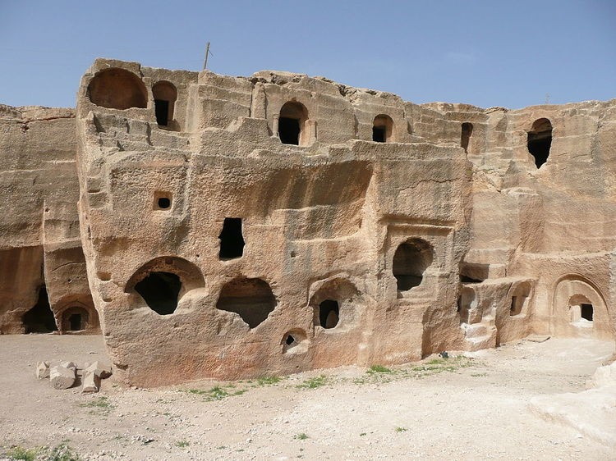
cities, too. Deserts protected those cities from other people.

Well-Traveled Trade Route

Because the Middle East was a crossroads, traders came here. Traders were people who sold things from other lands. Some traders came from far away. The
roads they traveled were called trading routes. Many trading routes crossed through the Middle East. The area became rich with new things and new ideas.
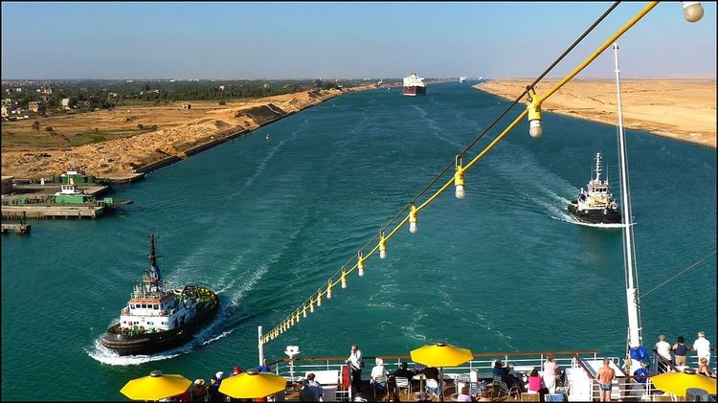
In 1869, a
new trading
route was made. It is called the Suez Canal.
This is a
waterway that was cut through the desert of Egypt. The canal connected the Mediterranean Sea and the Red Sea. Now ships could carry even more ideas and things through the Middle East.
Rich In Natural Resources

The Middle East is also rich because of oil. Half of the world's oil is found in this region.
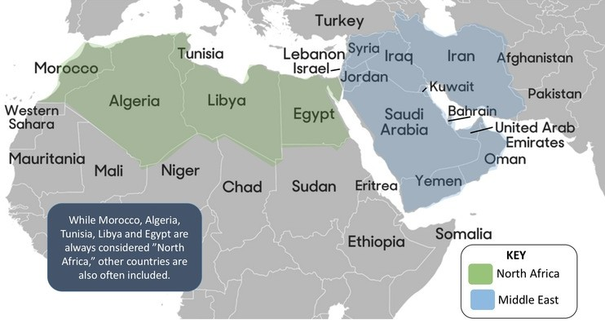
People here live in many different ways. Where they have good soil and water, they farm. Where they have grasslands, they herd sheep and goats. Where they have rivers and ocean, they fish. But most people in the Middle East live in cities. These cities are large and are growing fast.

