Who are the Kurds?

The Kurds are a non-Arabic *ethnic group* and speak a language related to Persian. Kurds are a largely Sunni Muslim people with their own language and culture.

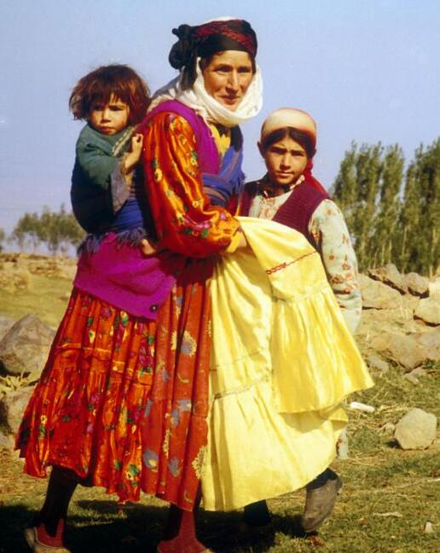

Before World War I (1914-1918), traditional Kurdish life was nomadic (a group of people with no fixed home and move according to the seasons and food supply), revolving around sheep and goat herding. The breakup of the Ottoman Empire after World War I created a number of new nation-states, but not a separate Kurdistan. Kurds, no longer free to roam, were forced to abandon their seasonal nomadic lifestyle and traditional ways.

Most Kurds today live in Turkey, Iraq, Iran, Armenia and Syria – a mountainous region of southwest Asia

generally known as Kurdistan, "Land of the Kurds," although Kurdistan is not a

sovereign nation. 15 million to 20 million Kurds live in a mountainous area straddling the borders of Armenia, Iran, Iraq, Syria and Turkey. About 8 million live in southeastern Turkey. Because the Kurds are an ethnic minority in the countries that they live in, they are often face discrimination and hatred.

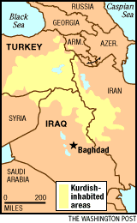

Most adhere to the *Sunni Muslim* faith. Kurdish folklore extols the moral beliefs of the people: reverence for elders (particularly women), hospitality, courage, valor, and the love of freedom. Among the Muslim Kurds reverence toward *pirs* (holy places) was widespread. Some of these holy places include stone mounds and the graves of saints and ancestors. Women leave offerings at the pirs and they believe that these pirs would save them from misfortune.

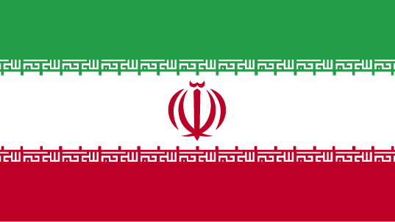Who are the Persians?

How do Persians differ from Arabs? Although they share the religion of Islam, their cultures and languages are different from those of Arabs. Arab culture did not take hold in countries such as Pakistan, Indonesia, Turkey, Iran and the Central Asian Republics. These peoples do not consider themselves to be Arab in any sense and are not considered to be Arab by Arabs.

The **Persians** are a non-Arabic ethnic group and speak a language called Persian or *Farsi*. The Persian language is one of the world's oldest languages still in use today, and is known to have one of the most powerful literary traditions including poetry.

*Map of Farsi speakers in Central and Southwest Asia*

Most of the population of Iran are ethnic Persians. Iran's population of nearly 77 million is growing by 1.3 percent annually. The capital, Tehran, has 12 million inhabitants. About 68 percent of the population lives in urban areas. Nomadic life has always played a role in traditional Iranian society, and more than 10 percent of the population is nomadic or seminomadic.

When most people think of Persians they think of the people living in Iran. But, Ethnic Persians can also be found in the countries outside Iran including Afghanistan Tajikistan, Uzbekistan and are usually called "Tajiks" and "Farsiwans.”

[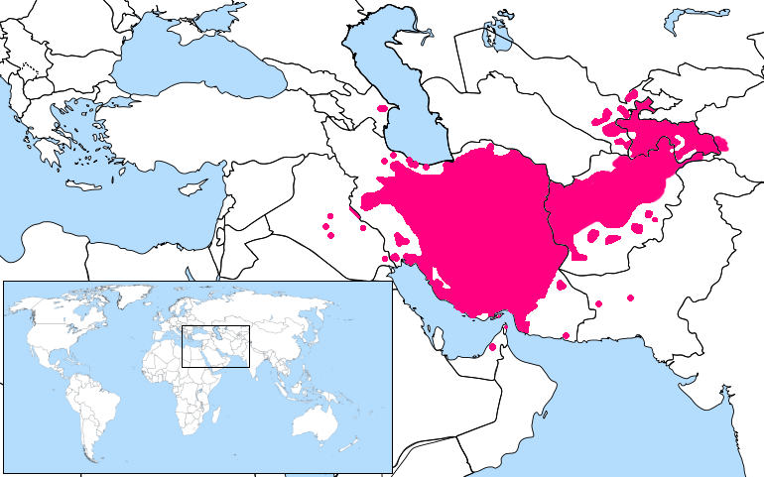](http://upload.wikimedia.org/wikipedia/commons/a/a0/Persian_Language_Location_Map1.png)Most Persians, about 89%, in Iran adhere to Shia Islam, although those to the east remain followers of Sunni Islam. Shia Islam is the state religion and has been since the 1500s. Small groups of Persians continue to follow the pre-Islamic faith of Zoroastrianism in Iran.

Who are the Arabs?

That is a difficult question to answer because the Arab people are very diverse. However, the term "Arab" is often applied to people who are:

* A member or descendant of the Semitic people inhabiting Arabia.
* A member of an Arabic-speaking people.

Arabs are a large group of people whose native language is Arabic. Arabs also share a common history and culture.

Arabs have also migrated to other countries. European countries with large Arab populations include Belgium, France, Germany, the Netherlands, Sweden, and the United Kingdom. In South America, Argentina and Brazil have many Arab people. So do Canada and the United States in North America.

It is important to note that all Arabs are NOT Muslim; for example there are Arab Christians. Arabs make up roughly 20-25% of the world's Muslim population. As a result, the Arab identity is defined independently of religion. More than 90 percent of Arabs are Muslims. Most belong to the Sunni branch of Islam. However, significant Shia Muslim communities exist in Iraq, the eastern Arabian Peninsula, Bahrain, and Lebanon. Some Shias live in most other Arab countries.

Small numbers of Arabs belong to other Muslim groups. Druses, who follow a religion related to Islam, live mainly in Lebanon, Syria, and Palestine. Most non-Muslim Arabs are Christians. Other Christian Arabs belong to various Eastern Orthodox, Roman Catholic, or Protestant churches. They live mainly in Iraq, Jordan, Lebanon, Syria, and Palestine.

Arabs today are united mainly by their culture. Among the most important aspects of Arab culture are the Arabic language and shared social values.

Therefore, language is an important characteristic of what it means to be Arab. The [Arabic](http://www.mideastweb.org/Middle-East-Encyclopedia/Arabic.htm) language was spread by the [Muslim](http://www.mideastweb.org/Middle-East-Encyclopedia/Muslim.htm) conquests, in part because the Qur’an must be recited in Arabic, and the essential prayers of Islam are said in Arabic. Arab speaking people range from North Africa to Iraq.

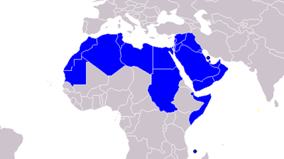

*Map of Arabic speaking countries*

Additionally, Arab culture has made significant contributions to advancements in art, architecture, literature, mathematics and science during the Golden Age of Islam that lasted from 750 to 1258 CE.

|  |  |  |  |
| --- | --- | --- | --- |
|  | **ARABS** | **PERSIANS** | **KURDS** |
| **What language do they speak?** |  |  |  |
| **Where do they live?** |  |  |  |
| **What is the dominant religion or subdivisions in the ethnic group?** |  |  |  |
| **What are the other religions or subdivision found in the ethnic group?** |  |  |  |
| **Other facts about the ethnic group** |  |  |  |