Name: Date:
Interpreting Graphs and Analyzing Charts Period:
Directions: Students will use the information provided in the various graphs and charts to answer the questions.

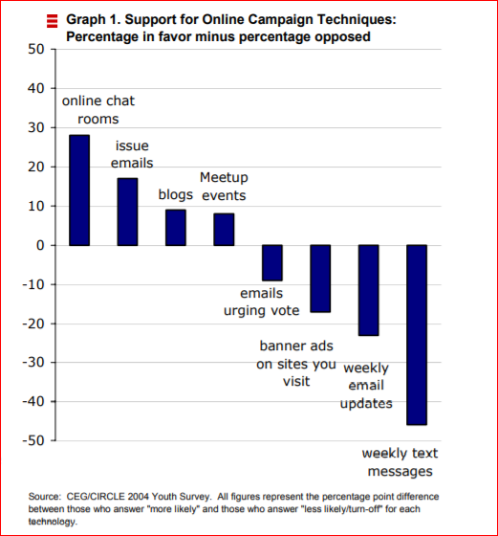

Rewrite the title as a question. _________________________________________________________
What is the graph displaying (showing)? _________________________________________________
__________________________________________________________________________________
What do the figures on the y-axis, or vertical line, represent? ________________________________
__________________________________________________________________________________
What do the figures on the x-axis, or horizontal line, represent? ______________________________
__________________________________________________________________________________
How many different forms of campaign techniques are being compared? _______________________
__________________________________________________________________________________
What was the most popular way among young voters to get information? ______________________
__________________________________________________________________________________

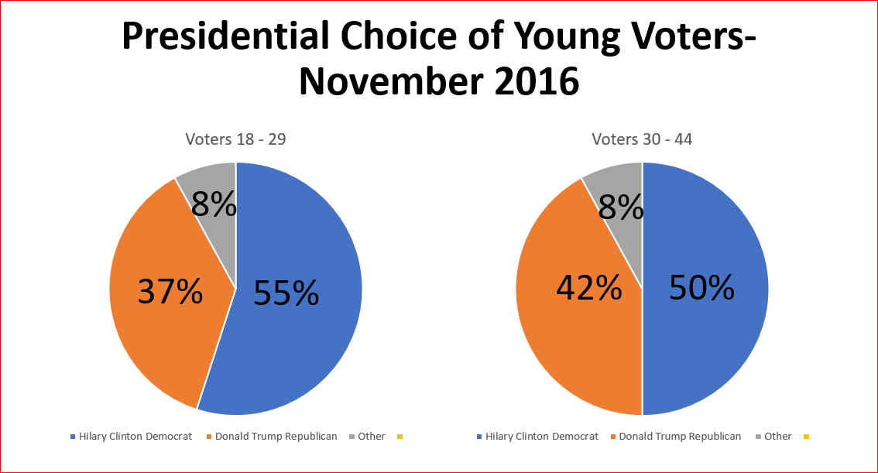

Rewrite the title as a question. _________________________________________________________
What is the difference in the information that the graphs represent? __________________________
____________________________________________________________________________________________________________________________________________________________________
Which presidential candidate did most 18-1o-29-year old voters select? ________________________
__________________________________________________________________________________
Which presidential candidate did most voters under 44 select? _______________________________
__________________________________________________________________________________
How might the information in these graphs affect each party’s actions in the future? _____________
__________________________________________________________________________________

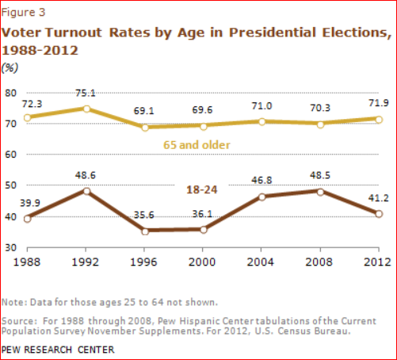
Rewrite the title as a question _________________________________________________________
What do the numbers along the y-axis, or vertical line, represent? _____________________________
_________________________________________________________________________________
What do the numbers along the x-axis, or horizontal line, represent? _________________________
_________________________________________________________________________________
Why are these two different kinds of lines on the graph? ___________________________________
__________________________________________________________________________________
How did the turnout change from 2000 to 2012, for 18 – 24- year olds? _______________________
__________________________________________________________________________________

- 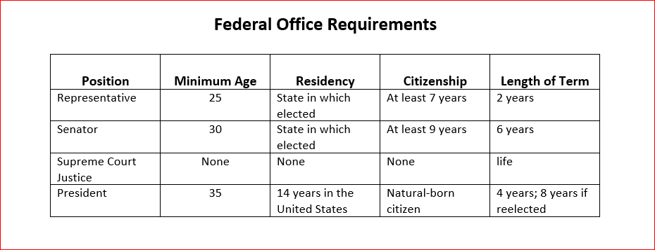
Rewrite the title as a question. ___________________________________________________________
What does the word federal mean? (infer meaning from the chart) ______________________________
_____________________________________________________________________________________
_____________________________________________________________________________________
What are the bold headings in the chart known as? ___________________________________________
_____________________________________________________________________________________
Which federal employee on the chart serves the shortest term before seeking reelection? ___________
_____________________________________________________________________________________
_____________________________________________________________________________________
Which federal employee can be born anywhere in the world and still serve in office? ________________
_____________________________________________________________________________________
The president selects the U.S. Supreme Court Justices. The candidates must be confirmed (agreed upon) by the Senate. Why are president’s choices so important? _____________________________________
_____________________________________________________________________________________
_____________________________________________________________________________________

