Ancient Palestine
Israel, once known as Palestine, is the ancient homeland of both the Jewish Israelis and Arab Palestinians. The first Jews came to Palestine around 2000 BC from southern Mesopotamia, now Iraq. Initially settling in the hilly interior of Palestine, the Jews believed this land was their Promised Land, the land that had been given to them in a covenant by their God in exchange for their promise to live according to God’s laws. The Palestinians, on the other hand, were of Greek origin who initially settled on the coastal plain around the same time.
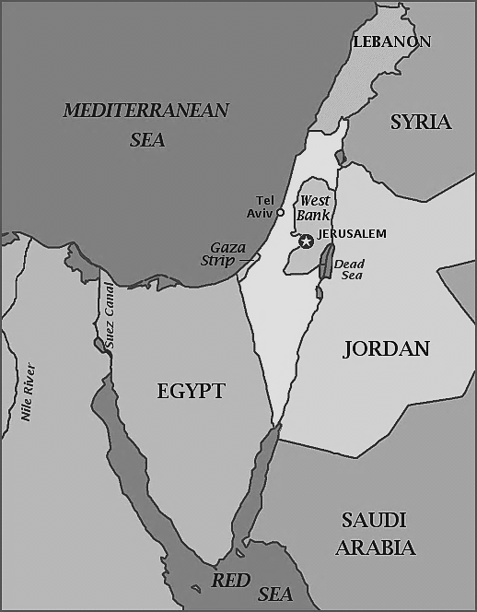
The Diaspora
About 200 years after the two groups settled in the area, the Jews established a kingdom called Israel. The Roman Empire later conquered the kingdom and the Jews revolted against Roman rule in 70 AD. The Jewish revolt resulted in the diaspora, during which the majority of Jews were forced from Palestine and scattered throughout Southwest Asia and Europe. While the Jewish population dispersed, the Palestinians remained in the region and mixed with other people there, mainly Arabs.
Zionism
After the Roman expulsion, the Jews lived as minorities in different lands, particularly Europe. These Jewish minority groups were often unwelcome guests in their new countries. As outsiders, these Jews faced anti-Semitism, or hatred and discrimination towards Jewish people. From the time of the diaspora, most Jews dreamed of a return to their ancestral homeland in the region of Palestine. In the 1800s, European Jews began organizing political movements aimed at moving back to Palestine and recreating a Jewish state. This movement became known as Zionism. In both western and eastern Europe, many Jews were tired of anti-Semitism. Therefore many joined the Zionist cause, participating in boycotts and protests.
Jewish Immigration into Palestine
Thanks to Zionism, waves of Jews had already begun immigrating to Palestine in the late 1800s. By 1914, Jews made up almost 10% of Palestine’s population. At this time, Palestine was ruled by the Ottoman Empire and occupied mostly by Arab Muslims. These Palestinians increasingly feared that Zionism was an extension of European colonialism in Palestine, taking their land and rights. Eventually, increased Jewish immigration and land purchases intensified these fears of Zionism among the Palestinian peasants. While initially most Jewish immigrants were poor, over time, their situations improved as they settled the land and formed communities. Meanwhile, Palestinian refugees who had been displaced from their land as a result of Zionist settlements moved into overcrowded cities and became increasingly impoverished.
Ottoman Empire Collapses
In World War I (1914-1918), the Ottoman Empire, who controlled most of Southwest Asia, joined forces with the Central Powers of Germany and Austria-Hungary in the fight against the Allied Powers of Great Britain, France, and Russia. During the war, Zionist leaders lobbied the British to allow for a Jewish country in Palestine should the British win.
After winning WWI, the Allied Powers officially claimed the remnants of the former Ottoman Empire in the San-Remo Agreement of 1920. According to this agreement, Britain would take control of Palestine under the mandate system. Although many religions claim ownership of Palestine, British control over the region did not become a large problem until about the 1930’s and 40’s. During this time, World War II was beginning and the Jewish community was being persecuted by Hitler’s Nazi party in the Holocaust. Looking for a safe haven during a turbulent time, Jews opted to immigrate to Palestine, which they believed was their rightful home.
UN Partition Plan
By 1936, Arab Palestinian discontent with British colonial rule and mass Jewish immigration erupted in a three year violent conflict known as the Arab Revolt. By 1947, with British soldiers tired of policing Arab-Jewish violence, the British government turned Palestine over to the United Nations (U.N). The U.N. intended to solve the Palestinian-Israeli conflict by partitioning Palestine into two states, one Jewish and one Arab (Palestinian). While Zionist leaders initially accepted this plan as a step towards reclaiming the Promised Land, Arab leaders were strongly against any plan that called for the division of their homeland. At this time, there were 1,300,000 Palestinians and 600,000 Jews living in Palestine. As the majority population that had lived there for thousands of years, the Palestinians believed they had the right to govern all of Palestine. Even so, Jews favored a division of Palestine, and used biblical and anti-Semitic persecution as evidence that they should have their homeland.
Israeli Independence & More War
Although the British believed that Palestine should be a national home for the Jewish people, the Arabic community in Palestine disagreed. They began to notice how the Jewish community was increasing in the area, and became fearful that they would lose their land and rights. Even though the 1947 U.N. partition plan was meant to solve the Jewish-Arab land dispute, the arrangement proved unpopular. In 1948, conflict between the two sides broke out in the First Arab-Israeli War.
On May 14, 1948, towards the end of the First Arab-Israeli War, the Jewish State of Israel officially declared its independence. The First Arab-Israeli War ended in 1949, resulting in a variety of treaties that were supposed to protect both Palestinian and Israeli claims to the land. However, the treaties did not have much meaning and war still continues today, as Israel occupies various territories claimed by the Palestinians and the Palestinians fight for their land and rights. Also, various Arab Muslim political and religious extremist groups, such as Hamas, have committed acts of terror against Israelis, creating even more tension between the Jewish and Arab communities. Currently, the United Nations is still making an effort to resolve this conflict through various peace talks and peacekeeping acts.
Your Task
The Israeli-Palestinian conflict is a conflict between the Jewish community and the Arabic community, primarily the Palestinians, over ownership of land that is located in Palestine. The reading above gave you a picture of the history of Palestine and the two groups who are still fighting over the land today. You know that the Jews wanted a country in this region and that many opposed this - violently so. Considering all of the violence, you might wonder if it was all worth it. Therefore, your task is to analyze the documents that follow and find evidence to answer the question “Why was Israel created as a Jewish state in 1948?”.

