Nationalist Movements in Kenya & Nigeria
In the Circle Maps below, take notes about the nationalist movements (that wanted independence) you are reading about.

Nigeria’s Nationalist Movement

Kenya’s Nationalist Movement

Nationalist Movements in Kenya & Nigeria
In the Double Bubble Map below, compare Kenya’s nationalist movement and Nigeria’s nationalist movement.
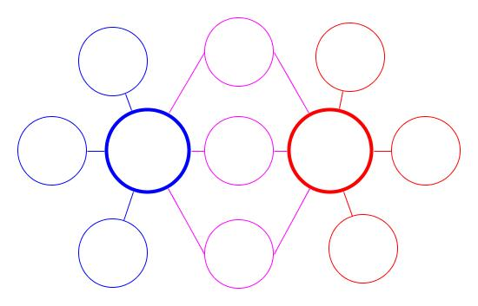
So What?
So Why?
Nigeria
Kenya

