African Geography “Cram Sheet”

Countries : Egypt, Sudan, South Sudan, Kenya, Nigeria, Democratic Republic of Congo, South Africa
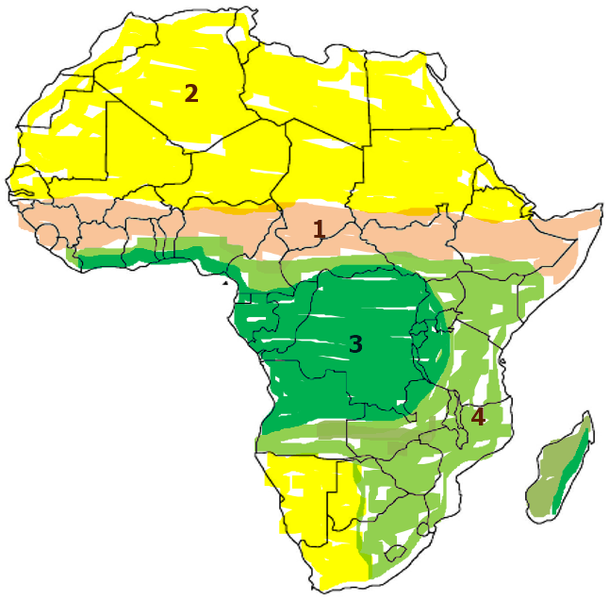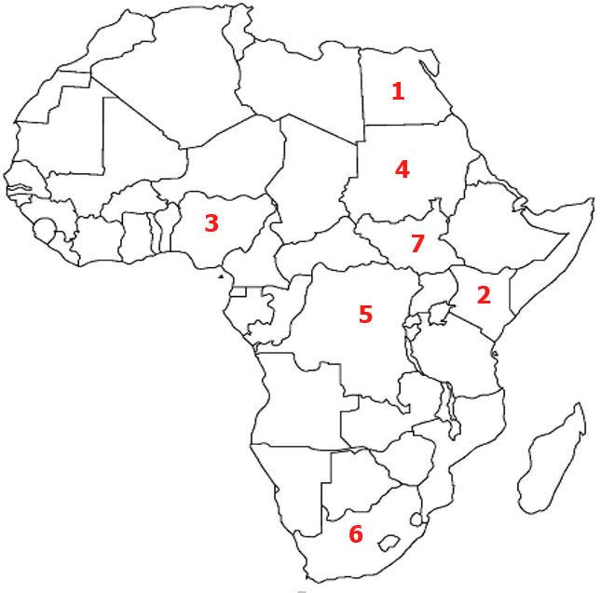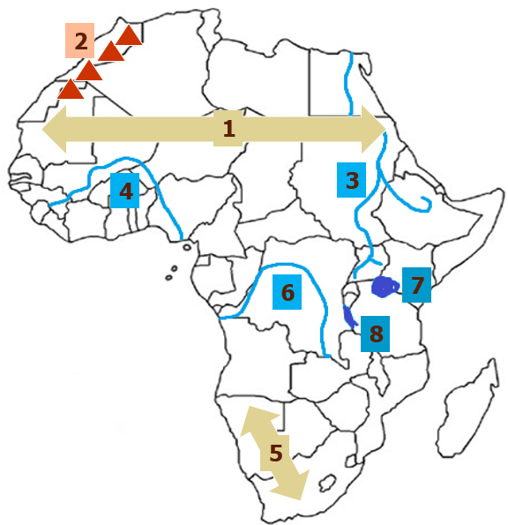
Physical Features: Atlas Mountains, Sahara Desert, Kalahari Desert, Nile River, Niger River, Congo River Lake Tanganyika, Lake Victoria
Climate Zones: (describe)
Sahara _______________________

Sahel ________________________

Savana _______________________
Tropical Rainforest
Vocabulary to know:
- Animist _________________________________________________________________________
- Deforestation _____________________________________________________________________
- Desertification _____________________________________________________________________
- Famine ___________________________________________________________________________
- Drought __________________________________________________________________________
- Slash and Burn _____________________________________________________________________
Name:_________________________________________________ Date:____________________________ Pd:________

Ethnic Groups
Arabs  Location:  Languages:  Religions: | Ashanti  Location:  Language:  Religions: | Bantu  Location:  Language:  Religions: | Swahili  Location:  Language:  Religions:
Of the traits mentioned above in ethnic groups, which one has the most diversity? ________________________
Of the languages, which is spoken the most? __________________________________
How are ethnic groups different from religious groups? ____________________________________________________
Africa’s ethnic groups are mostly linked by: (circle one) Religion, Nationalism, Language, or Region
Environmental Issues
Desertification  Causes:  Effects on Environment:  Effects on Humans: | Deforestation  Causes:  Effects on Environment:  Effects on Humans: | Water Scarcity & Pollution  Causes:  Effects on Environment:  Effects on Humans:
Identify
1. _________________________________ strip of semi-arid land south of the Sahara
2. ________________________________ large grasslands in Africa where most large animals live
3. ________________________________ world’s longest river- densely populated
4. ________________________________lack of rain
5. ________________________________lack of food for a long time
6. ________________________________river that flows through central Africa
7. ______________________________when arable (farmable) land turns into desert because of overgrazing or drought.
8. _________________________________cutting down trees which leads to poor soil in Sub-Saharan Africa
9. ________________________________world’s largest desert in Northern Africa

