**7th Grade CRCT Study Guide**

Name: ___________________________

Date: __________ Period: ___________

**Africa**

**Unit 5: People & Places of Africa**

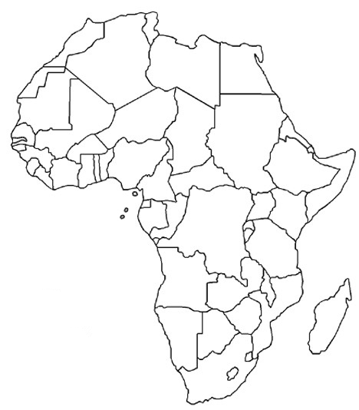

1. Locate (label) these countries: Dem Rep of Congo, Egypt, Kenya, Nigeria, South Africa, and Sudan
2. Locate (label) these physical features: Sahara Desert, Sahel, Congo River, Niger River, Nile River, Lake Tanganyika, Lake Victoria, Atlas Mts., Kalahari Desert
3. People in the **_________________** are usually nomadic herders and live near oasis
4. People in the Sahel do subsistence **_________________** & nomadic herding and live in cities that still have some **_________________**
5. People in the savanna do a lot of work in **______________** reserves, some **_________________** etc.
6. People in the rainforest **__________**, and use the forest to create medicines and harvest **_________**
7. Arabs—live in **_________________** Africa; see Unit 1
8. Ashanti—live in **_________________** Africa, known for **_________________**, and their religion is a combination of spiritual and supernatural
9. Bantu—considered to be the first people of Africa, **_________________** is still widely spoken, began in **_________________** Africa and migrated in **_________________**,
10. Swahili—found on the **_________________** coast of Africa, traded with India and the Middle East, language has Arab parts
11. Deforestation—cutting down of **_________________** and creating unusable land
12. Desertification—when land becomes permanently **_________________** for farming

**Unit 6: Conflict & the Shaping of Modern Africa**

1. Colonization of Africa
   * **_________________** powers lured by natural resources and new markets for **_____________**
   * Berlin Conference—Africa **__________** not based on **_____** groups and treated Africans badly
   * When European powers left, people were not ready to take care of themselves and **_______** struggles raged
   * Africa has never **_________________**
2. Nationalism—belief that your group is **_________________** and you deserve to **________** yourselves (have your own country)
3. Nationalist movement
   * Kenya—British colony, Jomo Kenyatta, Mau Mau, **________________** fight for independence
   * Nigeria—British colony, **__________** fight for independence, groups were favored over others
   * South Africa—British colony, early independence, Boers, **_______________** began afterwards
4. Apartheid
   * racial **_________________** in South Africa
   * FW de Klerk supported it but then worked with Nelson **_________________**
   * Mandela was a black man who fought against **_________________**
   * After apartheid ended in **___________**, de Klerk was elected president and Mandela was VP.
   * Eventually Mandela was elected the first black **_________________** in 1994
5. Pan-Africanism—movement that people of **_________________** decent should band together so African nations can be **_________________**.
6. Education is slowed down by gender **_________________**, war, **_________________** etc.
7. When a government is **_________________**, they do not help their people
   * They don’t give **_________________** to combat **_________________**
   * They don’t help when there are **____________** and often use that **______** for the government
8. Drinking water is often contaminated by cholera and pollution

**Unit 7: Government & Corruption in Africa**

dictatorshipnotext monarchynotext parliamentarydemocracynotext

**________________________** **_________________________** ______**_____________** Democracy

theocracynotext presidentialdemocracynotext republicnotext

**________________________** **________________** Democracy **____________________________**C:\Users\smd13143\AppData\Local\Microsoft\Windows\Temporary Internet Files\Content.IE5\MUQ694B1\MC900015071[1].wmf

Most Freedom

Least Freedom

1. Kenya
   * Republic
   * Democratic **_________________**
   * Place on ruler—around a **___**  because in recent years they’ve had rigged elections, citizens can criticize the government in limited amounts
2. Sudan
   * Dictatorship
   * Autocratic **_________________**
   * Place on the ruler—around a **___**, crimes against humanity in Darfur, no freedoms, somewhat Islamic state
3. South Africa
   * Republic
   * Democratic **_________________**
   * Place on ruler—around a **___**  because citizens have freedom of press, universal suffrage

**Unit 8: Economic Hardship vs. Economic Promise in Africa (*Review Unit 4 before reading this section)**

1. South Africa is more **_________________**than **_________________**
2. Kenya is moving toward **_____________** but government corruption keeps it more **______________**
3. Human capital—**_________________**that do work, if you **_________________**in your people they will be healthier smarter and work harder
4. Natural resources—gift of **_________________**, Africa has lots of natural resources but can’t **_________________**them like they should, they are often unequally distributed
5. Capital resources—**____________**, machines, technology etc, that are used to make **____________**, if you invest in these things your country’s Gross Domestic Product (GDP) will go up
6. Entrepreneurship is bringing together human natural and capital resources to take **_________________** in **_________________**
7. The higher the **_________________**rate the better standard of **_________________**