Today, you will…
- Follow the "Vietnam’s Independence" PowerPoint along with the class to fill in the “Vietnam Cloze Notes” page.
- Complete the Vietnam War EdPuzzle Activity along with your class (questions below).
- Create your “Signs of Peaceful Protest” (steps below).
- Think of something you care enough about to protest for.
- What would you write on your protest sign?
1) Create a slogan/phrase.
2) Write it (bold and proud) on your index card (like a little protest sign). Decorate to draw even more attention!
3) Use your “Mini” Protest Sign to start conversations, or just show what you believe in and support!
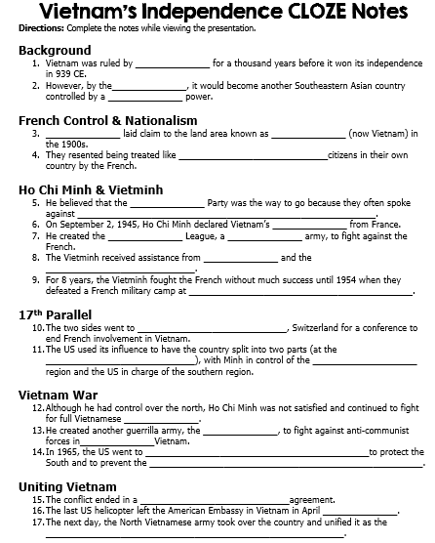
Vietnam War
EdPuzzle Video w/Questions

- Who was the communist leader in Vietnam during the time of French imperialism?
- Bao chi ho
- Sein ho Deimh
- Ho chi minh
- Tao minh sung

- The Cold War was fought between the U.S. and Soviet Union because....
- The U.S. wanted complete control of the territory of the Soviet Union
- The Soviet Union wanted to go to war in Europe over territory in Western Europe
- The U.S. was capitalist and they were fighting the communist Soviets and Chinese

- Why was the United States worried about the political future of Vietnam?
- The U.S. was worried that if Vietnam was run by Ho chi minh than all of Vietnam will fall to China
- The U.S. was worried about the domino effect in South Asia, that if one country "fell" to communism, they would all go communist
- The U.S. was worried that Vietnam would overwhelmingly vote democratic and gain great power in the region
- None of the above

- Who was assassinated in South Vietnam that helped the North Vietcong get more control over that territory?
- President Kennedy
- Ho chi minh
- P.M. Diem
- Bao se Chi

- What major event took place in Vietnam that escalated the U.S. military involvement in the region?
- The election of President Johnson
- Assassination of President Kennedy
- The Gulf of Tonkin attack on U.S. ships
- Operation Rolling Thunder bombing attacks

- What chemical weapon did the United States use in Vietnam that would cause great devastation in the jungle?
- They used sarin gas against the Vietcong
- They used no chemical weapons during this war
- They used mustard gas against the Vietcong
- They used napalm against the Vietcong

- Even though the United States had the technological advantage against the North Vietnamese, how did they North Vietcong have the advantage over U.S.?
- They fought from South to North and blended in easily.
- They could hide underground and blend in easily with the Southern Vietnamese.
- They could drop bombs and blend in easily with the Southern Vietnamese.

- Which offensive was considered "one of the bloodiest battles" in the Vietnam War?
- The Overlord Offensive
- The Gulf of Tonkin Offensive
- The Hue Offensive
- The Tet Offensive

9. All of the following are characteristics of the Mai Lai massacre EXCEPT?
- U.S. soldiers killed innocent men, women and children
- U.S. reported the event months later, in 1969
- U.S. reported about this massacre right away
- North Vietnamese people were murdered in their villages

- Why did the U.S. invade Cambodia in 1970?
- The U.S. wanted to destroy the Khmer Rouge communist group
- The U.S. wanted to colonize the country and make it democractic
- The U.S. wanted to end the war in Vietnam by making a surprise attack through Cambodia to Hanoi

- What document was signed by Vietnam and President Nixon that would bring an end to the war for the U.S.?
- The Paris Peace Accords
- The Appomattox Peace Accords
- The Versailles Accords
- The Yalta Peace Accords

12. All of the following happened to Vietnam after the war EXCEPT?
- U.S. military presence stayed in Vietnam after the reunification
- They are called the Socialist Republic of Vietnam
- All of Vietnam is now Communist controlled by the Vietcong
- Saigon was renamed Ho Chi Minh City

