Name: ______________________________________________ Date: _____________________ Period: _______ Page: _______

The Rebuilding of Japan after World War 2 Notes

- Pearl Harbor – December 7, 1941, U.S. enters WW2
- Hiroshima & Nagasaki – August 1945, Atomic bombs dropped on Japan
Hiroshima
The morning of ______________________________________ was a day of passing clouds and warm temperatures. Japanese people seeing a single silver plane ________________________ the warning sirens...they had _________________________________ from the firebombing in other cities.
In seconds, their world was changed forever.
Most Japanese dwellings were made of ______________. The firestorm the bomb produced spread devastation ___________________ in every direction.
Despite mass destruction of the Hiroshima and more than __________________ dead or missing, Japan’s Imperial Military staff _____________________________________________________________________ and only offered silence. President Harry Truman announced that Japan would receive a “rain of ruin from the air.” America got ready for a _____________________ mission from Tinian.

Nagasaki
The second atomic bomb was dropped at 11:02 AM on ____________________________________. The bomb that was dropped on Nagasaki was said to have been _________________________________________________________ than the uranium bomb dropped on Hiroshima.
At the moment of the explosion, there was a brilliant flash of light. Ten seconds later an enormous roar and a fearful blast swept across the area. Sharp rays of heat emitted massive amounts of radiation. Everything was incinerated.

Lasting Effects of the Bombs
Low-level amounts of ______________________ still exist in both modern cities . As the World War 2 generation dies, the memories of the terrible destruction dims. There were survivor benefits (medical care) awarded but accepting them came with a shame for having lived when many friends & neighbors became _________________ that day.

- World War II ___________________ in 1945 with the ___________________________ of Japan. Japan’s _____________________ and ______________________ were devastated.
In an effort to restore Japan to a thriving country, _______________________________________________ was sent as the Supreme Commander of the Allied Forces to _______________________________________ ______________________________________________________________________________________________________.
The United States __________________________________________________________________ from 1945-1952.
Japan’s ____________________________ was _____________________________ and weapons factories were closed.
___________________________ and __________________________ ________________________ involved with military aggression and Japanese bombings during the war were brought to __________________ and __________________________________________.
General MacArthur helped Japan establish a ___________________________ ____________________________ and __________________________________________________________________________________________________.

New Constitutional Reforms in Japan
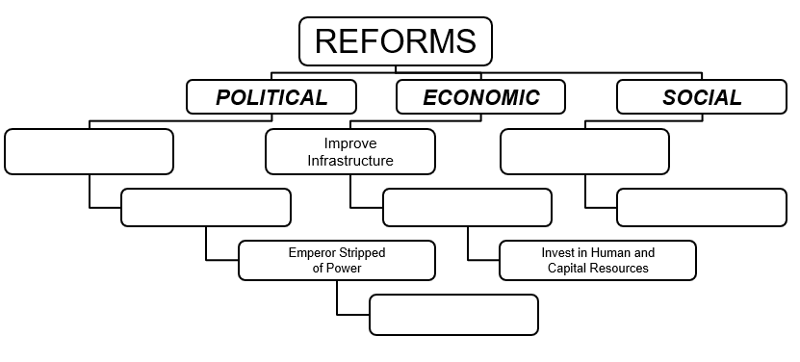

In 1952, power was transitioned back to ____________________________________________________________.

So, why was the U.S. involved in the rebuilding at all?
- Economic reasons – The U.S. wanted Japan’s _________________________ to get stronger so that it could become a ______________________________________________________________________________.
- Political reasons – The U.S. wanted to _________________________________________ __________________________________________________ in Asia (since China is so close) and ______________________________________________________________________.

Was the rebuilding of Japan successful (from the United States’ point of view)?
Yes, efforts were __________________________________.
Japan now has one of the ____________________________________________________________ in the world and a _______________________________________________________________________________________________.

