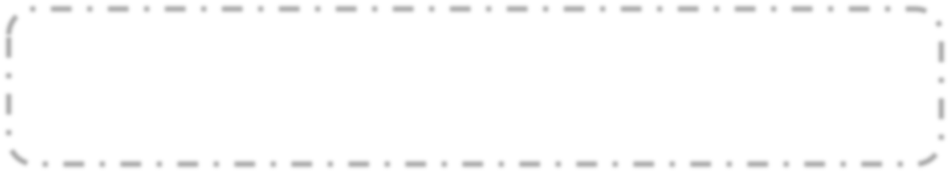

This religious holiday is part of the religion.

Followers of this religion are called .

Religious Symbol

This holiday occurs: (when/where)

When? (Day/Date)

Where? (Country/region, majority)



Some special traditions that are practiced during this holiday are: (at least three)

1.

2.

3.

Illustrate/paste important religious icons, foods, gifts, etc. associated with this holiday, at least 4, in this box.

Illustration

Illustrate/paste image of 3rd tradition.

Illustrate/past image of 2nd tradition.

Illustrate/paste image of 1st tradition.



Another interesting fact about the holiday.

Interesting fact about the holiday.

What do people say on this holiday?

This holiday is important to members of the religion because: