Who should replace Muhammad?
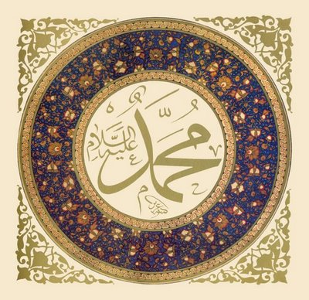

Muhammad is the prophet of Islam and the founder of one of the world’s largest and most influential religions. His guidance and inspiration have led his people to create the most powerful empire in Southwest Asia and build a religious movement that will influence history for thousands of years.

It is now the year 632, and Muhammad has died. Unfortunately, he never told anyone who should be his successor (replacement). The Muslim community must now choose a new leader. Two factions disagree over who this new leader should be.

Shia  One group believes that Muhammad’s vision and leadership are gifts from God. Only a relative of Muhammad could lead Islam. The logical choice, then, would be Ali, Muhammad’s cousin and closest family member. We call this group the Shia. | Sunnis  Another group believes that any good Muslim can lead. This leader would need to be wise and know a great deal about Islam. The logical choice, then, would be Abu Bakr, who was a Muhammad’s close friend and advisor. We call this group the Sunnis.

This disagreement leads to the division of Islam into Sunni and Shia sects, and many years of wars and other bloody conflicts. In the thousand years since the conflict started other differences have emerged between the two groups.

Now 85% of all Muslims are Sunni, while 15% are Shia. Even today, the division between Sunni and Shia Muslims is a major source of conflict in Southwest Asia. The largest population of Shia Muslims lives in Iran, while the second largest population is in Iraq.
The Sunni / Shia Division

What disagreement caused Islam to break into Sunni and Shia sects?

Shia  According to Shia belief, who can lead the Muslim people?  How many Muslims today are Shia?  The two largest populations of Shia Muslims live in which countries? | Sunni  According to Sunni belief, who can lead the Muslim people?  How many Muslims today are Sunni?

