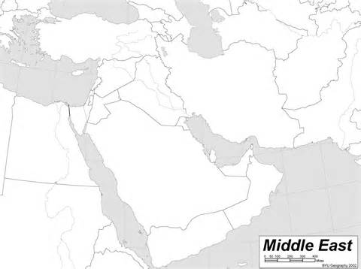
Water Sources
Jordan River
Mediterranean Sea
Red Sea
Dead Sea
Tigris River
Euphrates River
Population
(persons per square mile)
- >260
- 130-260
- 25-130
- 3-25
- <3

Use the Interactive Water Risk Map to answer the following questions…

- Which color areas have the least access to water?

- What Middle Eastern countries are struggling with access to enough water? List some and be sure to include a comment about how much water is accessible to Israel, Saudi Arabia, Iraq, Turkey, and the UAE.

Israel –
Saudi Arabia –
Iraq –
Turkey –
The United Arab Emirates (UAE) –

3. What types of things could limit access to fresh water? Which of these obstacles is natural (comes from the earth) and which are man-made?
Natural | Man-made

