Name:_________________________________________________________________ Date:_____________________ Pd:______
Oil in the Middle East: Read & Respond
SS7G7 The student will explain the impact of location, climate, physical characteristics, distribution of natural resources, and population distribution in Southwest Asia (Middle East)
a. Explain how the distribution of oil has affected the development of Southwest Asia (Middle East)
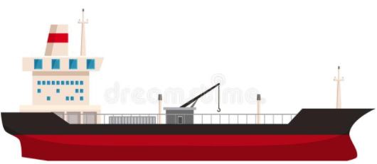
Two of the most important natural resources found in Southwest Asia are natural gas and oil. These two resources bring wealth into the region because they are needed for much of the world’s economy. Deposits of underground oil and natural gas were discovered in Southwest Asia at the beginning of the 1900s. At first, companies from the United States and Europe controlled the drilling and refining of most of this oil, but now most of the oil operations are controlled by the countries themselves. Over half of the world’s known oil reserves are found in this part of the world. This has made some of these countries extremely rich and has led them to have a lot of control over the global economy.
In the 1960s, several of these Southwest Asia countries joined with other oil-rich countries around the world to create the Organization of Petroleum Exporting Countries (OPEC) in order to have more control over the price of oil on the world market. OPEC has called for an embargo, or a slow-down or temporary halt, to oil supplies at different times in the past to get political and economic agreements from the other countries in the world. While some countries in Southwest Asia have grown very rich due to their oil production, others have struggled to help their populations make a decent living.
The Southwestern Asian countries with greatest reserves of natural gas and oil are Saudi Arabia, Iraq, Iran, and Kuwait. Some other countries have smaller reserves, especially those found around the Arabian Gulf. These countries have enjoyed tremendous growth in national wealth and an improved standard of living in the past fifty years. Those countries without oil reserves have had a much harder time improving living conditions for their populations. This difference in wealth in some of the Southwest Asian countries has led to conflicts among the nations.
- What are the two most important natural resources found in Southwest Asia?
___________________________________________________________________________________________
- How much of the world’s known oil reserves are found in this location?
___________________________________________________________________________________________
- What happened in the 1960s?
___________________________________________________________________________________________
- What does OPEC stand for?
___________________________________________________________________________________________
- What Southwestern Asian countries have the greatest oil reserves?
___________________________________________________________________________________________

Watch the video: “Can the Middle East Survive Without Oil?” and answer the question https://youtu.be/beGNG9X4TBI
Provide examples of at least three countries that are surviving, and what they have done to do so?
________________________________________________________________________________________________________
________________________________________________________________________________________________________
________________________________________________________________________________________________________

