States and Empires of West Africa
By World History Project, adapted by Newsela staff on 06.10.20 Word Count 1,271
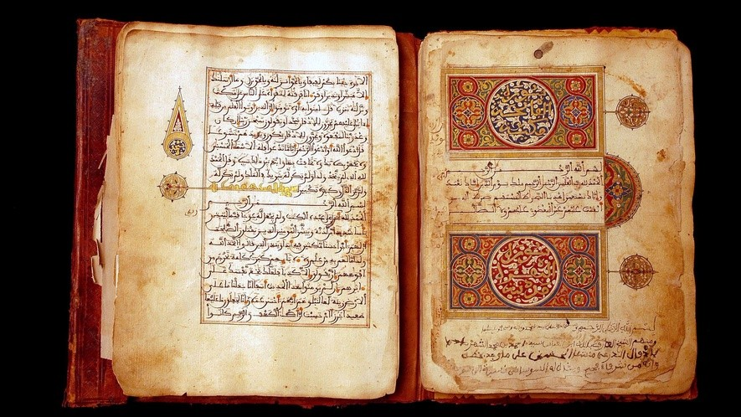
Level 920L
Image 1. Libraries of the desert: rediscovery and restoration of ancient Arab manuscripts in Bouj Beha, Mali, in April 2003. This manuscript of the Quran is from the private library of Abdelkader Haidara. On the lower part of the page on the right, a note indicates that several kings of Morocco owned this Quran. The writing is Moroccan of the 12th century. Photo by Xavier ROSSI/Gamma-Rapho via Getty Images

Agriculture wasn't easy in the dry West African Sahel. But people there grew whole kingdoms. Rulers who could manage trade routes, religion, and relationships with pastoralists had the best chance of success.
The Golden King

Examine the image below. A man sits in the middle of a late fourteenth-century map, staring at a yellow orb, a nugget of gold. He is clearly a king, for he wears a crown and holds a scepter. To Europeans, these are symbols of kings. The image was created by Abraham Cresques who lived in Spain around the year 1375. Yet the king is African, not European. He is Mansa Musa I, ruler of the state of Mali, and is possibly the wealthiest man of his time. He probably did not really have a crown or a scepter because these were not West African symbols of kingship. But the gold nugget is accurate because Mansa Musa controlled some of the richest goldfields of this era.

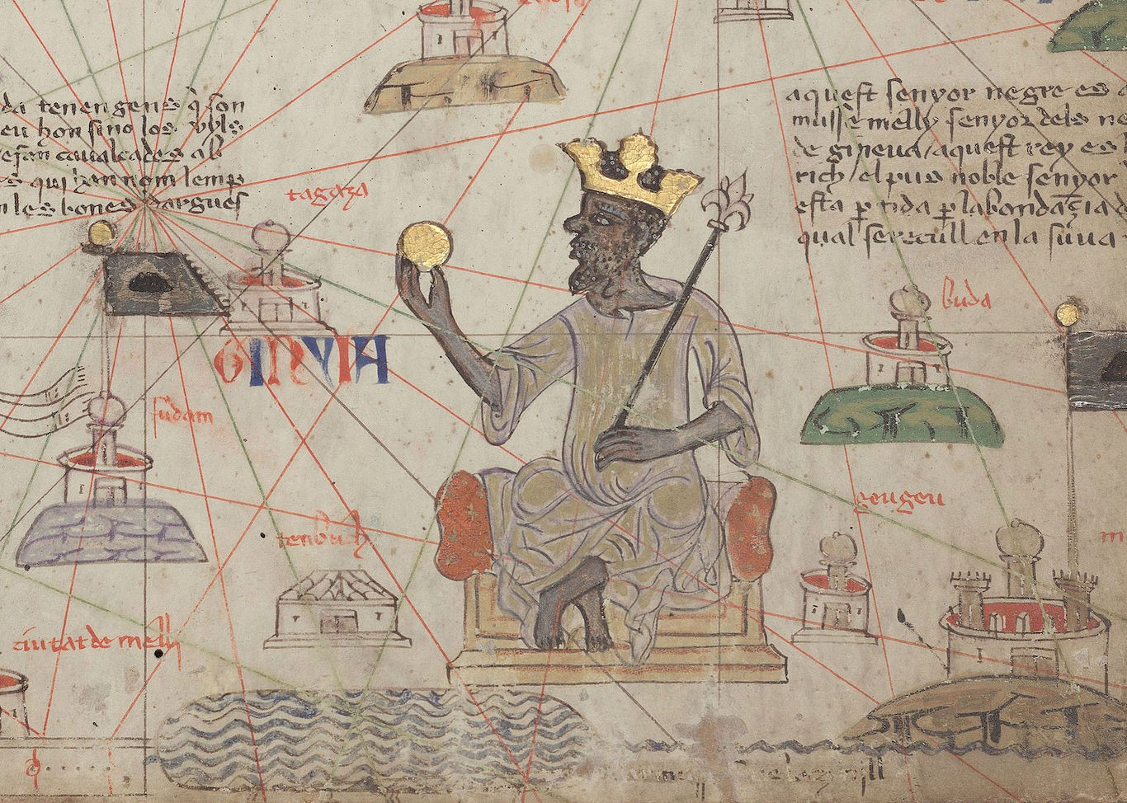
There were many West African states in this era, but Mali is the one that shows up in most textbooks. Mali emerged in a region that had given birth to many
earlier states. As early as A.D. 300, trade routes crossing the Sahara linked North Africa to the growing cities in West Africa. These cities had little centralized authority. That changed by 800 or 900.

States And Trade In The Sahel to 1100

The region south of the Sahara Desert was known as the Sahel. It was sometimes called the Western
Sudan. The Sahel was mostly dry grassland, with some wetter areas. Plus there were several lakes in an area known as the Chad Basin. A basin is an area where dry land dips down. It dips low
enough to support lakes, rivers, or streams. These wet areas could support large populations of people. As usual, that created a need for organization and government. So different communities built states, sometimes collaboratively, and sometimes forcefully. The earliest we know of was
Wagadu, the state we usually call by the title of its ruler, Ghana. It was probably established around the end of the sixth century. Nearby, the city of Gao controlled a region that we know as Kawkaw. Further to the east, a number of communities combined to build the state of Kanem in the Chad Basin around the ninth century. Many states in this region shared the same language, called Hausa.
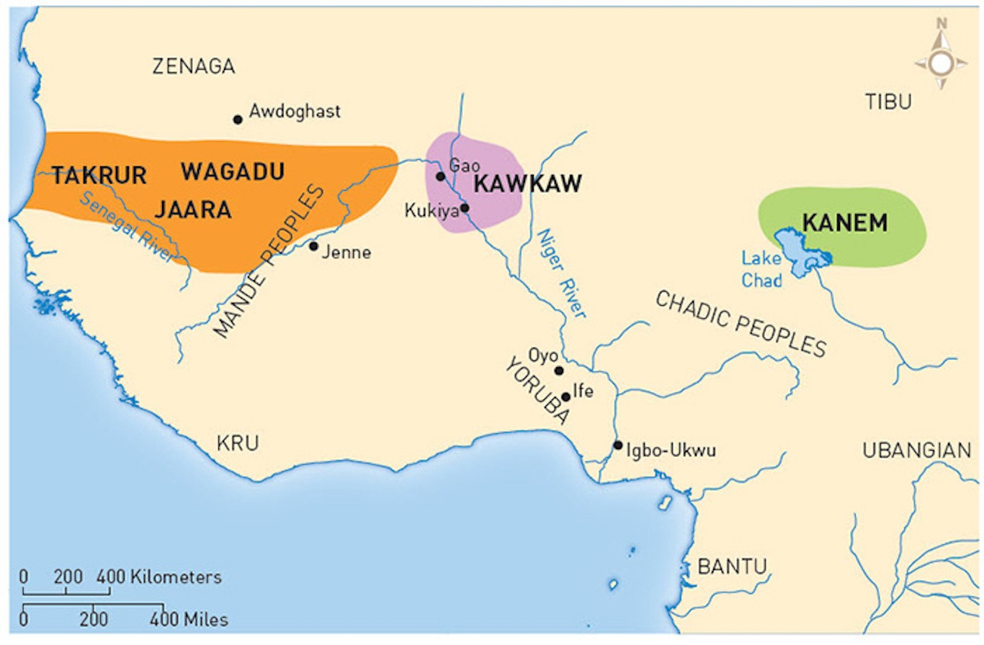
These kingdoms had three major elements in common. We call these the Sahelian state model.
First, these states generally dominated long-distance trade. It is how they got the money they needed to govern and survive. Wagadu, for example, controlled a large portion of the gold trade. Meanwhile, the
Hausa states and Kanem controlled the sale of kola nuts. (Kola has caffeine. It was one of the original ingredients that made Coca-Cola such a stimulating drink!) Takrur controlled regional trade in grain and
salt. These states also manufactured goods, especially textiles.
Second, these states all relied on wet centers where grains were grown. Many people lived there. These centers had little control over the people in the drier regions around them. Most of the people in drier areas were nomadic herders. The governments of the big states couldn't really rule them.
Finally, all of these states had to deal with religious diversity. Islam was a powerful force in the region. It was the religion of the traders from North Africa, and soon some West African
merchants became Muslims as well. But most of the people of the Sudan in this period followed local, non-Muslim religions. A few rulers chose to convert to Islam because it was useful for trade and because it had a written language. But most kings did not. Instead, they were very inclusive. One of the unique local features that remained important was tracing one's heritage and ancestry through the mother. It is called matrilineality. This was not a normal feature of Islam in many

other regions. This flexibility of facing in both directions—known as religious pluralism—remains a feature of many of the communities of this region today.
From The Decline Of Wagadu To The Rise Of Mali

During the twelfth century, Wagadu (Ghana) began to decline. It lost its status as the biggest state in the region. It is possible that this was partly because of an invasion by North Africans hoping to take control of the gold trade, but not too many historians buy that story. They may have merely been surpassed by a state to the south, Susu, which gained control over most of the gold and kola nut trade. It also had successful textile and iron industries. The Susu were the great power of the
region for a hundred years.
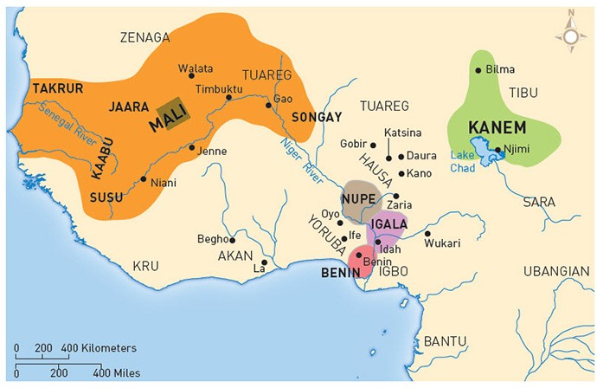
The Susu were defeated by a new power. It was the state of Mali, led by its first mansa (sultan, king, or emperor), Sunjata. Sunjata's full name was Sogolon
Mari Djata. "Sogolon" was actually his mother's name, and although he may have been Muslim, he still
embraced matrilineality and other local cultural and
religious ideas. Sunjata defeated Susu around 1240. In the wake of his victory, he built the long and lasting
state of Mali. Eventually, Mali stretched more than a thousand miles east to west.
If you ever want to watch a group of historians argue, ask them if Mali was an empire. On one hand, it had a core of people who shared a language and culture. Around them were conquered people who did not—like an empire, right? On the other hand, it was not very centralized. The different regions were fairly independent. There isn't a lot of evidence that conquered people were treated as inferior. That makes it seem less like an empire. But there is evidence that Mali's rulers got very rich by controlling the growing trade in the region. This was especially true as trade grew in North Africa and Europe in the early fourteenth century. This trade created a demand for currency, especially gold, and Mali controlled much of the gold production available in western
Afro-Eurasia.
African Diversities

Most high schools limit their teaching of African history, pre-1500 CE, to Mali and the Sudanic African states. They leave out many regions that had states and complex systems of trade. In the
forests to the south of the Sudanic zone, there were actually large kingdoms. These included Benin and the Yoruba and Igala states. In the mountains of Central Africa, the kings of Kitara and their neighbors created systems of nobility and monarchy based on ownership of cattle. Along the Congo River, chiefs gave gifts to each other to secure military and political alliances. In northeast Africa, the massive kingdom of Ethiopia was ruled by a Solomonic dynasty, so named because it claimed the biblical king Solomon as an ancestor. In Southeast Africa, extensive states like the one centered on the stone city called Great Zimbabwe existed alongside smaller societies. Historians are learning much more about these kingdoms, which we once ignored. It's a great example of how history's many narratives can grow and change based on the evidence and on who is telling the
story.

