The Songhai Empire: The Rise and Fall of a Great West African Empire
By Encyclopaedia Britannica, adapted by Newsela staff on 08.10.17 Word Count 770
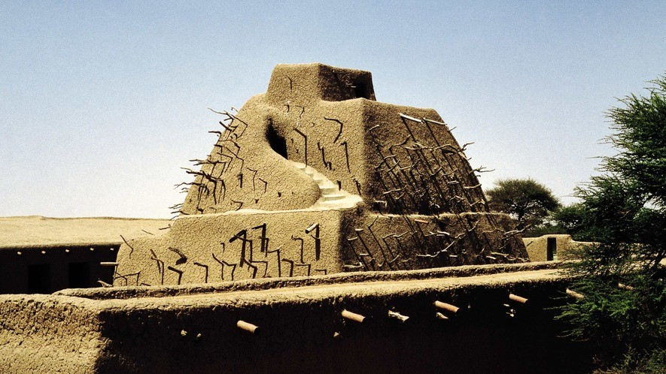
Level 810L
Image 1. Tomb of Askia Muhammad, Emperor of Songhai, in Gao, Mali, 15th century. Photo: DeAgostini/Getty Images.

The Songhai are a West African people. They mainly live in the country of Mali, but also in other parts of Africa. Hundreds of years ago, they ruled one of West Africa's greatest empires.
Before Songhai, the largest empire in West Africa was Mali. When the Mali empire became
weaker, many of its lands were taken over by Songhai. The Songhai empire became the strongest and richest empire the region had ever seen.
The capital city

The city of Gao used to be the capital of the Songhai empire. It is located on the Niger River at the southern edge of the Sahara Desert.
Gao is one of the oldest trading centers in West Africa. It was built by fishermen, and the Songhai people settled there around 800 A.D. About 200 years later, the city became their capital.

The town grew very rich through trade. It became a large trading center for gold, copper, salt and slaves. Slaves are captured people who are bought and sold. They are forced to do whatever their master tells them. Gao was taken over by the Mali empire in 1325, but Songhai took it back 40 years later.
Expansion during the rule of Sonni ʿAlī

In 1464, Sonni ʿAlī became Songhai's king. At the time, the kingdom was just a small area around Gao itself. Sonni ʿAlī was determined to conquer more territory.
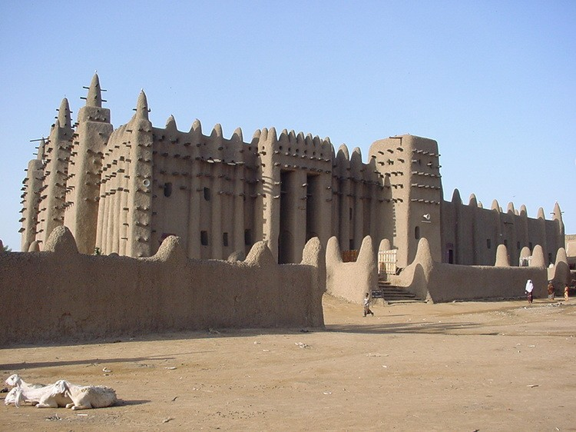
In 1468, he got his chance. Timbuktu was a city to the west of Gao, and had been conquered by the
Tuareg. The leaders of Timbuktu asked Sonni ʿAlī
to help push the Tuareg out of the city. Sonni ʿAlī did help free the city, but he then took it for himself.
Next, Sonni ʿAlī attacked the rich trading city of
Djenné. The city surrendered to him in 1473. Soon, more territories fell to Sonni ʿAlī's armies and a large and mighty empire was born.
Muhammad I Askia

After the death of Sonni ʿAlī, the throne was supposed to pass to his son. Instead, a rebel named Muhammad ibn Abī Bakr Ture took over.
Muhammad was a strong follower of Islam. Islam is a religion that only follows one god and that started around 600 A.D. Muhammad soon made the Songhai kingdom into an Islamic state.
Muhammad was able to organize the regions conquered by Sonni ʿAlī. He began by dividing Songhai into provinces ruled by governors.
He set up a fixed army, led by a general, and a navy, led by an admiral. Muhammad also created a well-organized system of taxation. Taxes are money that citizens pay to their government. The government then uses this money to build parts of the city or give services to the citizens.
Muhammad created many new positions in government, like a minister of finance, of justice, of agriculture, of waters and of forests. He also made sure government workers were well-trained.
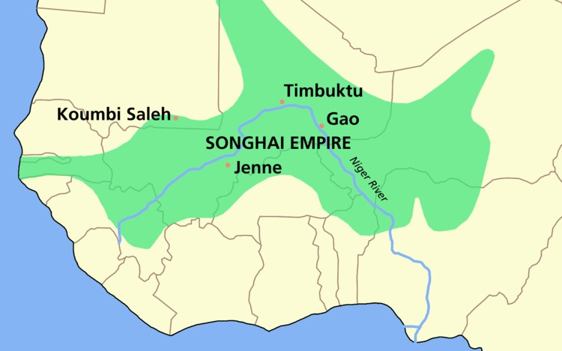
The empire of Songhai had a large effect on its neighbors too. Muhammad let Muslim scholars go to places they had never been before. These scholars taught more people about the faith of Islam and helped spread the religion.
Muhammad's reign came to an unhappy end, however. In 1528, his oldest son, Musa, killed
Muhammad's top general and then seized the throne from his father. Three years later, Musa was killed by one of his own brothers.

When that son took power, Muhammad was sent off to a far-away island "infested with
mosquitoes and toads." He remained there from 1528-1537, powerless to stop his children from fighting.
In 1537, another ruler, Muhammad's son Askia Ismaïl, allowed his father to return to Gao.
Muhammad died only one year later. His tomb is still standing in Gao. Over time, it became one of the holiest Islamic religious sites in all of West Africa.
The fall of the empire

The end of the Songhai empire came quickly. In 1591, Moroccan forces attacked the Songhai
empire because they wanted to take over the gold and salt trade. The Moroccan soldiers won by using guns, which the Songhai did not have.
The Songhai empire was ruled by the Moroccans for some time. At some point, the Moroccans gave up their control of the region, and the once-mighty empire split apart. Dozens of smaller kingdoms were formed instead.

