How modern states of the Middle East were created
By WGBH, adapted by Newsela staff on 11.01.19 Word Count 1,494
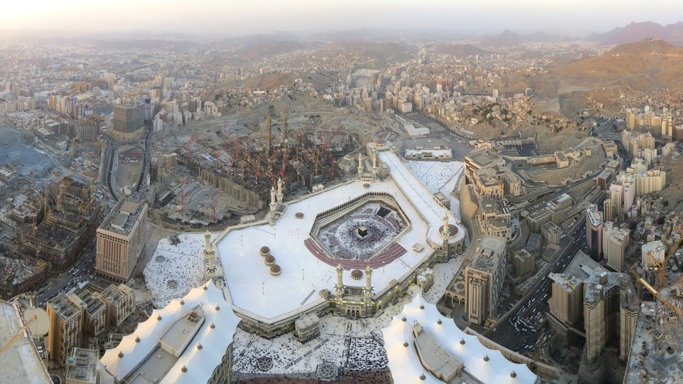
Level 1180L
Image 1. Cropped panoramic image of an aerial view of Mecca, Saudi Arabia. Mecca is a city that is an important pilgrimage site for Muslims around the world. The city was once under control of the Ottoman Empire. Photo from: Wikimedia Commons/Wurzelgnohm.

The map of the Middle East, as we know it today, was shaped by the events of the World War I. Prior to that time, the Ottoman Empire controlled much of the area.
The Ottomans

The Ottoman Empire was a massive empire that reigned from 1300 to 1922. The land ruled by the Ottomans included much of the Balkans, Anatolia, the central Middle East to the borders of Iran, and most of North Africa. The Ottoman Empire was a multiethnic, multi-religious world power
ruled through an extensive administration under laws derived from Islam and by the sultan's dictates. The empire ruled a quarter of Europe for hundreds of years.
By the 1700s, Ottoman power was beginning to weaken. The Ottoman Empire was built on permanent expansion. It would conquer new lands and then tax the people who lived in them. But expansion suddenly ground to a halt. A siege of the Austro-Hungarian city of Vienna in 1683 was

unsuccessful. Then, less than 100 years after that, they were forced to give up territory. The Treaty of Küçük Kaynarca surrendered significant territory to Russia in 1774.
The Ottomans also began to fall behind in structural changes. The industrialized European nation- states performed more efficiently than the Ottoman system, and new sea routes meant that
merchants no longer traded along land routes in Ottoman territories.
European Imperialism
While Ottoman power waned, the influence of western European nation-states grew. All of the great powers of Europe tried to control resources and expand their spheres of influence in the
Ottoman Empire, Egypt, North Africa and Iran prior to World War I. With more control of more lands, the countries could have more money for themselves back home.
France occupied Algeria in 1830 and Tunisia began losing territory to European colonies in 1881; the British took control of Aden (in Yemen) in 1836 and Egypt in 1882; and Italy occupied Libya in 1911. All of the above lands had been a part of the Ottoman Empire at one point.
The Ottoman Response

In the 1800s, the Ottomans tried to combat the growth of European power and influence. They trained their armies in new techniques and equipped them with up-to-date weapons. They created new government structures and state school systems modeled on those of Europe. They borrowed money to develop their infrastructure, building railroads, telegraph lines and modern ports.
Ironically, modernization got them further under the control of the Europeans, who provided the loans.
At the same time, nationalism was beginning to challenge the authority of the multicultural Ottoman Empire. People were beginning to identify with and support their own cultural and
religious groups and lose identification with the larger Empire. Greece won independence from the Ottomans in 1832, and other Balkan nations began to follow suit.
World War I

In World War I, the Ottoman Empire joined forces with the Germans and Austro-Hungarians.
Some Arab leaders, tired of living under Ottoman rule, agreed to help the other side, the Allies. In return, the British promised them independence after the war. The British and French, however, had already made a secret deal called the Sykes-Picot Agreement. This agreement would allow the British to actually carve up land in the Middle East for themselves into areas of direct or indirect control.
A final complication was the Balfour Declaration made by the British in 1917, promising their support for "the establishment in Palestine of a National Home for the Jewish people." This
agreement conflicted with the promise of Arab independence and set the stage for much further conflict.
The Balfour Declaration and the Sykes-Picot Agreement created a tradition of resentment toward colonial rule and distrust of Western motives that persists for many in the Middle East, even today.
The Mandate System In Arab States

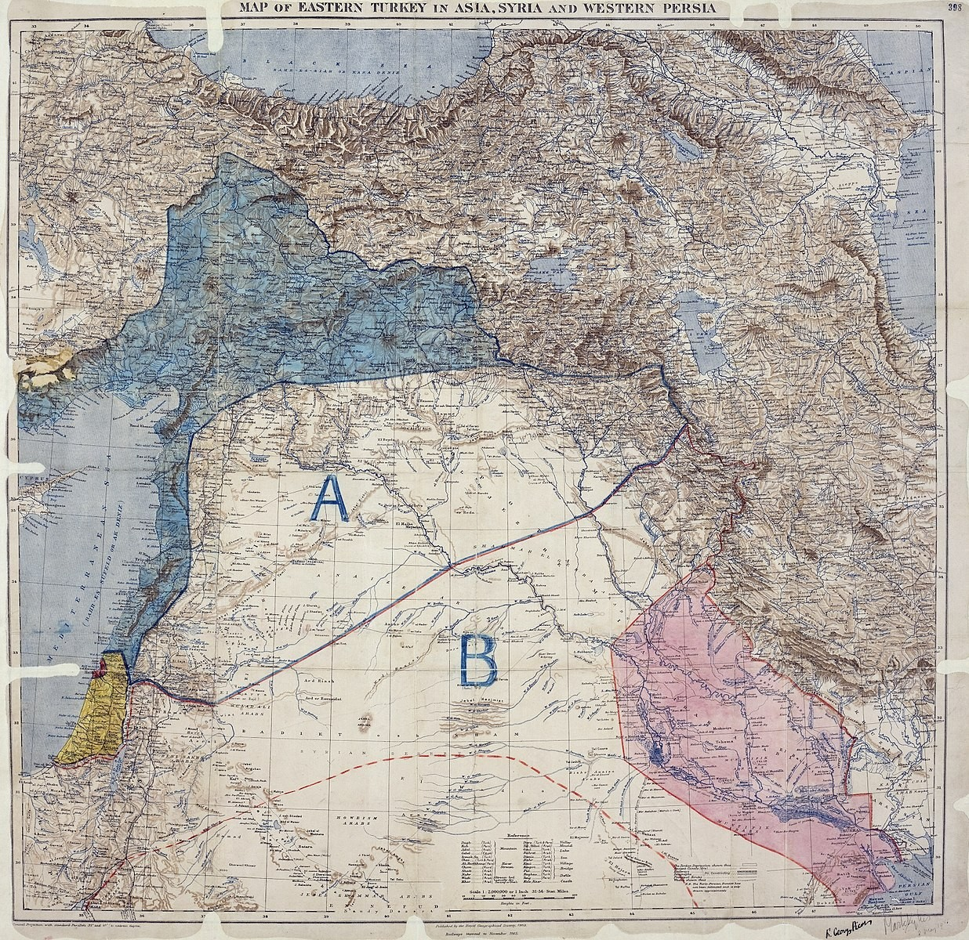
After World War I, an international group, The League of Nations, was created. Its job was to
mediate in international issues, like what to do with Arab lands once ruled by the Ottomans. In 1920, the League divided Ottoman Arab provinces between Britain and France along the lines of the Sykes-Picot Agreement, with borders drawn up entirely by the colonial powers.
France was given control of Syria. Britain got just about everything else in the Middle East. Britain held mandates over Palestine, which later became Israel and Jordan, and also mandates over Iraq. To appease the Arabs, the British made the sons of the Sharif of Mecca, Hussein bin Ali, who rebelled against the Turks, rulers of two of these new states. Hussein's son
Faisal was made king of Iraq. Abdullah was made king of what is now Jordan. Britain decided to let Egypt become an independent nation.
Some groups had their hopes for a nation-state dashed. The Kurds were briefly promised an independent state by the Allies in 1920, but in the end, other interests triumphed. The areas of Kurdish settlement were divided among Turkey, Syria, Iraq and Iran.
Modernization In Turkey And Iran

As the Ottoman Empire collapsed, Turkish nationalists under Mustafa Kemal Atatürk created a new state in Anatolia and Thrace. Atatürk embarked on an aggressive campaign of Westernization. He changed the alphabet from Arabic to Latin characters, instituted a new law code based on
Switzerland's, worked to give women the right to vote, and even ordered men to wear European hats instead of the more traditional fez headdress. Most Turks are still proud of Atatürk's
Westernizing and nationalist legacy, although there have been some amendments to its more extreme aspects.
In Iran, Reza Shah Pahlevi took power, and introduced similar reforms there, as well, to make Iran more like a Western country.
The Role Of Democracy

While many Middle Eastern states have superficial democratic institutions or some genuinely democratic components within the state structure, their governments are often oppressive and do not allow open criticism or effective political opposition. Political openness varies widely throughout the Middle East. For example, Syria is a completely authoritarian state. Iran has an ongoing struggle between political moderates and authoritarian religious leaders. Morocco has
many elements of a functioning democracy. Israel and Turkey do have a vigorous and relatively open political debate.
When governments face popular discontent with their lack of political openness, they may try various means to build their legitimacy. Oil-rich states use their revenues from oil on social
spending, such as welfare systems. Iran uses Islamic or anti-Western rhetoric to appeal to public

sentiment. Citizens of Middle Eastern countries are, however, often brought together by genuine feelings of brotherhood with their fellow citizens, other Arabs, and/or other Muslims, and often feel strongly about regional political matters, such as the Gulf War or the Israeli-
Palestinian conflict.
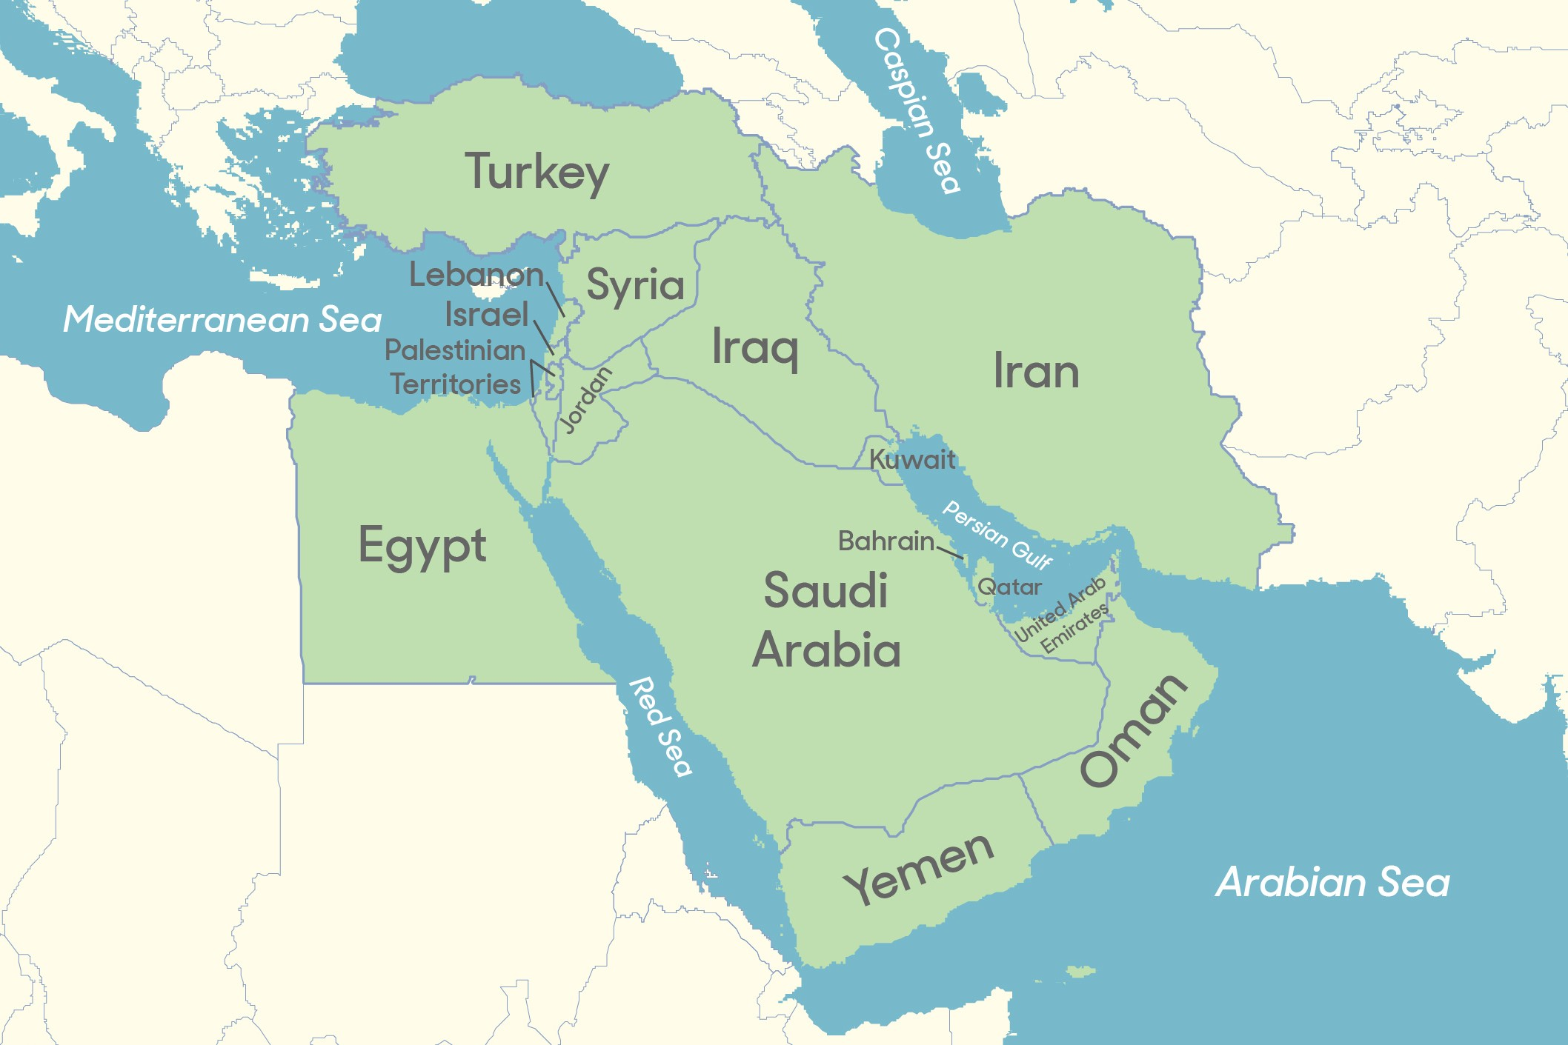
Ethnic Groups

Most governments in the region are dominated by a single ethnic and religious group, but there are
significant minority groups that often struggle to maintain their cultural identity and at least some political influence.
Major ethnic groups include the Kurds (in Turkey, Iraq, Iran and Syria) and Berbers (in North Africa).
Members of both of these groups are fighting for greater autonomy within — or independence from —
their countries, but face stiff resistance. Armenians in Anatolia had similar ambitions in the early 20th century, but their nationalism was seen as a threat by the state, and huge numbers of
Armenians were moved or killed by the Turks. Lebanon was separated from Syria by the French in order to preserve the political autonomy of its Christian population.
Israel is a special case. As a Jewish state, it is both homogeneous and multiethnic. Jews from all over the world — including Eastern Europe, Russia, North Africa, the United States, Ethiopia,
Yemen, Iraq and Iran — have emigrated to Israel. Many Arabs also live in Israel as Israeli citizens
— but the majority of them identify as Palestinian. They are in Israel because of where their families were when the war for Israel's creation happened, or were in land annexed by Israel during the Six-Day war of 1967. Most of them are Muslim, but some are Christians. Many rights in Israel and its occupied territories, however, apply only to Jewish citizens.
Palestinians continue to seek the establishment of an independent Palestinian state in the West Bank and Gaza Strip.

