Geography of the Middle East, an ancient and modern crossroads
By WGBH Educational Foundation on 01.09.18 Word Count 1,763
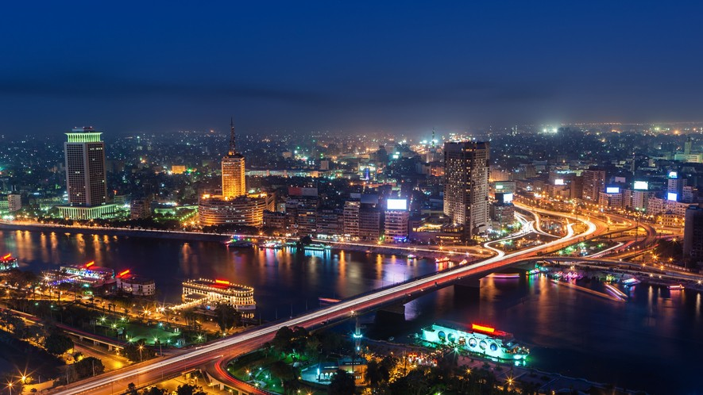
Level MAX
Image 1: The Nile River runs through the city of Cairo, which is the capital of Egypt and the second largest city on the African continent. Cairo and its surrounding areas are home to over 20 million people. Photo by: hadynyah/Getty Images

The Middle East is at the junction of trade routes connecting Europe and China, India and Africa, and all the cultures of the Mediterranean basin. Many of these routes have been documented from as early as 5,000 years ago, and the presence of so many different people and products over the years has had a profound effect on the region's culture, politics and economy.
More Than Deserts And Camels

The landscape of the Middle East is more diverse than the deserts that dominate movie screens and novels would suggest. Rivers allowing for productive agriculture were the key factor in the settling of cities. Mountain ranges kept cultures in separate areas, providing natural barriers to imperialist agendas.
The rich, fertile soil of the Middle East led early civilizations to settle, domesticate plants and animals, and thrive. The Fertile Crescent between the Euphrates and Tigris rivers known as Mesopotamia (now modern Iraq, and extending north into Syria and Turkey) was the home of the

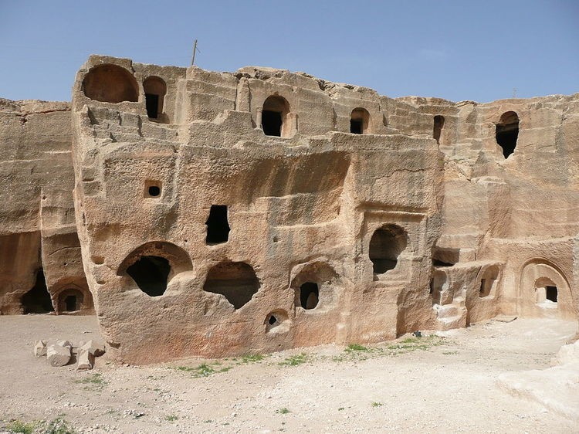
world's first urban culture, the Sumerians, 6,000 years ago. The Sumerians' Egyptian rivals took advantage of the annual flooding of the Nile for their regular harvest, later exporting (starting around 30 B.C.) a large portion of their produce to the Roman Empire. Some time after the Sumerians, the Hittites
settled in the golden, rolling hills of Anatolia (modern Turkey) and the Phoenicians of the eastern Mediterranean loaded olive oil and spices into their merchant ships to trade throughout the Mediterranean.
This region introduced many staples into the kitchens of the world, including olives, figs, lemons, coffee, chickpeas, lentils, pomegranates and asparagus. The cedar trees covering the hills of
Lebanon were forested in ancient times for their fragrant and structurally reliable wood.
The mountain ranges in the Middle East helped isolate various cultures from each other as much as, if not more than, bodies of water. The Taurus Mountains of southern Turkey separate Anatolia, also known as Asia Minor, from the rest of Asia, just as the Atlas Mountains separate Morocco from the rest of Africa. Iran's Elburz and Zagros mountains are high enough to host ski resorts.
In tumultuous times, mountains have also provided refuge for oppressed minorities, such as the Ismailis in Afghanistan; the Alawites in Syria; the Christians in Lebanon; the Kurds in Turkey,
Syria, Iran and Iraq; and the Berbers in North Africa.
A Well-Traveled Trade Route

The Silk Route, also called Silk Road, refers to the trading routes stretching from China through Central Asia to the Middle East. (Even when Europe participated in this overland exchange, traders continued through the Middle East to avoid having to cross the Caspian Sea to the north.) Silk Route merchants were the first to introduce Chinese products like paper and gunpowder to the West. The people who traveled these roads exchanged not only products, but, maybe even
more importantly, ideas - scientific, religious, and artistic - that would challenge and change institutions in China as well as in the Middle East.
Perhaps the most significant movement of people on this route was the Turks' migration into
Anatolia. The Christian Byzantines had ruled Byzantine from Constantinople in western Anatolia for four centuries, with the Taurus Mountains providing a natural barrier against their Muslim neighbors to the south and east. The victory by the Seljuk Turks over the Byzantines at the Battle of Manzikert in 1071 in southeastern Anatolia opened the way for Turkish tribes to settle in
Anatolia and provoked the first European Crusade.
Although it was religious wars that first introduced European armies into the region, the strategic location of the Middle East was the motivation for a continued European presence in the 19th and 20th centuries. The British and French both coveted a route to India and Southeast Asia. The building of the Suez Canal in Egypt (completed in 1869) allowed military and commercial ships to pass between the Mediterranean and Red Seas and into the Indian Ocean, rendering the long and dangerous trip around Africa unnecessary.

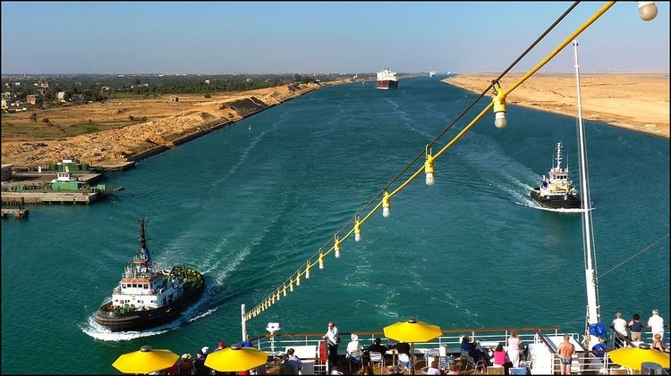
Geographical Features Bring Economic And Political Riches

Geography and natural resources have always influenced political power in this region. The Nile and Mesopotamian rivers can support a rich agricultural base, but only if the water distribution can be
sustained and controlled through irrigation systems. And the prosperity of these regions has depended on a government's ability to maintain irrigation systems
over the long term. If a central government can keep the irrigation systems in good working order, then well-irrigated fields produce more crops, which can then be taxed to support the government. Conversely, when local populations do not cooperate to maintain a stable government, their crop yields may drop.
Mesopotamian farmers used salty water to irrigate for centuries, and now, as a result, much of southern Iraq's soil is too salty to grow crops. Agriculture in the region now relies on modern practices like fresh water irrigation, rotating crops each year, and technologically sophisticated dam projects.
Today, the wealth in Middle Eastern soil comes not from crops, but from petroleum. This region contains about two-thirds of the world's known petroleum reserves, the geological remnants of lush tropical forests of eons past. When the United States and Europe increased their consumption of oil drastically during World War II, the oil reserves in the Middle East became critically important to U.S. foreign policy, and have remained so ever since.
Human Geography

The ethnic and cultural diversity of the population of the Middle East is as varied as any place on Earth, save the New World. People in the Middle East live a variety of lifestyles - nomadic and
semi-nomadic, farming and fishing, and, increasingly, urban.
How people put food on their tables is intimately tied to their physical surroundings. While the herding lifestyle of the nomadic peoples of the Middle East may have captured the romantic imagination of Europeans and Americans, in reality, pure nomads have always been a small
minority in this region. In fact, many so-called nomads were simply seasonal migrants who grazed their livestock in one region in the summer and moved elsewhere in the winter. These migratory populations gained a reputation for breeding fine horses and camels, although most supported themselves raising sheep and goats. This system of seasonal migration functioned well until
modern states established exclusive ideas of property and land ownership.
Most states in the region with large nomadic or semi-nomadic populations have pursued a
settlement policy in order to better track and control the historically independent tribes. Clan and family relationships are still a vital part of their social structure.
Other families depend on the sea, or rivers, for their sustenance. The long Mediterranean, Persian Gulf, and Red Sea coastlines and large river systems of the region support many communities through both fishing and water-borne trade. The pearl industry of the Persian Gulf spawned a
specialized economy there.

Productive areas of both rain-fed and irrigated agriculture support rural farming populations, which are usually organized as tight-knit villages rather than isolated farms. Village identity is
extremely strong, so much so that when people migrate to the city or even abroad, they often settle in communities of their co-villagers. A neighborhood in Detroit, for example, may be made up of immigrants from one particular village in Lebanon. Immigrants often aspire to earn enough
money to return to their village, buy land, and build a large home.
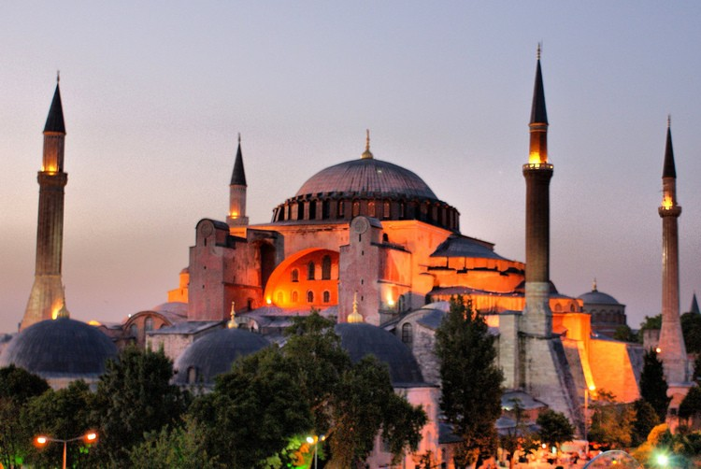
Rapid urbanization was a marked feature of the Middle East in the late 20th century. Cairo, Istanbul, and Tehran each have more than 10 million residents and continue to grow. While migration to the cities offers attractive opportunities of employment and
modern amenities to poor villagers, the rapid rise in urban populations has strained water resources, transportation facilities, and other public services as well as contributing to pollution.
What's In A Name

Many different terms have been used to describe this area of the world, and although various geographic and cultural descriptions have major overlaps, each may significantly exclude different regions.
The region can be referred to most neutrally by continental terms, such as "West Asia" or "Southwest Asia and North Africa."
Linguistically, the "Arab world" includes the Arabic-speaking countries from North Africa, Southwest Asia, and the Arabian Peninsula, but excludes Iran, Turkey and Israel.
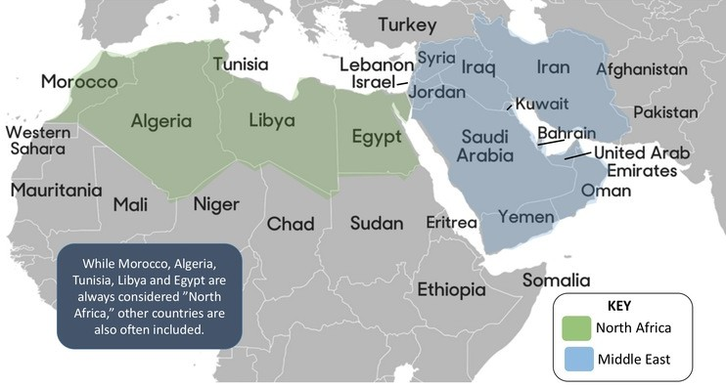
The "Islamic world" includes all of the Arabic countries, as well as neighboring Turkey and Iran. Other nations that are predominantly Muslim, like Indonesia, Pakistan, Afghanistan, and many sub-
Saharan African countries, should be considered as integral parts of the Islamic world, but terminology for the region often omits them. In addition, there are significant populations of Christians, Jews,
Zoroastrians, and other religious groups that live in
these same nations that make up the so-called Islamic world.
The "Middle East" is a term derived from a European perspective. For 19th-century Europeans, the Middle East was differentiated from India and the Far East (Southeast Asia and China).
Originally, the Near East referred to areas under Ottoman control, from the Balkans to the border of Iran. The term "Middle East" was introduced in the early 20th century to include the area around the Persian Gulf, and the Near East was used to refer to the Ottoman Balkans. After World War II, Middle East became the dominant term for the whole region.
Because "Middle East" is an outsider's term describing neither geography nor culture, it is an ambiguously applied name. For some, it refers to the area bounded by the Mediterranean Sea, the

Arabian Peninsula, and the Taurus and Zagros mountains. For others, Egypt, Arabia, and the Persian Gulf states fall under their description of the Middle East. Still others use the term as a
synonym for the Arab world, sometimes including Turkey and Iran based on their proximity and linguistic and religious affinities to the region. Despite its foreign origins, the term "Middle East" has been translated and adopted into many Middle Eastern languages, including Arabic, Hebrew, Persian and Turkish.

