Geography of the Middle East, an ancient and modern crossroads
By WGBH Educational Foundation, adapted by Newsela staff on 01.09.18 Word Count 1,041
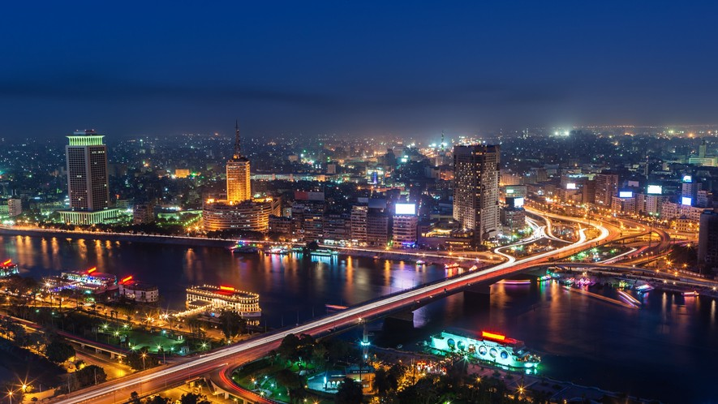
Level 1040L
Image 1: The Nile River runs through the city of Cairo, which is the capital of Egypt and the second largest city on the African continent. Cairo and its surrounding areas are home to over 20 million people. Photo by: hadynyah/Getty Images

The Middle East sits at the crossroads of trade routes from east, north, south, and west. These routes connected Europe and China, India and Africa, to all the cultures of the Mediterranean
basin. Some of these routes were ancient, having been used going back 5,000 years or more. Many different people and products over the years have deeply affected the region's culture, politics and economy.
More Than Just Deserts

The landscape of the Middle East has a great deal of variety. Movies make it seem like it is all desert, but this isn't accurate. Rivers allowing for productive agriculture were the key factor in the first development of cities in ancient times. Mountain ranges provided natural barriers to invaders.
The fertile soil of the Middle East led to the development of early civilizations. The area that
stretches from the Tigris and Euphrates rivers northwest to the Mediterranean coast and then

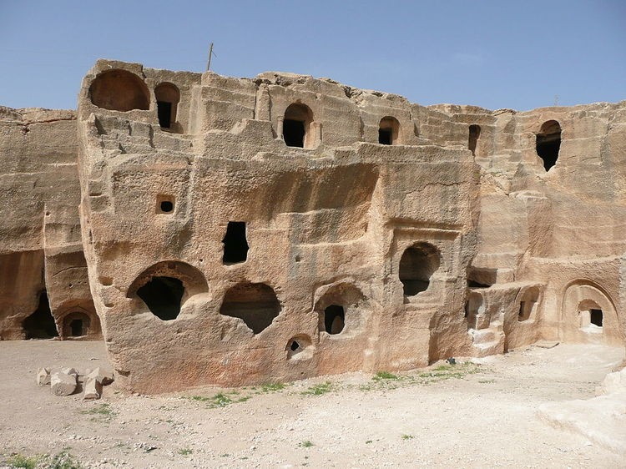
down to the Nile River is often referred to as the Fertile Crescent. Here people farmed, domesticated plants and animals, built cities, and prospered. The lands between the Tigris and Euphrates was called Mesopotamia in ancient times. This was home to the Sumerians 6,000 years ago, the world's first city- based culture. The Egyptians, rivals of the Sumerians, lived along the Nile River and had rich harvests because the river's annual flooding fertilized the soil. They exported wheat and barley all over the region.
Their cities were protected from invaders by vast deserts. Soon, the Hittite civilization in Anatolia
(modern Turkey) and the seagoing Phoenicians in the eastern Mediterranean (modern Israel, Lebanon, Palestine) were competing with the Egyptians and the Mesopotamians for trade and power.
Mountain ranges in the Middle East helped isolate various peoples from each other. The Taurus Mountains of southern Turkey separated Anatolia, also known as Asia Minor, from parts of Asia. This kept the Hittites and Mesopotamians apart, while the Zagros Mountains protected Mesopotamia from the invaders to the east.
Mountains have also provided refuge for oppressed minorities, such as the Alawites in Syria; the Christians in Lebanon; and the Kurds in Turkey, Syria, Iran, and Iraq.
A Well-Traveled Trade Route

The Silk Road was one of many trading routes that crossed into the Middle East. It consisted of
routes stretching from China through Central Asia to the Middle East. Silk Road merchants were the first to introduce Chinese products like paper and gunpowder to the West. These traders also exchanged significant scientific, religious and artistic ideas.
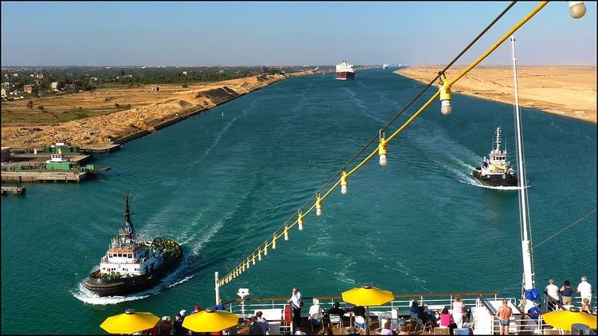
Religious wars brought the first European armies into the region a thousand years ago. But in the 19th and 20th centuries, the Middle East's geographic location motivated the British and French to come and stay.
They both wanted a way to get to India and Southeast Asia. The building of the Suez Canal in Egypt (paid for by the British and French, and completed in 1869) allowed military and commercial ships to pass between the Mediterranean Sea to the Red Sea, and
on into the Indian Ocean. Now, the long and expensive trip around Africa became unnecessary.
Unique Features Bring Economic And Political Riches

Geography and natural resources have always contributed to the political power in this region.
Farmers in Mesopotamia and Egypt long ago developed many agricultural technologies to successfully irrigate their fields with water from the rivers of the region. Over the centuries, agriculture generated enough wealth to support empires.

Today, the wealth in Middle Eastern soil comes not from crops, but from petroleum, or oil. This region contains more than half of the world's known petroleum reserves. Over the past 70 years,
the global need for oil has grown enormously. As a result, the oil reserves in the Middle East have become important to the whole world.
Human Geography

The populations of the Middle East have a great deal of ethnic and cultural diversity. Many different people live different lifestyles here — nomadic and semi-nomadic, farming and fishing, and, increasingly, in cities.
How people put food on their tables is closely tied to their physical surroundings. The herding lifestyle of the nomadic peoples of the Middle East captured the romantic imagination of Europeans and Americans. Actually, few people here are pure nomads. Most are seasonal migrants who graze their livestock in one region in the summer and move elsewhere in the winter.
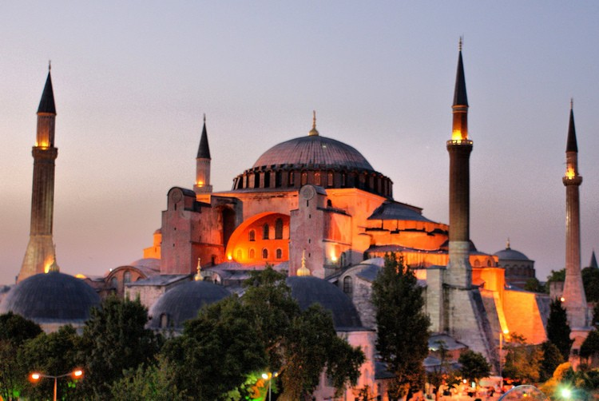
Other families depend on the sea or on rivers for their living. They fish or carry out trade along waterways.
The long coastlines of the Mediterranean Sea, the Persian Gulf, and the Red Sea, as well as those of the large river systems, support many communities.
Farming populations are usually organized as tight- knit villages rather than isolated farms. Village identity is strong. When villagers migrate to a city or even abroad, they often settle in communities of their co-villagers.
Rapid urbanization was a major feature of the Middle East in the late 20th century. Cairo and Istanbul each have more than 10 million residents and continue to grow. The rapid rise in city
populations has caused problems. It has strained water resources, transportation facilities, and created large-scale pollution problems.
What's In A Name

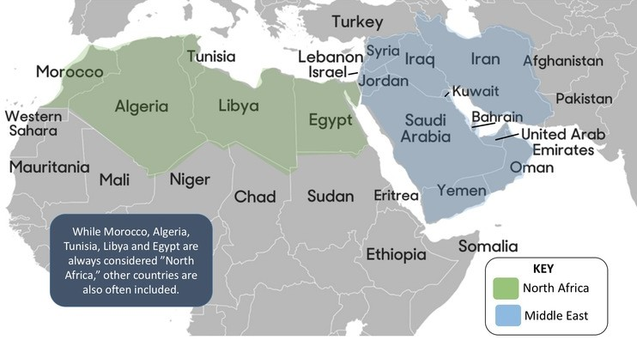
The name "Middle East" comes from a European point of view. Those areas east of Europe that were nearest were called the "Near East." Those farthest from Europe, like China and Japan, were the "Far East." By the mid-20th century, "Middle East" became the main term for the Southwest Asia and North
Africa.
Because "Middle East" is not a precise term, however, sometimes it is used in ways that are confusing.

