The Ancient City of Meroe in the Kingdom of Kush
By Ancient History Encyclopedia, adapted by Newsela staff on 07.20.17 Word Count 774
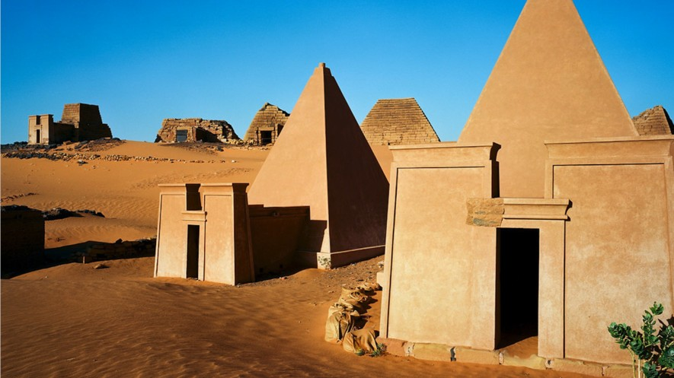
Level 780L
A close look at the reconstructed pyramids of Meroë, in Sudan, modeled for what they might have looked like at the time of the Nubian Kingdom of Kush. Photo: Christopher Michel

Meroe was a rich city in the ancient African Kingdom of Kush. It stood in what is today the country of Sudan. For more than 1,100 years, from about 800 B.C. to A.D. 350, it was a proud and mighty city.
Egyptian influence fades

The Kingdom of Kush was ruled by the Nubians. At first, however, these Nubians followed Egyptian practices and customs. While they were shown in art as black Nubians, they called themselves by Egyptian titles.
In time, however, Egyptian practices gave way to new, native customs. In addition, Egyptian hieroglyphs were replaced by a new system of writing known as Meroitic.
The break from Egyptian culture happened in the 200s B.C. Before then, Kush's high priests had great power. They were believed to communicate directly with the Egyptian god Amun. It was up

to them to decide who became king and for how long they ruled.
The health of the king was thought to be linked to the fertility of the land. The priests had the power to determine if the king was no longer fit to rule. If they decided he was unfit, they would send a message to the king. The message was understood to be from the god Amun himself.
The message informed the king that his rule on Earth was completed and that he must die. The kings had always obeyed these orders. They would take their own lives for the supposed good of the people.
King Ergamenes holds his power

However, King Ergamenes (295–275 B.C.) refused to obey when his time came. Instead of taking his own life, he brought troops to the temple of Amun and killed all the priests.
Ergamenes then ended the rule by priests. From then on, he governed as he saw fit. Ergamenes passed laws that made Meroe a culture separate from that of Egypt. After 285 B.C.,
Egyptian language, writing and art disappeared from Meroe. Nubian gods such as Apedemak were worshiped. Apedemak was related to the Egyptian gods like Amun.
Candaces: The queens of Meroe

After 285 B.C., queens shared power with the king, unlike in the Egyptian system. The title of the queen was "Candace," which meant "Queen Mother."
There were at least seven Candaces between 284 B.C. and A.D. 115. The Candace Amanishakheto is pictured in art as a huge, tall figure conquering her enemies, who are all shown as smaller and helpless. The Candace Amanitore is pictured in the same way. Such images reveal the power
women rulers had in the culture of Meroe.
Legend has it that a Candace scared away the Greek warrior-king Alexander the Great. Historians think it is just a story, but a Roman emperor was scared off by the Kushites.
In 22 B.C. the Kush empire went to war with Roman Empire. Augustus Caesar was the Roman
emperor. He had defeated Cleopatra and taken control of Egypt. Then he sent troops into Nubia, but Meroe fought back and launched attacks into Egypt. After the war ended, Augustus signed a peace treaty that helped Meroe.
The rise of Meroe

At its height, Meroe was a great center of farming and trade. The Egyptians and Romans wanted African goods from Meroe, such as rare woods and ivory.
Meroe also became famous for its iron work. The ironworkers of Meroe were considered to be the best, and tools and weapons made by them were much desired.
Meroe was on the banks of the Nile River. It overlooked grasslands and fields for farming. The city was filled with temples and pyramids, huge stone statues and wide streets.
The royalty of the city lived in great palaces. The working people lived in rectangular mud houses, as well as huts. The people gathered rainfall in huge water tanks. These were 800 feet around and

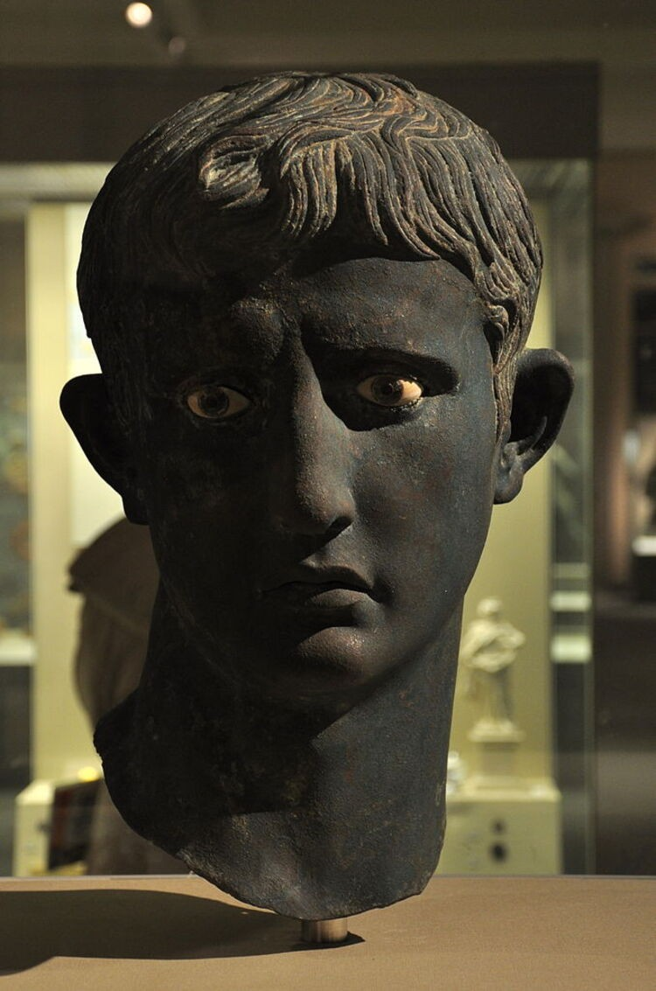
20 feet deep and decorated around the sides with figures of animals.
A prosperous city disappears

Meroe was conquered by the Kingdom of Aksum around the year A.D. 330. Following this, the Meroitic language died out.
Invaders were not Meroe's only problem. Over time, the city's farmable land had turned to desert due to overuse. By the A.D. 400s, the city had faded away.
Today, the remains of Meroe can still be seen. The
ruins of pyramids, palaces and buildings stand silent where a busy city once thrived.

