The Ottoman Empire
By History.com on 11.27.17 Word Count 1,278
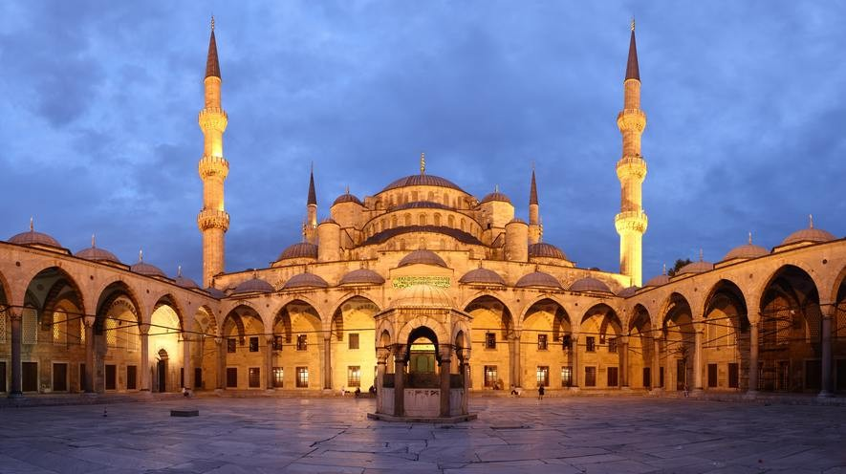
Level MAX
Panoramic view of the courtyard of the Blue Mosque, in Istanbul, Turkey. The mosque was built between 1609 and 1616 during the rule of Ahmed I. Photo by: Benh Lieu Song/Wikimedia.

The Ottoman Empire was one of the most robust and long-lasting dynasties in world history. This Islamic-run superpower ruled large areas of the Middle East, Eastern Europe and North Africa for more than 600 years. The chief leader, known as the sultan, was given absolute religious and political authority over his people. While Western Europeans generally viewed it as a threat, many historians regard the Ottoman Empire as a source of great regional stability and security, as well as important achievements in the arts, science, religion and culture.
Origins of the Ottoman Empire

Osman I, a leader of the Turkish tribes in Anatolia, founded the Ottoman Empire around 1299. The term "Ottoman" is derived from Osman's name, which was "Uthman" in Arabic.
The Ottoman Turks set up a formal government and expanded their territory under the leadership of Osman I, Orhan, Murad I and Bayezid I.
In 1453, Mehmed II the Conqueror led the Ottoman Turks in seizing the ancient city of Constantinople, the Byzantine Empire's capital. This put an end to the 1,000-year reign of the

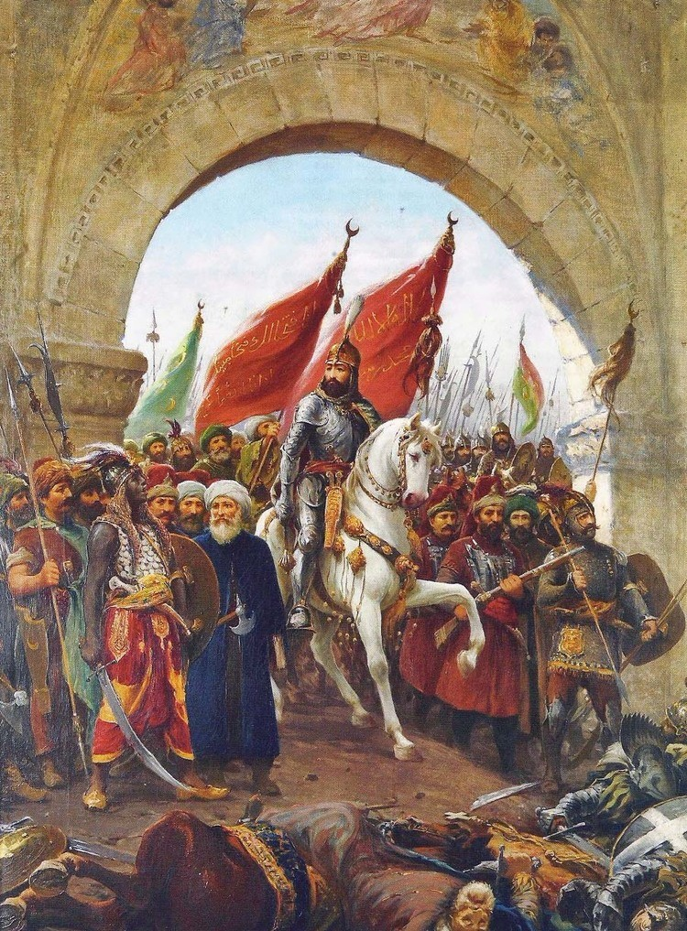
Byzantine Empire.
Sultan Mehmed renamed the city Istanbul, meaning "the city of Islam" and made it the new capital of the Ottoman Empire. Istanbul became a dominant international center of trade and culture.
Mehmed died in 1481. His oldest son, Bayezid II, became the new sultan.

Suleiman and the period of expansion

By 1517, Bayezid's son, Selim I, brought Syria, Arabia, Palestine and Egypt under Ottoman control.
The Ottoman Empire reached its peak between 1520 and 1566, during the reign of Suleiman the Magnificent. This period was marked by great power, stability and wealth.
Suleiman created a uniform system of law and
welcomed different forms of arts and literature. Many Muslims considered Suleiman a religious leader as
well as a political ruler.
Throughout Sultan Suleiman's rule, the empire expanded and included areas of Eastern Europe. At its height, the Ottoman Empire included the following regions:
- Turkey
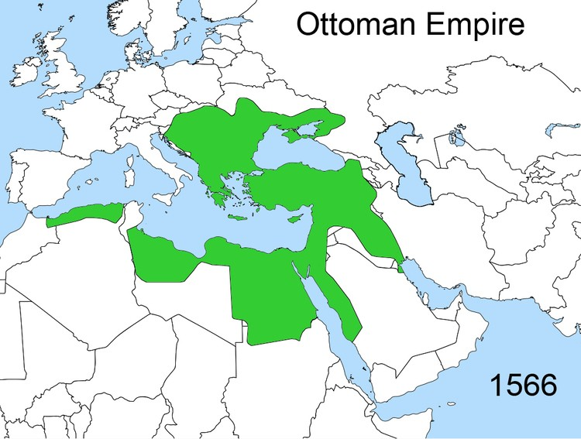
- Greece
- Bulgaria
- Egypt
- Hungary
- Macedonia
- Romania
- Jordan
- Palestine
- Lebanon
- Syria
- Some of Arabia
- A considerable amount of the North African coastal strip
Ottoman art and science

The Ottomans were known for their achievements in art, science and medicine. Istanbul and other major cities throughout the empire were recognized as artistic hubs, especially during the reign of Suleiman the Magnificent.
Some of the most popular forms of art included:
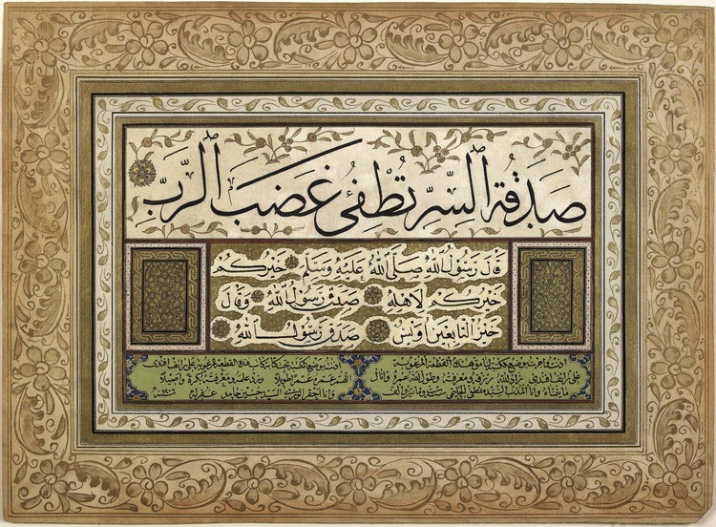
- Calligraphy
- Painting
- Poetry
- Textiles
- Carpet weaving
- Ceramics
- Music
Ottoman architecture also helped define the culture of
the time. Elaborate mosques and public buildings were constructed during this period.
Science was regarded as an important field of study. The Ottomans learned and practiced advanced mathematics, astronomy, philosophy, physics, geography and chemistry.
Additionally, some of the greatest advances in medicine were made by the Ottomans. They invented several surgical instruments that are still used today, such as forceps, catheters, scalpels, pincers and lancets.
Fratricide

Under Sultan Selim, a new policy emerged, which included fratricide, or the murder of brothers.
When a new sultan was crowned, his brothers would be imprisoned. When the sultan's first son was born, his brothers and their sons would be killed. This system ensured that the rightful heir would take the throne.
But, not every sultan followed this harsh ritual. Over time, the practice evolved. In the later years, the brothers would only be put in prison — not killed.
Topkapi palace

A total of 36 sultans ruled the Ottoman Empire between 1299 and 1922. For many of these years, the Ottoman sultan would live in the elaborate Topkapi palace complex in Istanbul. It contained dozens of gardens, courtyards and residential and administrative buildings.
Part of the Topkapi palace included the harem, a separate quarters reserved for wives, concubines and female slaves. These women were positioned to serve the sultan, while the men in the harem complex were typically eunuchs.
The threat of assassination was always a concern for a sultan. He relocated every night as a safety measure.

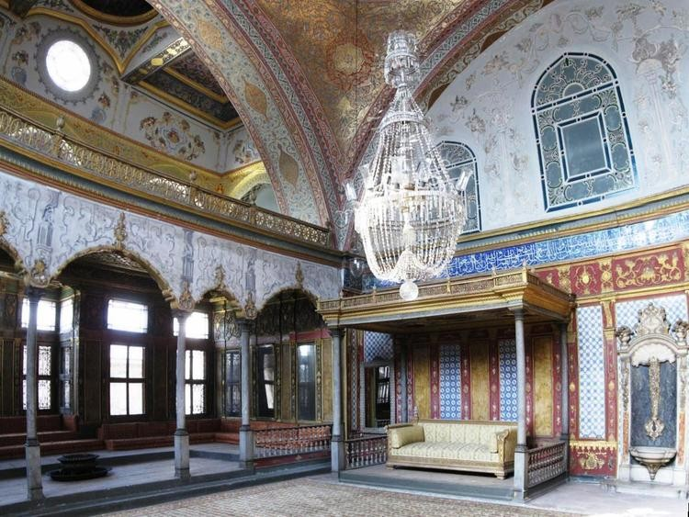
The Ottoman Empire and other religions

Most scholars agree that the Ottoman Turk rulers were tolerant of other religions.
Those who weren't Muslim were categorized by the millet system, a community structure that gave
minority groups a limited amount of power to control their own affairs while still under Ottoman rule. Some millets paid taxes, while others were exempt.

Devshirme

In the 14th century, the devshirme system was
created. This required conquered Christians to give up 20 percent of their male children to the state. The children were forced to convert to Islam and become slaves.
Although they served as slaves, some of the converts became powerful and wealthy. Many were trained for government service or the Ottoman military. The elite military group, known as the Janissaries, was primarily made up of forced Christian converts.
The devshirme system lasted until the end of the 17th century.
Decline of the Ottoman Empire

Starting in the 1600s, the Ottoman Empire began to lose its economic and military dominance to Europe.
Around this time, Europe had strengthened rapidly with the Renaissance and the dawn of the Industrial Revolution. Other factors, such as poor leadership and having to compete with trade from the Americas and India, led to the weakening of the empire.
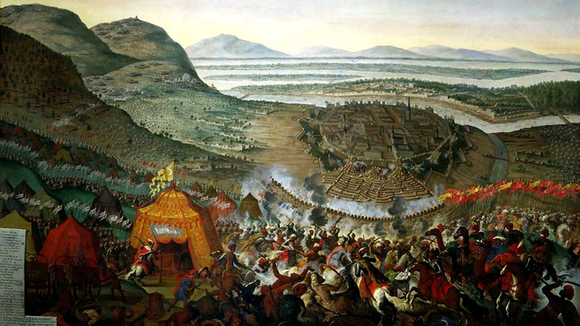
In 1683, the Ottoman Turks were defeated at the Battle of Vienna. This loss added to their already waning status.
Over the next hundred years, the empire began to lose key regions of land. After a revolt, Greece won its independence from the Ottoman Empire in 1830.
In 1878, the Congress of Berlin declared the independence of Romania, Serbia and Bulgaria.
During the Balkan Wars, which took place in 1912 and 1913, the Ottoman Empire lost nearly all its territories in Europe.
When did the Ottoman Empire fall?

At the start of World War I, the Ottoman Empire was already in decline. The Ottoman Turks entered the war in 1914 on the side of the Central Powers (including Germany and Austria- Hungary) and were defeated in 1918.

Under a treaty agreement, most Ottoman territories were divided between Britain, France, Greece and Russia.
The Ottoman Empire officially ended in 1922 when the title of Ottoman sultan was eliminated. Turkey was declared a republic in 1923.
Armenian genocide

The Armenian genocide was perhaps the most controversial and damning event associated with the Ottomans.
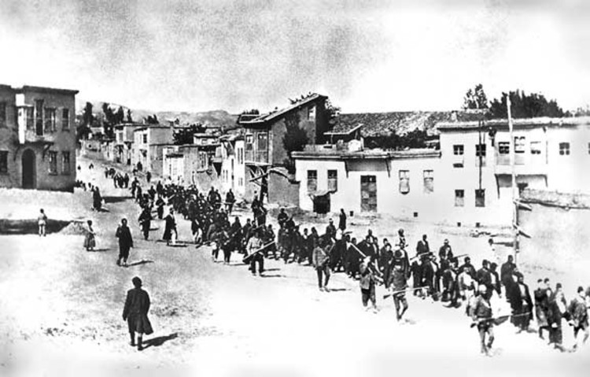
In 1915, Turkish leaders made a plan to massacre Armenians living in the Ottoman Empire. Most
scholars believe that about 1.5 million Armenians were killed.
For years, the Turkish government has denied
responsibility for a genocide. In fact, it's illegal, even today, to talk about the Armenian genocide in Turkey.
The Ottoman legacy

After ruling for more than 600 years, the Ottoman
Turks are often remembered for their powerful military, ethnic diversity, artistic ventures, religious tolerance and architectural marvels.
The mighty empire's influence is still very much alive in the present-day Turkish Republic, a modern, mostly secular nation thought of by many scholars as a continuation of the Ottoman Empire.

