The Ottoman Empire
By History.com, adapted by Newsela staff on 11.27.17 Word Count 1,224
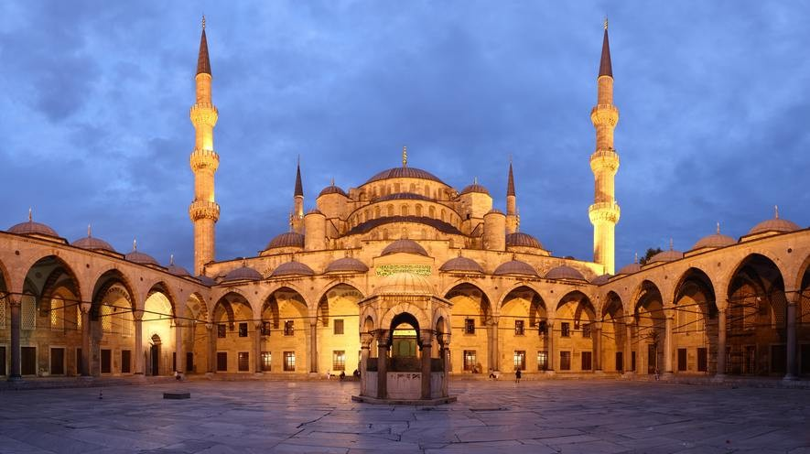
Level 970L
Courtyard of the Blue Mosque, in Istanbul, Turkey. The mosque was built between 1609 and 1616 during the rule of Ahmed I. Photo by: Benh Lieu Song/Wikimedia.

The Ottoman Empire was one of the most powerful and long-lasting dynasties in world history. This Muslim superpower ruled large areas of the Middle East, Eastern Europe and North Africa for more than 600 years. The empire's leader, known as the sultan, had absolute religious and political authority over his people. Western Europeans generally viewed the Ottomans as a threat.
However many historians believe that the Ottoman Empire made the region more stable and secure. It also was the source of great achievements in the arts, science, religion and culture.
Origins of the Ottoman Empire

Osman I, a leader of the Turkish tribes in Anatolia, founded the Ottoman Empire around 1299. The term "Ottoman" comes from Osman's name, which was "Uthman" in Arabic.
In 1453, Mehmed II the Conqueror seized the ancient city of Constantinople. It was the greatest city in the world and the capital of the Byzantine Empire, a Christian empire. This put an end to the 1,000-year reign of the Byzantine Empire. It's important to note that historians are the ones

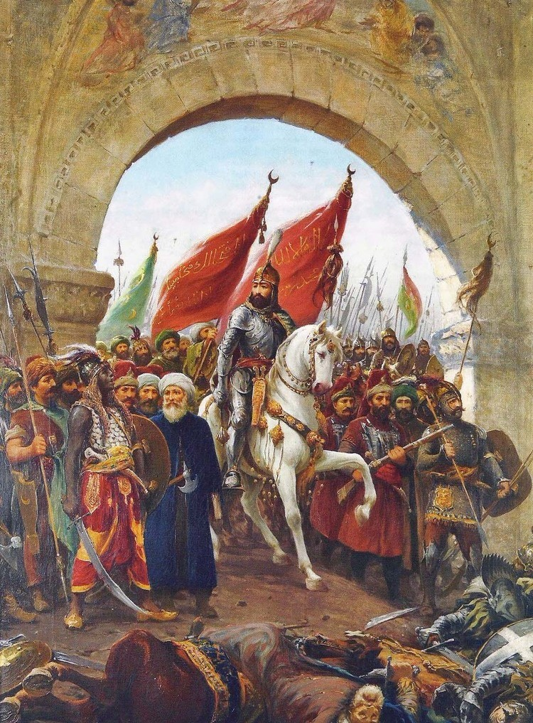
who call it the Byzantine Empire. To the people living in it, it was the new capital of the Roman Empire, after Rome had fallen.
Sultan Mehmed renamed the city Istanbul, meaning "the city of Islam." He made it the new capital of the Ottoman Empire. Istanbul became a dominant international center of trade and culture.

Suleiman and the period of expansion

The empire reached its peak between 1520 and 1566, during the reign of Suleiman the Magnificent. This period was marked by great power, stability and
wealth.
Suleiman gave the Ottomans a modern government and law. He gave protections to Christians and Jews. Suleiman also changed the tax system. People had to pay taxes according to their income. The rich paid
more than the poor. Government jobs became based on ability, rather than on family connections. All
Ottoman citizens had to follow the law.
Suleiman also welcomed different forms of arts and literature.
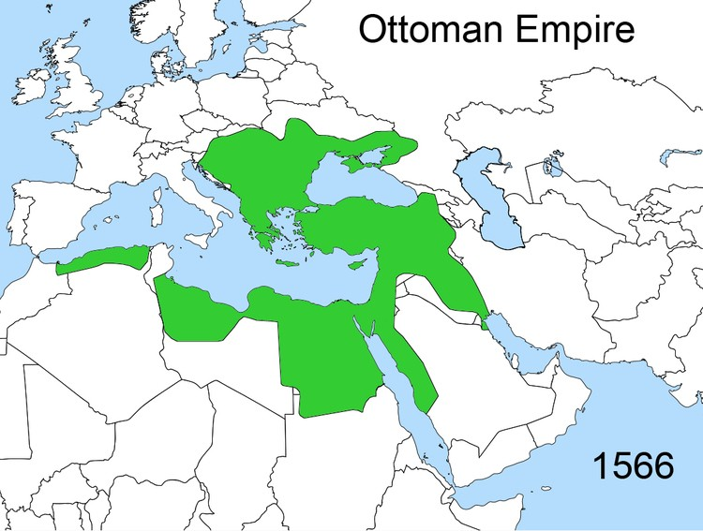
Throughout Sultan Suleiman's rule, the empire expanded and included areas of Eastern Europe. At its height, the Ottoman Empire stretched from North Africa to the Middle East and up into Central Europe.
Ottoman art and science

The Ottomans were known for their achievements in art, science and medicine. Istanbul and other major cities became artistic hubs, especially during the reign of Suleiman the Magnificent. The Ottomans absorbed learning from the Arab lands they had conquered, as scholars from places like Egypt, Syria and the Holy
Land headed to Istanbul. The Ottomans also came to control the Silk Road trade routes. They traded with Italian city-states like Venice and also Asian nations. These roads also brought new ideas and culture.
Some of the most popular forms of art included calligraphy, painting, poetry and music. The Ottomans were also known throughout the world for their magnificent textiles, carpets and ceramics.
Ottoman architecture helped define the culture of the time. Soaring mosques and magnificent public buildings were constructed during this period.

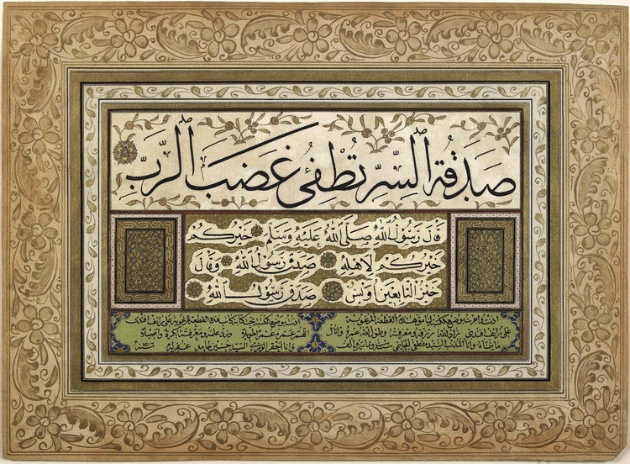
Science was regarded as an important field of study. The Ottomans studied advanced mathematics, astronomy, philosophy, physics, geography and chemistry.
Additionally, some of the greatest advances in
medicine were made by the Ottomans. They invented several surgical instruments that are still used today.

The Ottoman Empire and other religions

The Ottomans were more tolerant of other religions than Christian kingdoms in Europe were at that time.
It is true that Jews and Christians were considered inferior to Muslims and had to pay extra taxes. But Jews, Christians and Muslims mostly lived together peacefully until the 1800s.
Christians and Jews had some power to control their own community affairs and practice their religions.
Devshirme

In the 1300s, the devshirme system was created. This required conquered Christians to give up
some of their male children to the government. The children were forced to convert to Islam and become slaves.
However, being picked to join the devshirme was one of the best ways to get ahead in Ottoman society. Some of the converts became powerful and wealthy. Many were trained for government service or the Ottoman military. The elite military group, known as the Janissaries, was mainly made up of forced Christian converts. The Janissaries filled many government jobs and in many ways were the ones who ran the empire on a day-to-day basis. But the Janissaries were never allowed to marry, so they couldn't create a class of people who would challenge the power of the sultan.
The devshirme system eventually came to include many boys from Muslim families. The system lasted until the end of the 1600s.
Decline of the Ottoman Empire

Much of the Ottomans' wealth and power came from constantly taking over new lands. The sultan would rent conquered lands to his favorite subjects, and these aristocrats would tax the farmers on the land. Starting in the 1600s, the Ottoman Empire began to lose its economic and military dominance.
Several factors were in play. European nations grew stronger, partly with gold they'd taken from the Americas, while at the same time poor leadership and ineffective sultans weakened the empire. The Europeans brought new types of economic competition. They used gold from the Americas to buy the raw materials like wool and leather that Ottoman artisans and their trade guilds needed.
Ottoman manufacturing was greatly hurt. Also, the Ottomans could not compete with trade from the Americas and India.

In the 1700s and 1800s, the empire lost key regions of land. After a revolt, Greece won its independence from the Ottoman Empire in 1830.
During the Balkan Wars, which took place in 1912 and 1913, the Ottoman Empire lost nearly all its territories in Europe.
When did the Ottoman Empire fall?

By the start of World War I, the Ottoman Empire was already in decline. The Ottoman Turks
entered the war in 1914 on the side of Germany and Austria-Hungary and were defeated in 1918. Most Ottoman territories were divided between Britain, France, Greece and Russia.
The Ottoman Empire officially ended in 1922. Turkey was declared a republic in 1923.
Armenian genocide

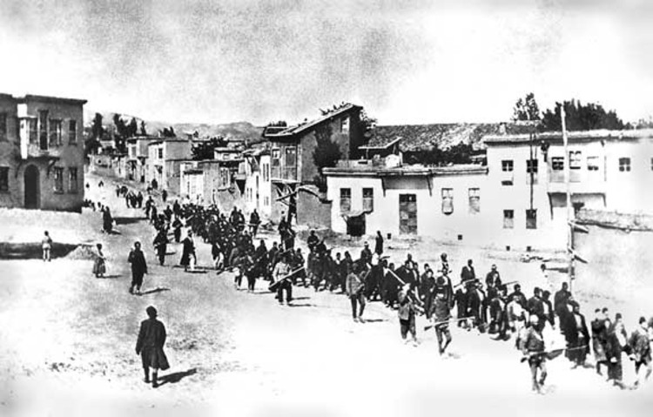
The Armenian genocide was perhaps the most controversial and damning event in Ottoman history.
In 1915, Turkish leaders made a plan to massacre Armenians living in the Ottoman Empire. Most
scholars believe that about 1.5 million Armenians were killed. This wasn't the first massacre of
Armenians. Armenians had begun asking for more rights in the late 1800s, and in 1895 the Ottomans
massacred between 100,000 and 300,000 Armenians because of it.
The Turkish government has denied that a genocide took place in 1915. In fact, it's illegal to talk about it in Turkey even today.
The Ottoman legacy

The Ottoman Empire lasted for more than 600 years. A total of 36 sultans ruled the empire between 1299 and 1922. They are remembered for their powerful military, ethnic diversity, art, religious tolerance and architecture.
The mighty empire's influence is still very much alive in the Turkish Republic today.

