The Ottoman Empire
By History.com, adapted by Newsela staff on 11.27.17 Word Count 733
Level 610L

Courtyard of the Blue Mosque, in Istanbul, Turkey. The mosque was built around 400 years ago during the rule of Ahmed I. Photo by: Benh Lieu Song/Wikimedia.

The Ottoman Empire was one of the strongest in the world. It was based in Turkey and lasted more than 600 years. The Ottomans ruled large areas of land. Their official religion was Islam. Their leader was known as the sultan. The
Ottomans were also known for art, science and culture.
Origins of the Ottoman Empire

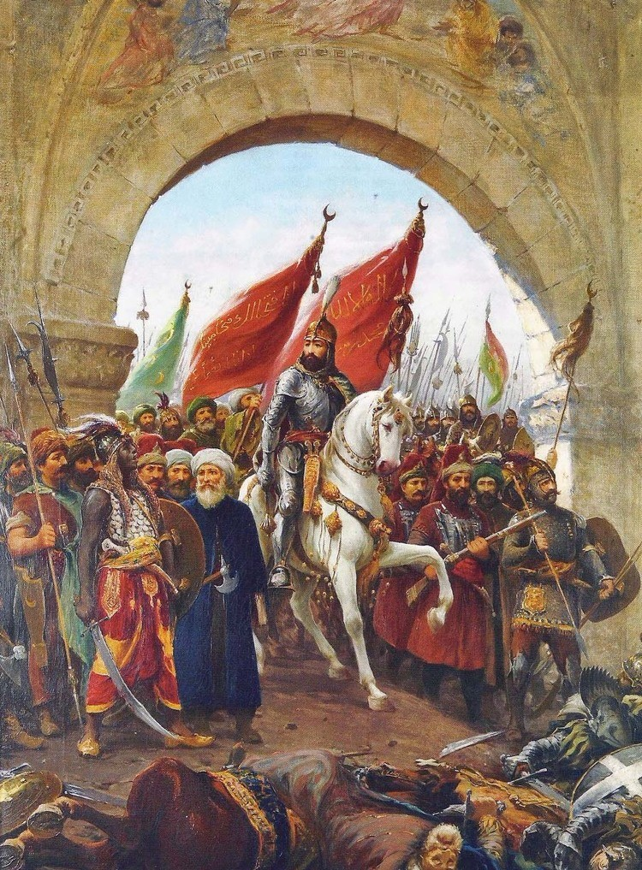
Osman I founded the Ottoman Empire around 1299. He was a leader of the Turkish tribes in Anatolia. The area is now in present-day Turkey.
In 1453, Mehmed II the Conqueror defeated Constantinople. The city was the capital of the Byzantine Empire.
The city was renamed Istanbul. Istanbul means "the city of Islam." It became the new capital of the Ottoman Empire.
Suleiman and the period of expansion

Suleiman the Magnificent was the most important sultan. He ruled between 1520 and 1566. He made the empire powerful and rich.
Suleiman gave the Ottomans a modern government and law. He gave protections to Christians and Jews. Suleiman also

changed the tax system. People had to pay taxes according to their income. The rich paid more than the poor. Government jobs became based on ability, rather than on family connections. All Ottoman citizens had to follow the law.
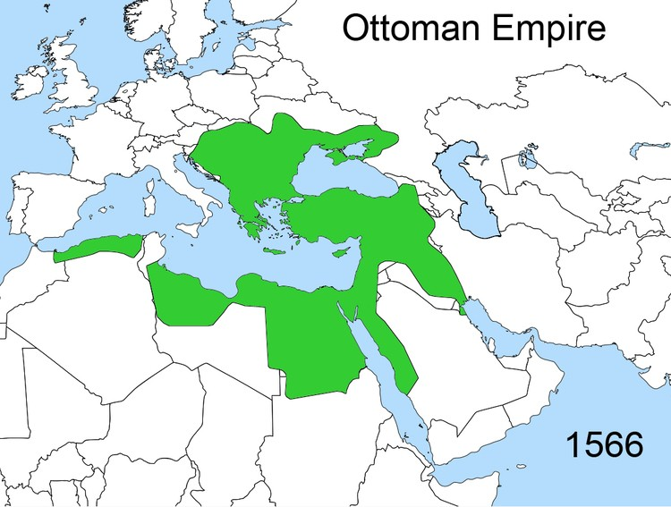
Suleiman conquered huge amounts of territory. At its largest, the empire stretched from North Africa to the Middle East.
Ottoman art and science

The Ottomans learned from the Arab lands they had conquered. Scholars from places like Egypt, Syria and the Holy Land headed to Istanbul. The Ottomans also controlled the Silk Road trade routes. They traded
with Italian city-states like Venice. They also traded with Asia. These roads brought new ideas and culture to Istanbul.
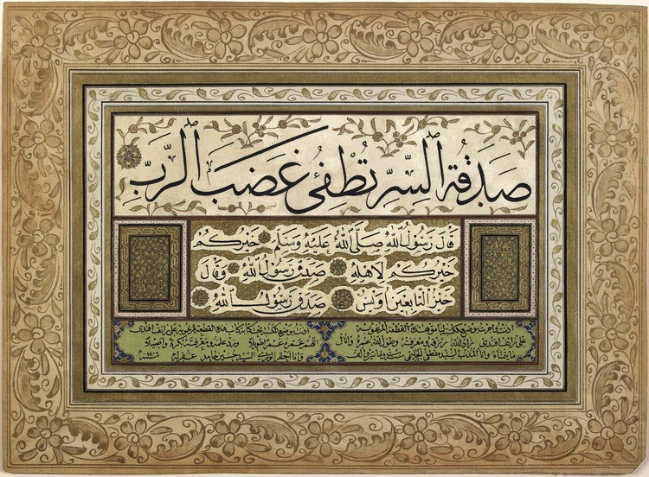
The Ottomans became famous for their art, science and medicine. Painting, poetry and music were also popular.
They built beautiful mosques and other buildings.
The Ottoman Empire and other religions

The Ottoman Empire was Muslim. It was more tolerant of other religions than Christian kingdoms in Europe at that time.
Jews and Christians were considered
inferior to Muslims. They also had to pay extra taxes. But Jews, Christians and Muslims mostly lived together peacefully until the 1800s.
Decline of the Ottoman Empire

Much of the Ottomans' wealth and power came from taking over so much land. The sultan would rent conquered lands to his favorite people. Then these rich people would make the farmers on the land pay taxes. In the 1600s, the
Ottoman Empire began losing power and land.
There were several reasons. First, European nations grew stronger. European traders were competitive. They had taken gold from the Americas. They used it

to buy raw materials like wool and leather that Ottoman artisans needed.
Ottoman manufacturing was hurt. Second, the Ottomans had weaker
leaders. Finally, the Ottomans could not compete with trade from India and the Americas.
When did the Ottoman Empire fall?

World War I began in 1914. Many nations fought in the war. By that time, the Ottoman Empire was already failing. The Ottoman Turks were on the side of Germany. They fought against the United States, Britain and France. The
Ottomans were defeated in 1918.
Most Ottoman territories were divided up. Different countries each took a
share. The Ottoman Empire ended in 1922. It was renamed Turkey and became a democracy in 1923.
Armenian genocide

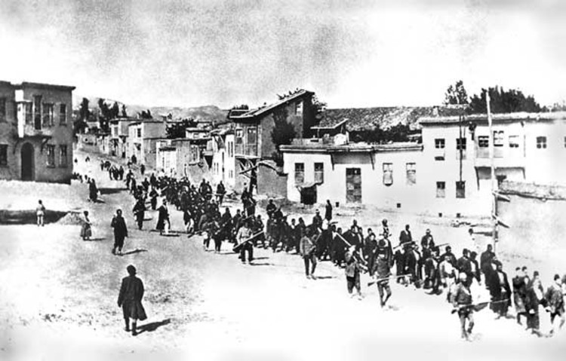
Many different groups lived in the Ottoman Empire. The Armenian Christians were one of them. They had begun asking for more
rights in the late 1800s, and in 1895 the
Ottomans massacred between 100,000 and 300,000 Armenians. Then in 1915, Turkish leaders planned to wipe out Armenians.
About 1.5 million Armenians were killed.
The Turkish government denies the genocide. Today, it is against Turkish law to talk about it.
The Ottoman legacy

The Ottoman Empire lasted from 1299 to 1922. It had a total of 36 sultans. The Ottomans are remembered for their army, art and buildings. They accepted different religions and cultures.
At its height, the empire was mighty. It has a big influence on Turkey today.

