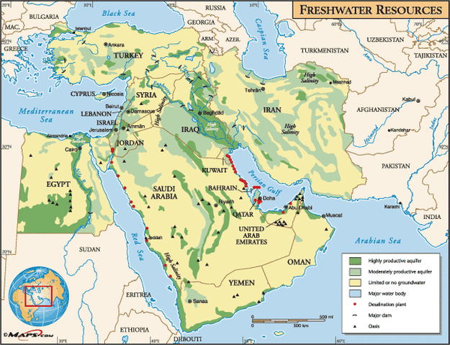

[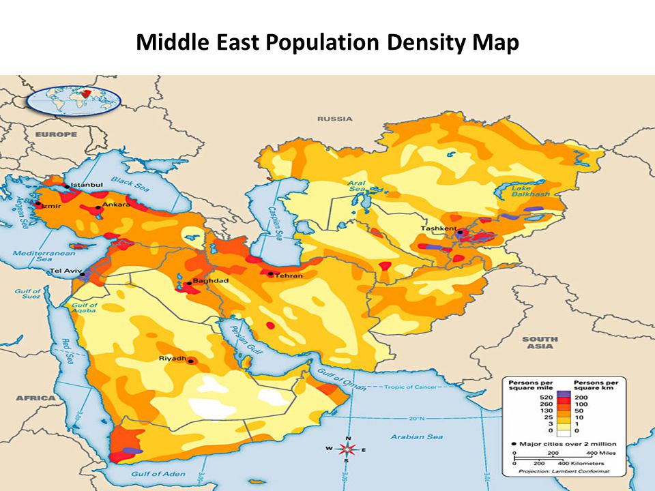](http://www.google.com/url?sa=i&rct=j&q=&esrc=s&source=images&cd=&ved=0ahUKEwiK86nGqrfOAhUK4SYKHXK4AWAQjRwIBw&url=http://slideplayer.com/slide/4420727/&psig=AFQjCNHj44XQnT2vXm9YWWyXllDKf1ozQQ&ust=1470935060523218)

