Name:_______________________________________________ Date:______________
“What’s the Cost of Water?” IDM Task 1 Period:_____________

Students will be able to analyze maps and videos to answer the questions in complete sentences. (Use any color ink except for black, yellow and orange, to complete this activit.)

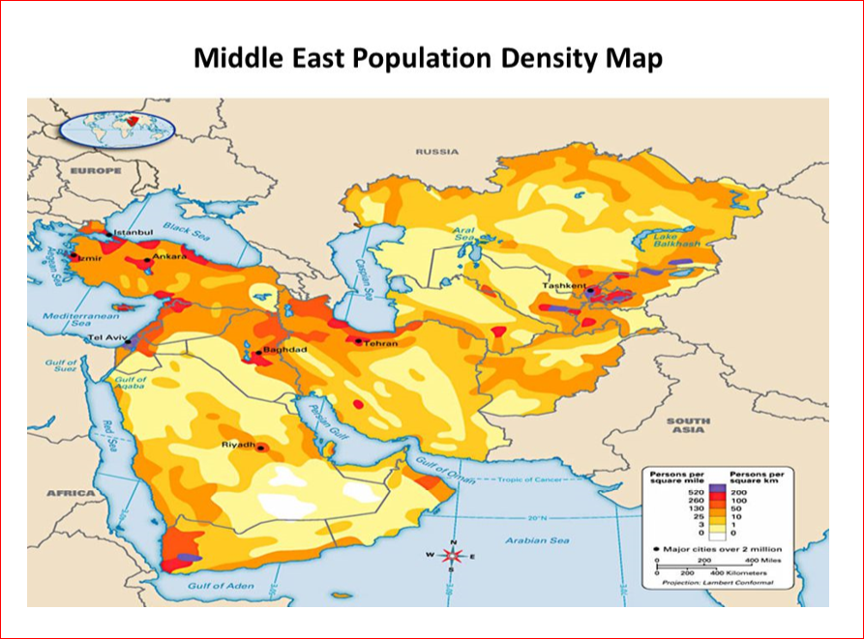

- What color represents the densest population?

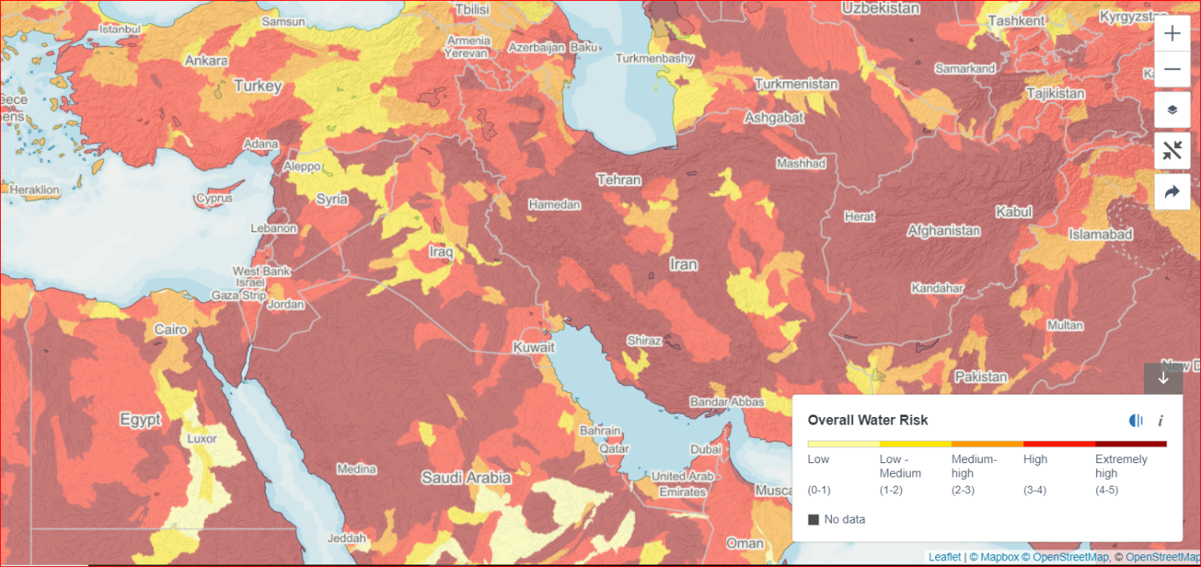

- Which colors represent the least access to water?

Click to watch. Water Desalination in Israel...

- Israel is a Middle Eastern country that is struggling with having enough access to water. What is Israel doing to meet its water needs?

Click to watch. How powerful is Israel?

- How is Israel able to afford desalination technologies?

Click to watch. Saudis desalinate Red Sea Water...

- Saudi Arabia is a Middle Eastern country that is struggling with having enough access to water. What is Saudi Arabia doing to meet its water needs? How are they able to afford it?

- Iraq is a Middle Eastern country that is struggling with having enough access to water. What is Iraq doing to meet its water needs?

- United Arab Emirates (U.A.E) is a Middle Eastern country that is struggling with having enough access to water. What is the U.A.E. doing to meet its water needs?

- Turkey is a Middle Eastern country that is has some issues with having enough access to water. What is Turkey doing to meet its needs?

