Text | Guiding Questions
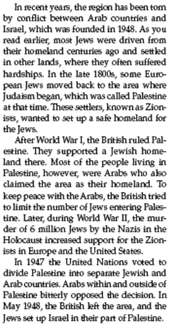  1)  2)  3)  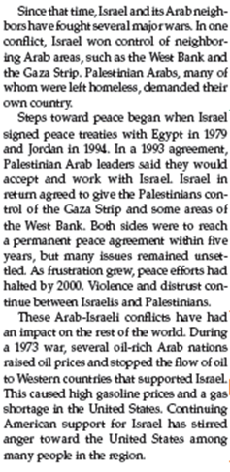  4)  5)  6) | The state of ___________________________________ was created in 1948.  What do you think “hardships” means in the 7th line of paragraph 1?  ____________________________________________________________________  ____________________________________________________________________  What did the “Zionists” want?  ____________________________________________________________________  ____________________________________________________________________  The Israeli Jews and Palestinian Arabs both claimed ____________________ as their homeland.  In line 10 of paragraph 2, it states (says) “the Holocaust increased support for the Zionists in Europe and the United States.” Why did the Holocaust “increase support” for the Jewish homeland?  ____________________________________________________________________  ____________________________________________________________________  ____________________________________________________________________  ____________________________________________________________________  To be fair to the Jews and Arabs, the ______________________ decided to partition Palestine into two separate countries.  In line 4 of paragraph 3, what does “bitterly opposed” mean?  ____________________________________________________________________  ____________________________________________________________________  According to paragraph 4, have the Israeli Jews and Palestinian Arabs lived in peace since 1948? If not, what is one of the areas they are conflicting over?  ____________________________________________________________________  What do the Palestinian Arabs want?  ____________________________________________________________________  Israel signed its first peace treaty (agreement) with which North African country? ____________________________________________________________  True or False –  “Today, the Israeli Jews and Palestinian Arabs live in peace and harmony.”  Support your decision with text evidence (details) from paragraph 5.  ____________________________________________________________________  ____________________________________________________________________  ____________________________________________________________________  ____________________________________________________________________  ____________________________________________________________________  True or False –  “Conflict between the Arab & Jewish ethnic groups has affected other regions in the world.”  Support your decision with text evidence (details) from paragraph 6.  ____________________________________________________________________  ____________________________________________________________________  ____________________________________________________________________  Why do some Arab nations (still) resent (have negative feelings toward) the United States?  ____________________________________________________________________  ____________________________________________________________________

