Name:______________________________________________________________ Date:______________ Pd:________
African History: Colonialism Vocabulary
Directions: Write definitions from African History Vocabulary PowerPoint and draw a picture to go along with it
- Scramble for Africa: _____________________________________
_____________________________________________________
- Imperialism: __________________________________________
_____________________________________________________

- Colonization: __________________________________________
_____________________________________________________
- Indirect Rule: __________________________________________
_____________________________________________________
- Assimilation:___________________________________________
______________________________________________________

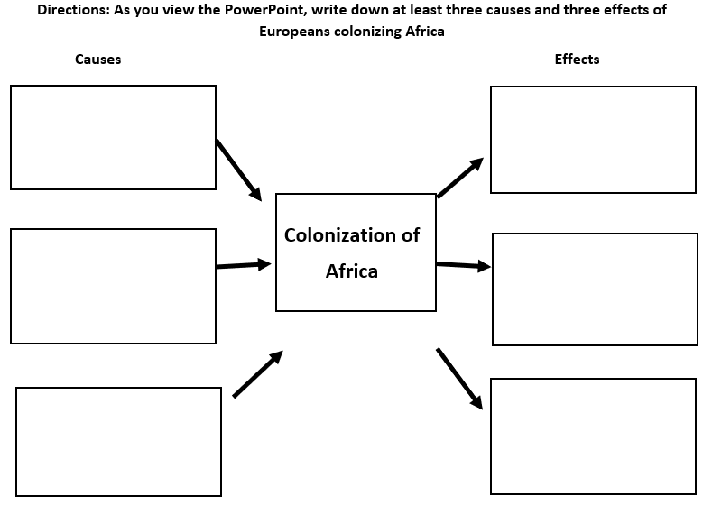

African Colonization
What do these cartoons / images from the PowerPoint tell us about Africa Colonization?
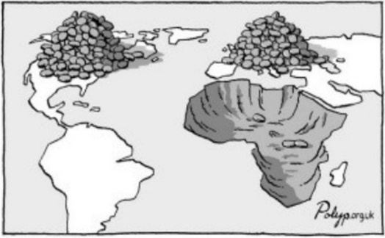
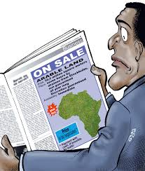
“GOLD”
______________________________________________________
______________________________________________________

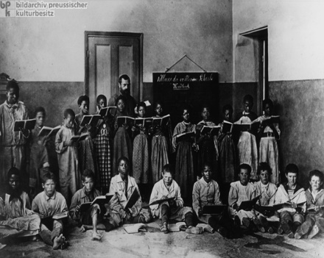
“GOSPEL”
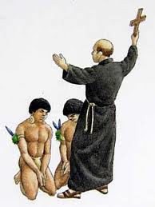
_____________________________________________________
_____________________________________________________
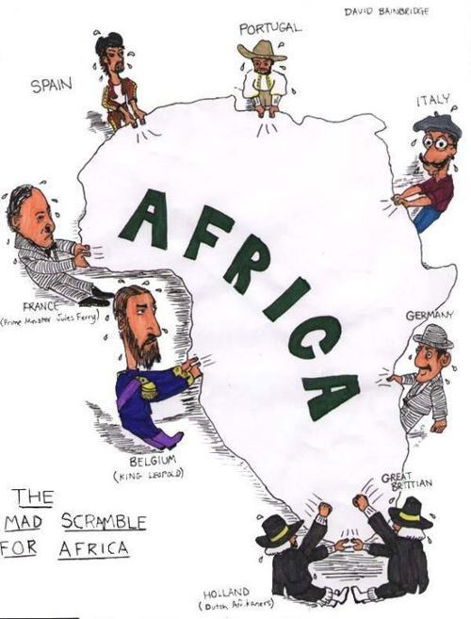
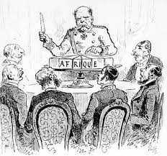
“GLORY”





