African Geography “Cram Sheet”

Countries : Egypt, Sudan, South Sudan, Kenya, Nigeria, Democratic Republic of Congo, South Africa
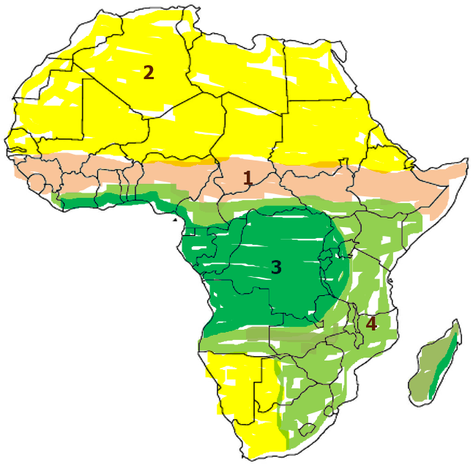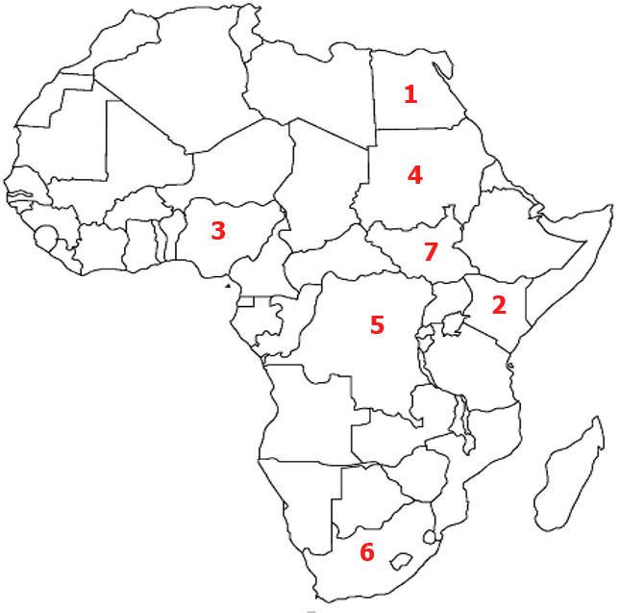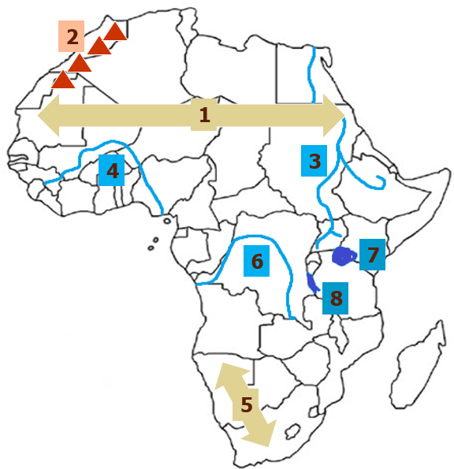
Physical Features: Atlas Mountains, Sahara Desert, Kalahari Desert, Nile River, Niger River, Congo River Lake Tanganyika, Lake Victoria
Climate Zones: (describe)
Sahara world’s largest desert/ makes up north Africa
little to no water
Sahel between sahara & savanna- dry land
Savana grasslands, arable, covers half of Africa
Tropical Rainforest near equator, Congo River runs
through it, shrinking due to Deforestation
Vocabulary to know:
- Animist Religious practice that inanimate objects and animals have a spiritual essence
- Deforestation the removal of trees or forests
- Desertification the process of dry areas becoming more desert like
- Famine widespread scarcity of food
- Drought extended period of dry weather; damages crops
- Slash and Burn farming method in which farmers clear land and burn it to increase nutrients in soil. (temporary fix)
Name:_________________________________________________ Date:____________________________ Pd:________

Ethnic Groups
Arabs  Location:  Northern & Eastern Africa  Languages:  Arabic  Religions:  Mostly Islamic | Ashanti  Location:  West Africa (Ghana)  Language:  Bantu & Arabic  Religions:  Mostly Christian  Some Islam  Traditional Religions | Bantu  Location: Sub Saharan, spread out. Bantu migrated thousands of miles  Language:  Bantu  Religions:  Traditional  Islamic  Traditional | Swahili  Location:  East Africa  Language:  Swahili, Mix of Bantu and Arabic  Religions:  Mostly Islamic
Of the traits mentioned above in ethnic groups, which one has the most diversity? Religion
Of the languages, which is spoken the most? Bantu
How are ethnic groups different from religious groups? You can choose religion. Religion does not always reflect ancestry
Ethnic groups are largely based on what? Language
Environmental Issues
Desertification  Causes:  Deforestation (clearing of trees)  Livestock over-grazing  Drought  Effects on Environment:  Less farming land  Shrinking Savana  Effects on Humans:  Less food  people must move | Deforestation  Causes:  Slash and Burn technique  Expanding population  Need for jobs  Factories  Effects on Environment:  Poor soil which causes farmers to use slash and burn which causes even more deforestation  Effects on Humans:  Less oxygen, greenhouse effect (climate change) | Water Scarcity & Pollution  Causes:  Location  Regional Conflict  Animal & Human Wastes  Fertilizer  Effects on Environment:  Pollution  Effects on Humans:  Disease  No clean water to drink  No water for irrigation  Women spend all day obtaining water and therefore do not get an education. No education = lower  Competition among countries for clean water
Identify
1. Sahel strip of semi-arid land south of the Sahara
2.Savana large grasslands in Africa where most large animals live
3. Nile River world’s longest river- densely populated
4. Drought - lack of rain
5. Famine lack of food for a long time
6. Congo river that flows through central Africa
7. Desertification when arable (farmable) land turns into desert because of overgrazing or drought.
8. Deforestation cutting down trees which leads to poor soil in Sub-Saharan Africa
9. Sahara - world’s largest desert in Northern Africa

