**7th Grade CRCT Study Guide**

Name: ___________________________

Date: __________ Period: ___________

**Southwest Asia (the Middle East)**

**Unit 1: People & Places in SW Asia**

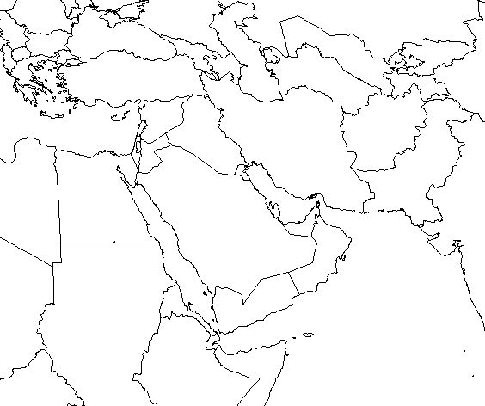

1. Locate (label) these countries: Israel, Jordan, Saudi Arabia, Iran, Iraq, Syria, Lebanon, Kuwait, Turkey, Afghanistan
2. Locate (label) these physical features: Jordan River, Tigris River, Euphrates River, West Bank, Gaza Strip, Suez Canal, Persian Gulf, Red Sea, Arabian Sea
3. **­­­­___________**—oldest religion, ancient Hebrew people, Abraham, Diaspora, Torah, Israel, Jerusalem
4. **_____________________**—middle religion, Jesus Christ, Holy Bible, Jerusalem
5. **______________**—youngest religion, Muhammad, Mecca, Koran/Qur’an, 5 Pillars
6. “Conflict over caliphs created Muslim split”
   * Sunni—qualified person can lead, **______** of Muslims
   * Shia—only descendant of Muhammad can lead, **______** of Muslims
7. **______________** group—group of people who share language, race, traditions, religion etc.
8. **______________** group—group of people who share the same beliefs, creed, traditions, etc.
9. **__________**—collection of ethnic groups, can be different religions, most of the **___** and **__________**
10. **______________** —non-Arab, **______________**, speak Farsi, mostly Shia Muslim, known for their accomplishments (algebra, polo, Persian rugs)
11. **______________** —non-Arabs, northern **______________**, Syria & SE Turkey, Sunni Muslim, want their own country, Saddam Hussein very mean to them

**Unit 2: Modern History of SW Asia**

1. **______________** Empire broke up and became modern day **______________**
2. **________________________** took over after Ottoman Empire broke up
3. Why **______________** happened
   * **______________** thought God gave them land in **____________________________**
   * Jews left in the Diaspora in the first few centuries AD and then spread across the world
   * **______________** was prejudiced against Jews, called **____________________________**
   * After WWII, **______________** started---idea that Jews should have a homeland
4. Israel was created by UN in **_________** —Palestinians got the West Bank and the **________________**
5. Conflict over land in ME is caused by:
   * Lack of **______________**
   * Unequal distribution of natural resources especially **______________**
   * Lack of **____________________________** to farm
   * Control of **______________**
6. There’s conflict over **______________** because…
   * 3 major religions born there: **________________**, **________________**, and **_______________**
   * Share some holy sites
   * Majority **______________** —very small **______________** and **__________________**population
   * Persian Gulf War
     + **____________________________** invades Kuwait
     + **______________** forces say get out
     + Saddam burns the **____________________________**
     + He is defeated in less than **______________**
   * Invasion of Afghanistan
     + Afghanistan was friends with **____________________________** in 1970s
     + Fighting for 10 years and then **______________** take over and create Islamic state
     + 9/11 happens and US invades to look for **____________________________**
   * Invasion of Iraq
     + **____________________________** is still repressing people
     + He is rumored to have weapons of mass destruction
     + Told Saddam to get out or **______________** will happen
     + Didn’t leave, so **______** & Britain invaded
     + Saddam lost power, disappeared and US helped to create **______________**
   * Water impacts SWA—control the beginning of **______________** you control everything, lots of **______________** has to happen to grow things.
   * Water is **______________** lessening the ability to use it
   * OIL = LIFE IN Southwest Asia! Oil has allowed to many countries to raise their standard of **______________** and create wealth
   * **______________** —controls oil and is not just in SWA but most members are

**Unit 3: Power, Authority, & Government in SW Asia**

State

Government

State

Government

State

Government

State

Government

State

Government

federalnotextLevels of Government

unitarynotext

National

Government

**_______________________ ______________________ _____________________**

Role of the Citizen

autocracynotext oligarchynotext democracynotext

**_______________________ ______________________ _____________________**

1. Parliamentary—head of government is head of legislature and elected by **______________**, symbolic leader and legislative leader, legislative is usually called a **__________________________________**
2. Presidential democracy—head of government and the legislature are elected **___________**, head of government is **________________**, does not have to be member of majority party in **______­_______**

C:\Users\smd13143\AppData\Local\Microsoft\Windows\Temporary Internet Files\Content.IE5\MUQ694B1\MC900015071[1].wmf

Most Freedom

Least Freedom

1. Saudi Arabia
   * Absolute **_____________________**
   * Autocratic Unitary
   * Place on ruler—around **____** closer to least freedom for citizens
2. Israel
   * **_____________________**Democracy
   * Democratic Unitary
   * Place on ruler---around a **____** because of freedom of speech, free fair elections, Knessett is parliament
3. Iran
   * **_____________________**
   * Oligarchy Unitary (because of the shared power between state and religion, but could be considered autocratic too)
   * Place on ruler—around **____** because its restrictive for women, based on Sharia law, no freedom of speech etc.

**Unit 4: Economies of SW Asia**

1. 4 types of economies
   * Traditional—**_____________** and **______________**customs answer the 3 economic questions
   * Command—the **_________________**answers the 3 economic questions
   * Market—**_________________**consumers answers the 3 economic questions
   * Mixed—**_________________**and **_________________**answers the 3 economic questions
2. Most countries are **_________________** because the government and people share power—shown on a continuum
3. Saudi Arabia is more **_________________** than **_________________**
4. Israel is more **_________________** than **_________________**
5. Turkey used to be **_________________** and is moving more toward **_________________**
6. Specialization is where people **_________________** on what they are good at so they don’t have to do everything—creates **_____________________________** and grows trade
7. Types of trade barriers
   * tariff—tax on **_________________**
   * quota—only let a certain amount of **_________________** in the country
   * embargo—cuts off trade usually for **_________________** reasons
8. Currencies must be **_________________** so international trade can occur
9. Deserts in Southwest Asia (Middle East)
   * Make it so **_________________** is hard
   * People crowd around **_________________** and sources of water
   * Most work in **___________** industry
10. Major Rivers in Southwest Asia (Middle East)
    * Tigris, Euphrates, and Jordan Rivers
    * Provide precious **_________________** for drinking, animals, and irrigation